18th October 2016
West Sands St Andrews, Licence for Sediment Removal onto Sand Dune System for the purpose of dune restoration.
Licence No: 05559/15/0 Ref No: 05559
Location: West Sands St Andrews:
56 21.58’N 002 48.43’W
56 21.59’N 002 48.25’W
56 21.25’N 002 48.33’W
56 21.26’N 002 48.16’W
Annual Report
Licence Budget: 2000 wet tonnes over 3 years to 30th October 2018.
Operation detail:
Works began to harvest sand from agreed donation area marked FCCT Donation Area on attached map on 8th February 2016 using shallow scrape system to a depth of 50cm, which infilled on following tide. This work continued over 9th and 10th February. The sand was placed in tidal damaged blow outs along the eastern seaward edge of the sand dune system. 5 locations received sand donations to a maximum depth of 2m. 300 tonnes were harvested per day. These blow-out repairs were then fenced off and planted with dune grass (Marram and Lyme).
Total Sand Budget Used: 900 tonnes

Ranald Strachan
Fife Coast and Countryside Trust
East Sands Leisure Centre
St Andrews KY16 8LH

Donation site
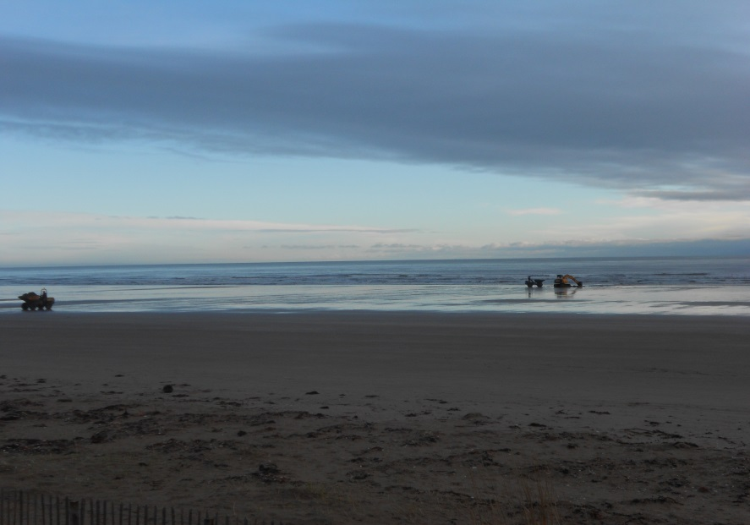

Loading and profiling new dunes.
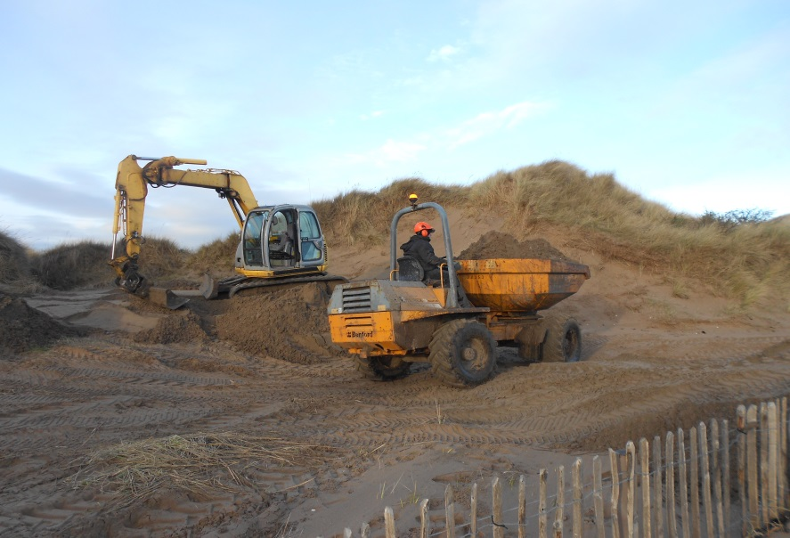
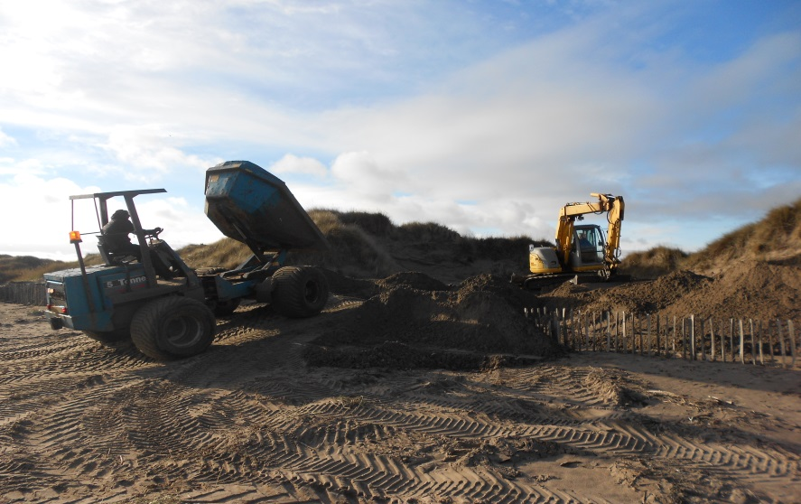

Beach Impact from Multiple trips
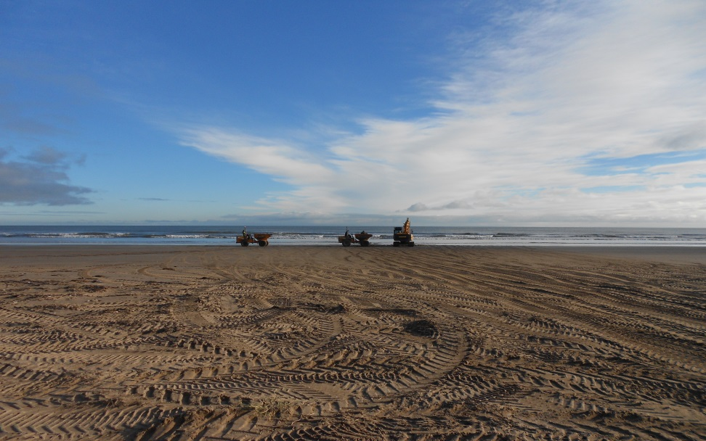
Completed Dune Section
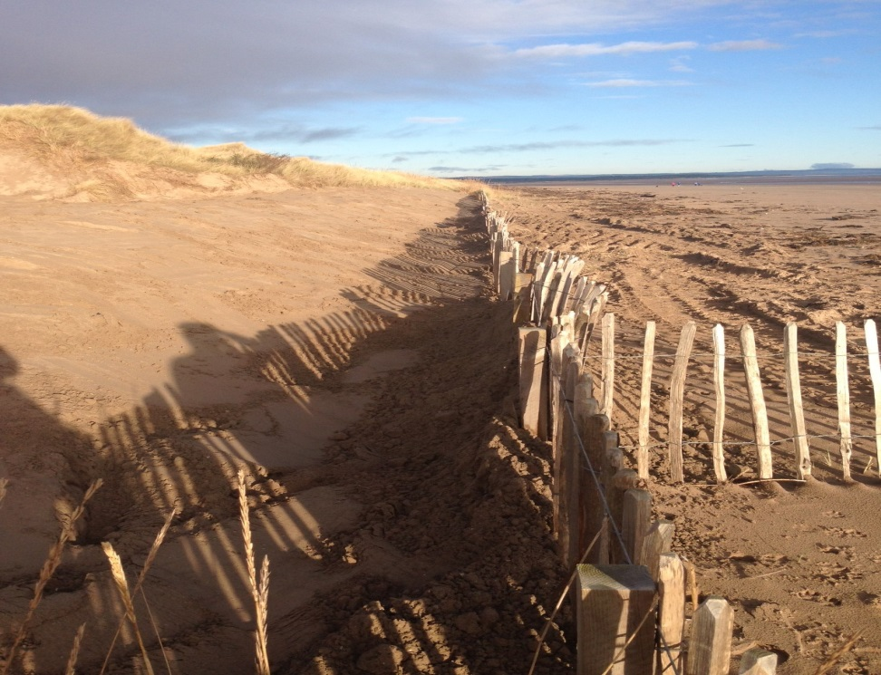

APPENDIX.1 Supporting Sediment Levels Report
Report on sand removal from the West Sands for use on the Links Golf Courses from May 2015 to August 2016
Jack Jarvis B.Sc P.hd
Introduction
Beaches provide protection for land that lies above the High Water Mark. Wave energy is absorbed by the beach and a wide beach may reduce the impact of wave activity at the HWM. Potentially the removal of sand from below the HWM could allow wave energy to more easily penetrate onshore and enhance coastal erosion at the maximum reach of wave activity.
The area of the West Sands beach adjacent to the site of sand removal by the Links Trust for dressing bunkers and other uses on the golf courses has been surveyed at regular intervals since 2011.This report comments on the impact of sand removal from the West Sands by the Links Trust during 2015-2016. An area of the West Sands extending approximately 200m south and 300m north of the site of sand removal by the Links Trust has been surveyed using a geodetic GPS system with a accuracy of better that 2cm. Sand elevations in the vicinity of the extraction site are reported from 4 surveys and this data is used to evaluate the likely effect of sand removal on the environment of the West Sands. The area of survey has been visually checked at monthly intervals and surveys have been undertaken at 3 monthly intervals or when inspection indicated that beach change had taken place.
This report builds on that submitted in previous years and extends the observations to August 2016.
During the report period from 8 September 2015 until 7 September 2016 the Links Trust removed sand volumes of approximately 545 tonnes in total from the beach on 11th and 12th January 2016 and 900 tonnes in total for sand dune restoration on 8th, 9th and 10th February 2016 under the licence held by FCCT (Licence no: 05559/15/0). This was part of the sand dune restoration programme and the donation site lies to the south of the Links donation sits. Sand is scraped from the surface layer of the beach to a depth of approximately 50cms and removed to the Trust’s storage area or as in 8th-10th February, onto the sand dunes.
The process used to assess the impact of sand removal on the beach is to survey the beach adjacent to the site of sand extraction. This is carried out in order to determine if measured changes can be seen to be out of character with natural changes. It is noted that the volume of extracted sand has been reducing recently since the Links Trust now import some sand from other sources.
Beaches respond to wind and wave forces, driven by both local and regional weather. For most beach localities movement of the HWM reflects the changing protection of the backshore area from erosion. In this report the surveys carried out this year enable one to comment on the movement of the High Water Mark during the last year and to compute sand volumes in the survey area above a given datum. Sand movement on the beach is reflected in the displacement of contour lines during the year and this data are supported by vertical profiles of the beach and a photographic record.
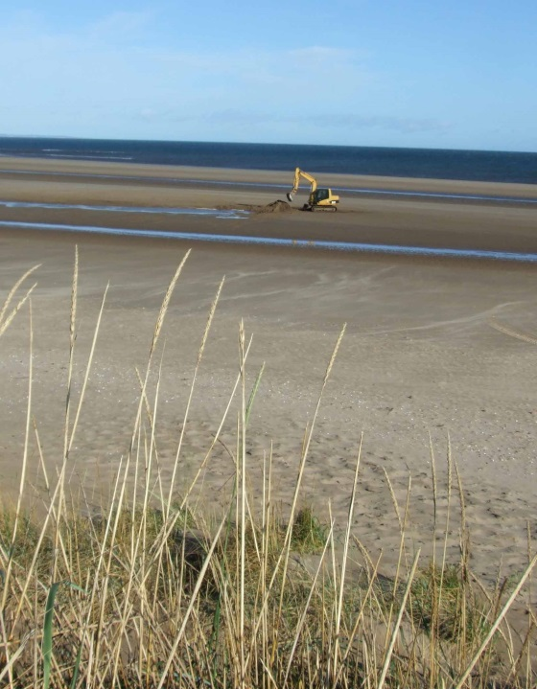
Figure 1
Sand extraction from crest of a ridge with runnel towards shore

Coastal Change 2015-2016
The effect of the coastal erosion that took place in January 2014 is still impacting the beach. Beach recovery reported from that January erosion in last year’s report continued into the first part of the period discussed in the present report.
During January 2014 erosion took place on the upper beach along the whole of the West Sands. During 2015 – 16 the West Sands has not experienced the same level of onshore wave activity during the winter and there had been a return to positive accumulations of wind -blown sand up until January 2016. However, as can be seen from the computed sand volumes (Figure 5) there was a loss of material during late winter-early spring - 2016 and beach volumes returned to those of January 2014. Since April sand has returned and volumes now approach those of August 2015. These changes are partly explained by the pattern of ridges and runnels that develop on this part of the beach during modest weather conditions. Volumes in the survey area are affected by high sand levels associated with ridges and low sand levels associated with runnels. (Figures 6,7)
It is likely that the sand levels at the north end of the West Sands beach are modified by the open environment of the Outhead Spit and its exposure to greater wave activity from the easterly sector. The channel crossing the spit noted in last year’s report has widened and slightly deepened during the year and now seems to be a permanent feature of this part of the estuary.
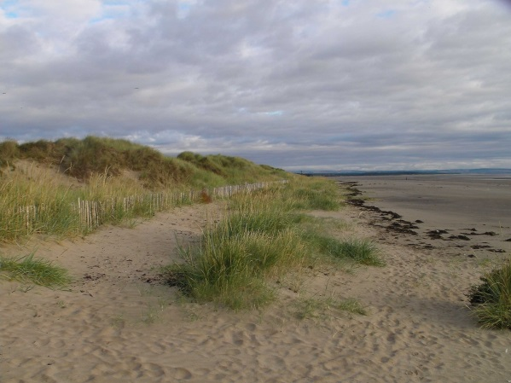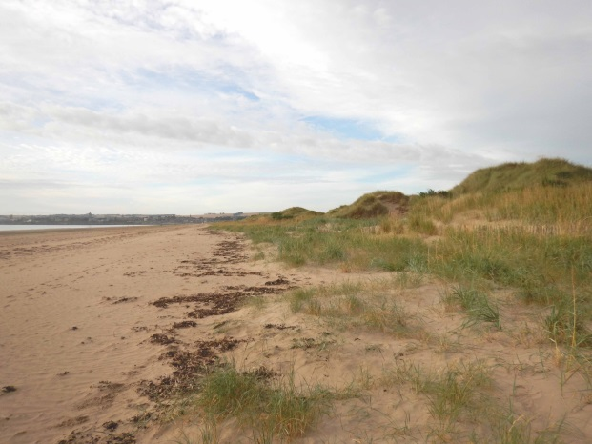
August 2015 July 2016
Figure 2 West Sands
Changes along much of the West Sands during the last 12months have generally resulted in the accumulation of sand on the upper beach. This is illustrated in Figure 2 that shows the beach to be accumulating seaward of the Chestnut paling fence installed in March 2014. The sand is stabilised by the growth of Marram grass. In 2015 there was no development of embryo dunes but the sand accumulations of 2016 has been moulded into small dunes up to 60cm high. During this time the chestnut paling fence line has been partly buried by accumulating sand and no longer provides a barrier to people entering the mature dunes.
It is possible to demonstrate the sequence of sand accumulation since 2015 landward of the extraction site by measuring the volume of sand within the survey area from a given beach elevation (1mOD) to the upper beach at a height of 3mOD.

Figure 3 Sand volumes on the beach by the Links Trust extraction site
Thus beach development during 2015-16 at the extraction site is summarised by the plot of sand volumes and also the changes in the location of the 2.5m OD contour shown in Figure 4. This contour approximates to the High Water Mark and shows that there was no movement in the southern part of the survey area but the eastward movement of the contour in the north indicates that some retreat has taken place there since November 2015.
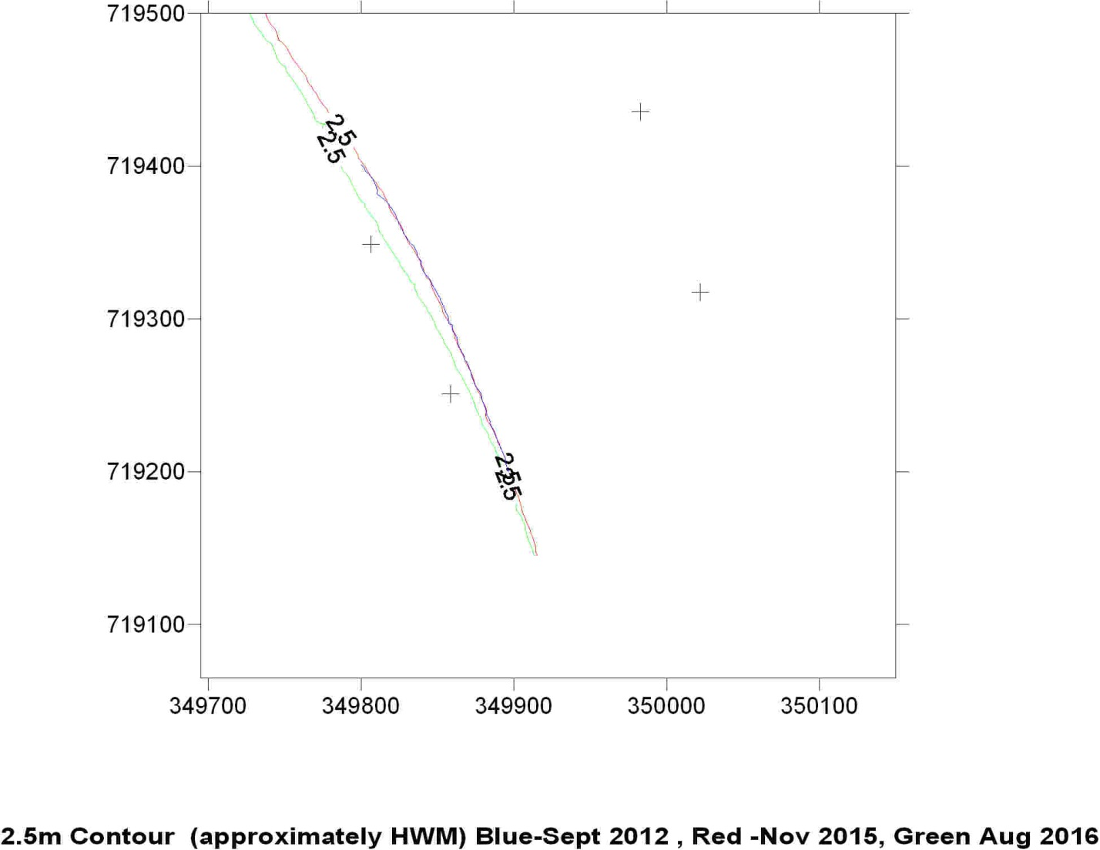
Figure 4 Movement of the HWM December 2014-August 2015.
Figure 3 shows that some 6,000cu m was lost from the survey area between November 2015 and March 2016 but by August 2016 some 4500 cu m had returned to the survey area. Despite the return of sand this has mainly affected the middle beach levels rather than the HWM since the 2.5m contour lies inland of the November survey and it is of interest that the 2012 survey position of the 2.5m contour lies above the November 2105 position and indicates a level of stability of this part of the West Sands. The beach profiles (Figures 5, 6) by the extraction site show the presence of ridge and runnel systems on the beach at the time of survey and indicates that the ridges and runnels that develop well during calmer wave activity and the profile lies both above and below the winter profiles of November 2015 and February 2012.

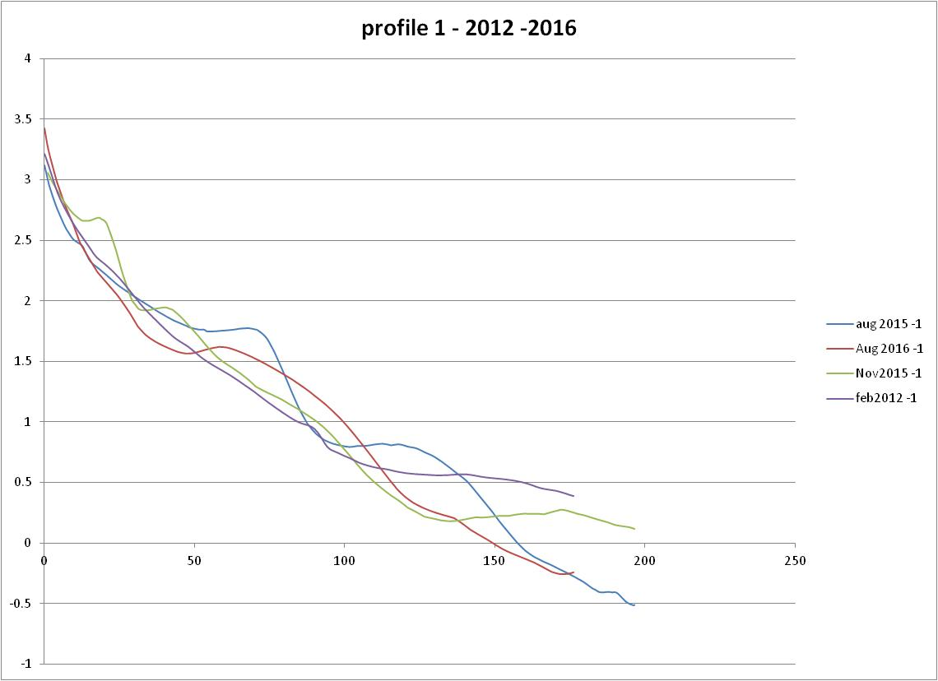
Figure 5 profiles 1 (Location in Figure 1) (February 2012-August 2016)

Figure 6 profiles 2 (Location in Figure 1) (August 2014-August 2015

Photographic record of Beach Change in the vicinity of the excavation site 2015- 2016
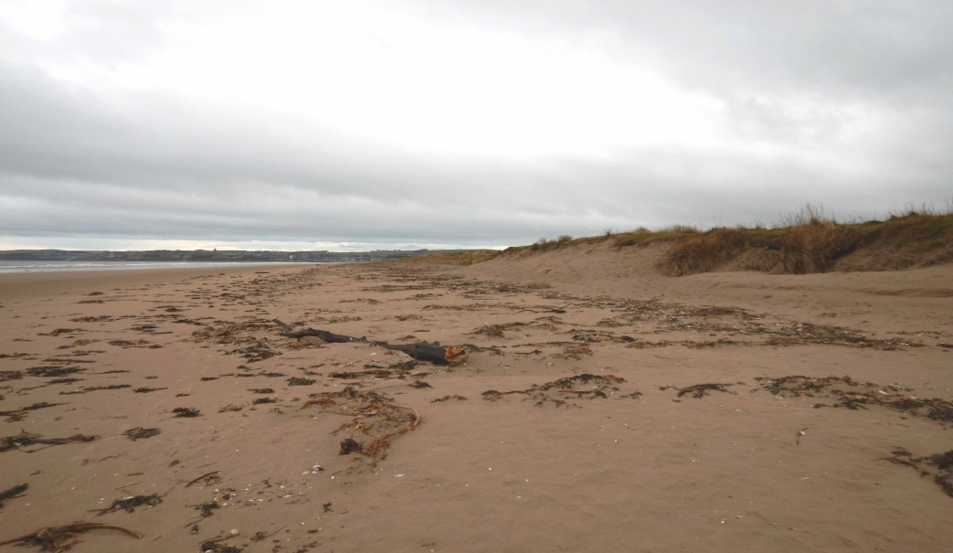
January 2016

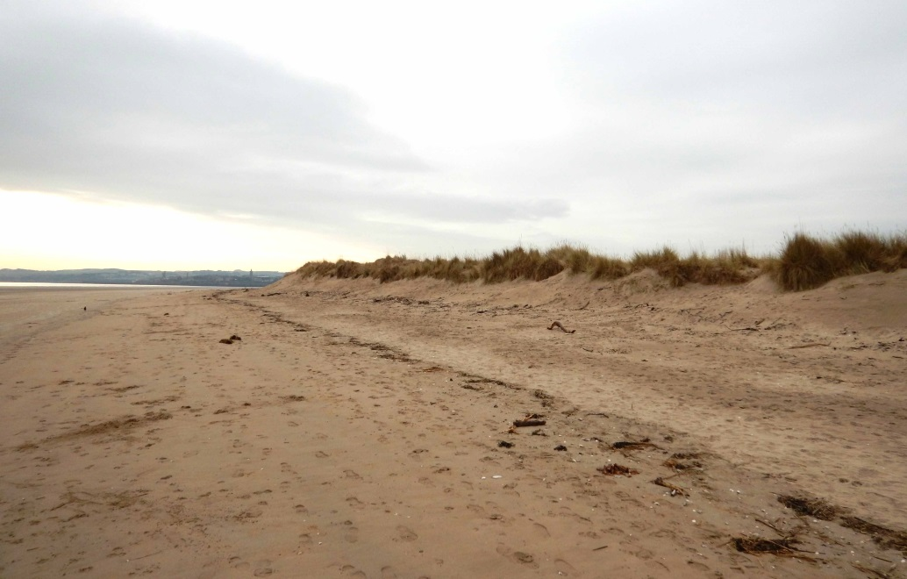
March 2016

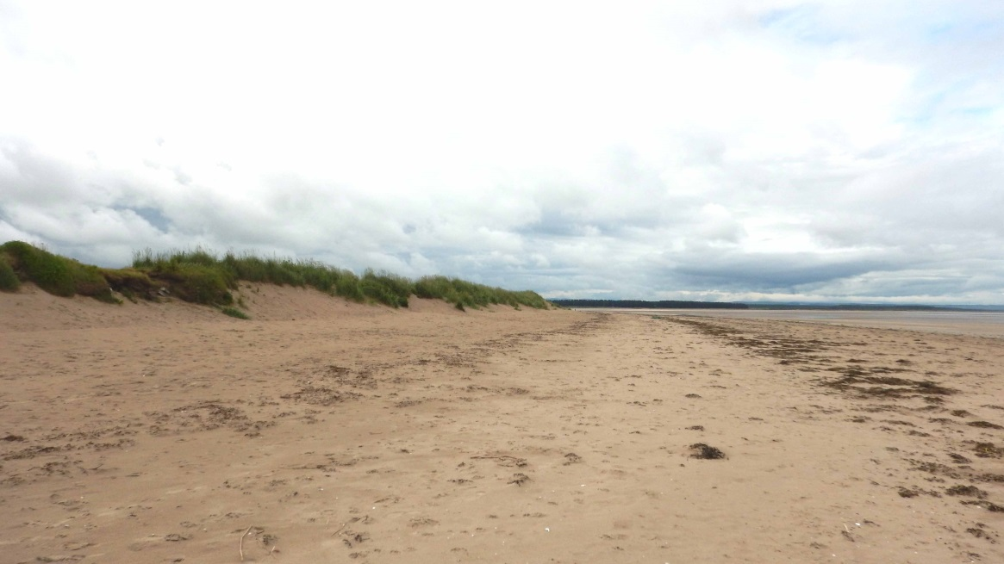
June 2016

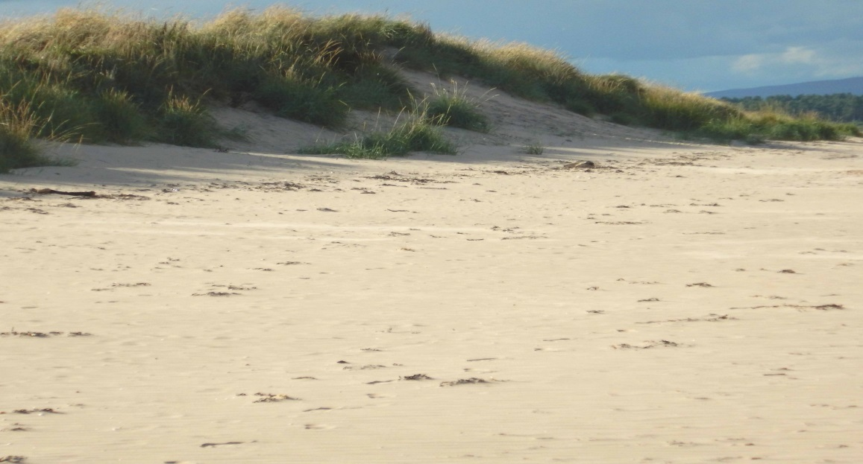
Aug 2016
The changes that have taken place along the West Sands during 2016 until August 2016 adjacent to the sand extraction site are illustrated in the photographs above.
Summary
All sand movements reported above are the result of natural changes resulting from both wave and tidal activity. Clearly the measured beach volumes in the area of sand extraction have changed by at least 10,000cu m since May 2015 and this is an order of magnitude greater than the sand volumes removed from the beach by the Links Trust. One can confidently assert that the changes observed in the limited section of beach surveyed have not been influenced by the small scale removal of sand from the beach by the Links Trust.

