Introduction
To give perspective to operations of this relatively new industry to decision makers, we will set out some of the timings, scale and techniques to be used.
New Wave Foods ltd, intend to apply to Marine Scotland for licenses to set light lines seeded with algae (up to 8 species) on new, purpose built Seaweed Reefs, to the West of Seil in Sound of Insh, to the West of Kerrera and to at Aird na Cuille (South East of Kerrera), all in Argyll and Bute. It is our intention to have the necessary consent in place to put the first equipment in the water by August 2018 and seeding lines in September 2018. Other sites will come on line the following summer (2019).
The license application and associated documents (such as this) will have the critical information required and we hope that when MS-LOT approach the statutory consultees you receive replies from each that Marine Scotland will be confident about consenting licences.
The works will be bounded within the coordinates outlined in attachments suffixed “Chart and outline” pdf “Lat/Lon” excel sheet for each site and “consent area variations” for anchoring and infrastructure details.
Deployment of lines will begin in Sep/Oct 2018 and Harvesting in Apr/May 2019. MS-LOT will be informed via an FEP5 form as directed on all operations undertaken. We will undertake regular monitoring of seaweed growth and duty of care over lines.
Our commitment to “Scotland’s National Marine Plan” can been seen in attachment “Seaweed Application – General Planning Principals”. Our commitment to wildlife, environmental and other users sensitivity is detailed in the later section on Designated Sites.
Seaweed Species
We are applying for consent to cultivate several Seaweed species – Alaria esculenta, Laminaria hyperborea, Laminaria digitata, Saccharina latissima, Himanthalia elongata, Porphyra species, Palmaria palmata, and Ulva lactuca. All these are found growing wild locally.
Our main target species at this time is Alaria esculenta (Atlantic Wakame). The details of the cultivation process described is for Alaria, but is close to the process of the other species.
The expected cost of each Seaweed Reef will be in the region of £200,000 each, so the marine licence application fee for a pair will be £2,250. New Wave Foods, the future license holder and site owners, will pay immediately by BACS to begin the process.
In water equipment
We will use a subsurface square, similar to that used by finfish farming, but with no surface cages. Only corner floats will be visible on surface as will appropriate special marks denoting the site outer limits. Each square will be roughly 50m x 50m and sit 2 abreast and 12 squares long (2 x 12 squares = 100m x 600m).
The anchoring system will be a relatively new, but proven corkscrew system by Aquamoor, which hugely reduces the footprint of the site and reduces seabed impact. The anchors are removeable if required as is all the in water equipment being used.
Light seaweed growing lines will be laid across these grids and held roughly 1.5m below the surface. We envisage a 1-2m spacing between the seaweed lines.

Seeding Process
Alaria is a brown kelp found on lower littoral and sub-littoral rocks exposed to strong wave action across Argyll.
The plant seeds into the water in late November through to early January, through fruiting bodies (sporophylls) that develop near the base of the plants. Seeded stock is cultured from locally-sourced reproductive material. The collection of fertile plants will comprise very small volumes (<1 wet kg), with no more than around 25% from any given patch on a shore. The small amounts collected are propagated in laboratory conditions into stocks of cells that can be held in stasis to suit operational needs. Around 1-2 months ahead of deployment, the cells are triggered to develop into microscopic plants that can be attached to growing media; typically thin twine wound round spools in 100m lengths. These spools are held under controlled conditions in aquaria until juvenile plants become visible (around 1-2mm long), at which point that are outplanted onto growing rope on the Seaweed Reefs. Cell culture and preparation of growing media will be conducted in partnership with commercial hatcheries, such as Scottish Association for Marine Science (SAMS) at Dunstaffnage.
The process can be seen here - http://www.bim.ie/media/bim/content/publications/aquaculture/BIM-Seaweed-Development-Programme-2016.pdf
Deployment Process
The lines will be deployed by existing mussel farm landing craft style vessels.
Narrow ropes (10mm or 12mm) are passed through the spools of Alaria string and the two fixed together. Researched is being undertaken to create a single infused line that can be directly deployed, cutting time and cost of deployment.
These combined lines are strung out in either horizontal, vertical or zig-zag patterns (optimum growing patterns are still being assessed) at depths between 0m and 6m below the surface.
We intent to use an underwater grid structure. A grid will be 50m x 50m and each of these will hold up to 24 to 48 50m lines.
Deployment is done between mid October and late November to give the juvenile plants time to establish on the lines before the darkest winter days shut down their growing. Growth should start to pick up again in late February as day length grows.
Harvesting Process
Regular monitoring will decide the optimum harvest periods.
Harvesting will be a reversal of the process using the same vessels.
The plants will grow rapidly through April into May. We would expect that we could achieve 1.5kg per m to 4kg per m of line between April and mid May. At these rates each 50m x 50m grid will produce between 3 tonnes and 8 tonnes of wet weight seaweed. Greater growth would be achieved if the lines were left into June and July, possibly 5kg, perhaps even 7kg per metre but the seaweed begins to be heavily fouled by other seaweeds, crustaceans and slimes and the value as a crop reduced to zero.
Harvesting will use a simple roller frame with cutting heads that will trim the useable 1.5m of the plant into bins or boxes while leaving the rope and growing base of the plant intact. We are looking at other cultivation operations where these can be returned to the water and coppiced again to create a 2nd crop, but this is dependent on the level of fouling.
Onward Processing
To keep the seaweed to the highest standard the product needs to be brought to shore and loaded onto temperature controlled vehicles, then to be processed as soon as possible. The processing is essentially one of lowering the water content without excessive heat, similar to herb processing. This creates a stable, storable product that can be rehydrated as an ingredient.
Other species and small amounts of Alaria will be kept as a wet, fresh ingredient with shorter shelf life, but the bulk of seaweeds will go through a drying process.
Future Work and support
New Wave Foods currently have a drying facility in Wick, but will in time need to develop a drying facility local to their growing sites to take on the increased volumes. A shore base, office and storage facilities, purpose built deployment and harvesting vessels plus contracted equipment, staff and other consumables will be required to make this new venture into a success. As will reasonable decisions by decision makers.
Seaweed Cultivation requires no input other than sunlight, creates a clean new habitat whilst it grows and other than a week at deployment in Oct/Nov and a few weeks harvest in Apr/May, minimum wildlife disturbance is taking place. New Wave Foods currently operates wild harvest sites certified as organic by the Soil Association and our intention is to bring our farms sites into organic certification also. Seaweed cultivation will be truly sustainable industry if allowed to begin.

Designated sites (SSSI, SAC and MPA)
Parts of the proposal lie within Inner Hebrides and the Minches cSAC for harbour porpoise and Firth of Lorn SAC for Rocky Reefs. The sites’ status means that the requirements of the Conservation (Natural Habitats, &c.) Regulations 1994 as amended (the “Habitats Regulations”) or, for reserved matters the Conservation of Habitats and Species Regulations 2010 as amended, apply.
Consequently, Marine Scotland will be required to consider the effect of the proposal on the cSAC and SAC before the proposal can be consented (commonly known as Habitats Regulations Appraisal). The SNH website has a summary of the legislative requirements (http://www.snh.gov.uk/docs/A423286.pdf).
Inner Hebrides and the Minches cSAC for harbour porpoise
In SNH’s view, it is unlikely that the proposal will have a significant effect on the Inner Hebrides and the Minches cSAC for harbour porpoise, either directly or indirectly. An appropriate assessment is therefore not required for this site.
New Wave Foods have scanned the literature and can find no evidence of cetaceans being caught up in mussel or finfish farms. We will remain vigilant to the welfare of these and other sea mammals that are abundant in the area. Please note that the operation of a seaweed reef does not utilise sound devices or any feed or chemical inputs.
Firth of Lorn SAC for Rocky Reefs
The Sound of Insh development site lies within Firth of Lorn SAC for Rocky Reefs. SNH expressed concern that these proposals may be likely to have a significant effect on reefs, which will need to be fully considered by the competent authority when considering a formal application.
Below is New Wave Food’s assessment of impacts from:
Benthic Shading – The Seaweed Reefs will be sited (est 100m) off from the coast to ensure they do not interact with the Rocky Reefs in the area, both in the SAC for their protection and at the other proposed sites outwith the SAC. This will prevent any shading damage to the wild seaweed forests and the communities they support in these habitats.

We used simple arithmetic to calculate the amount of shading under the Seaweed Reef the plants will create as they grow.
With the assumptions
- the lines and floats provide a negligible level of shading
- The sun’s azimuth (midday) at this latitude moves from Sep 40º, Dec 15º, Mar 40º, Jun 60º. But we will assume overhead sun (which it never is) and that the plants will stand out at 90º from the lines (which they never will).
- Even at maximum density, alaria plants do not blanket coverage of the water (coverage est 50% max), nor do they block all available light (shading est 50% max).
- Assuming seeded lines will be 50m long and 2m apart = 100m² of area either side of a line, thus coverage % = plant growth x 50m x 100 x 0.5, shading% = coverage x 0.5
- Seeded lines are placed in the water in Nov, plant length 0cm = 0% coverage = 0% shading
- Growth by end Dec <10cm = 2.5% coverage = 1.25% shading.
- Growth by end Jan <25cm = 6.25% coverage = 3.13% shading.
- Growth by end Feb <50cm = 12.5% coverage = 6.25% shading.
- Growth by end Mar <75cm = 18.8% coverage = 9.4% shading.
- Growth by end Apr <100cm = 25% coverage = 12.5% shading.
- Growth by end May <125cm = 31.25% coverage = 15.63% shading.
- Growth by end Jun <10cm (harvested) = 2.5% coverage = 1.25% shading.
- Growth by end Jul <50cm (regrowth) = 12.5% coverage = 6.25% shading.
- Growth by end Aug <10cm (coppiced) = 2.5% coverage = 1.25% shading.
- Plants naturally stop growing and produce sporophills (fruiting bodies).

With these assumptions we estimate the maximum shading around the end of May, after which harvesting will reduce the plant lengths. The conservatively high figure of ~15% shading at this point should pose no lasting detrimental effect to the benthic mud communities of the seafloor, 20m to 30m below the seaweed array.
The vast volume of water that moves through any given spot on this coast will make any effects from shading on the water column negligible.
Deposition of Accumulations of Seaweed Fragments - Alaria plants are robust and at point of harvest almost all plants still have their narrow pointed tips. We thus we conclude that there is a negligible loss of plant material over the growing season. Photographic evidence of intact plants at harvest is provided.

During recent harvesting operations, where 600 kg (wet weight) of Alaria was cut, the offcuts and discards from the operation were swept up and estimated to be less than 3kg (wet weight) of plant material. This equates to ~0.5% of waste of harvest weight. We offer that this is a negligible amount of plant material to drift into the wider system and rot away as vast amounts of other wild seaweeds do.
A process for the disposal of fouled, harvested material is being sought through SEPA (Waste Management Licensing (Scotland) Regulations 2011, para 7(1) – see Table 2 (aquaculture) 02 01 03 Plant-tissue waste). This involves a licensing process for the disposal of seaweeds that fail our strict quality control procedure during our factory processing. The license will give consent for the seaweed to be disposed on land as agricultural composting.
Any Risk of Enhanced Sedimentation due to Alterations in Water Flow and the Potential for Physical Impacts to Arise as a Result of the Placement of Moorings - The sites for these seaweed reefs are deliberately chosen for their active nature, both in current and wave exposure. Given the relative mass of the lines and supports of the seaweed reefs and the natural hydrodynamic nature of the alaria we intend to grow, we are confident that there will be no alteration to the water flow at our sites.

As the seaweed cultivation process does not require any inputs of feed or chemical to sustain or nurture the plants, we do not foresee our activities to add to the sedimentation of the area. Also, as indicated, given the current and wave exposure of the chosen sites, we cannot foresee that out activities will impede or alter existing sediment transport.

Any Operations Required for the Establishment and Subsequent Maintenance of the Development Site - This is an area for speculation, but we will consider worst case scenarios;
- The establishment of the seaweed reef is estimated to be no more than 1 (working) week of boat time on station. (Aug).
- Deploying of seaweed lines is estimated to be no more than 2 (working) weeks of boat time on station. (Nov).
- Harvesting of seaweed lines is estimated to be no more than 4 (working) weeks of boat time on station. (Apr – May).
- Plant husbandry, monitoring and sampling will be done regularly by rib, estimated at fortnightly.
- Maintenance of the seaweed reef infrastructure will be contracted to a specialist company, requiring divers and support vessel and will likely be bi-annual, a day each time for each reef.
- The level at which more mature plants will require husbandry over time is unknown.

The Seaweed Reefs will be sited away from the shoreline and the Rocky Reefs along it and as such the vessel movements during the phases above should pose no greater disturbance during construction of operational phases than any other vessel movement along this coast.
SNH have indicated that, after considering the above information during the application process, they may be in a position to advise Marine Scotland that there is no need for them to undertake an Appropriate Assessment as part of the their HRA in relation to this application.

Marine Protected Area (MPA)
The development site lies within the Loch Sunart to the Sound of Jura MPA. However, due to its scale, SNH advise that this development will have no significant impact on the site.
New Wave Foods appreciate the view point of SNH on this matter. We wish to be kept included in any discussions, should the scale of our operation cause any concern to SNH or Marine Scotland about cumulative effects.

South Kerrera and Gallanach SSSI
The development site off the west coast of Kerrera is close to the South Kerrera and Gallanach SSSI (geological). To avoid any damage to the SSSI, SNH recommend on-land construction activities or storage of materials should not occur in this location (down to MLWS).
New Wave Foods will site all proposed Seaweed Reefs off from the coast (est 100m) to ensure there is no interaction with Rocky Reefs (both in the SAC and out) and to minimise disturbance to wildlife onshore (otters and breeding birds). Therefore, none of the Seaweed Reef infrastructure, equipment or personnel will touch shore at the sites during construction or operational phases, preventing any interaction with the SSSI (geological).

Landscape Impact
SNH expressed concern that the proposed Aquamoor cultivation system is new, and as such, it is difficult to predict the resulting landscape impacts from these developments.
At this time SNH do not predict that a full LVIA will be required to be submitted as part of the application to enable us to consider the landscape impacts of this development. But would like to be assured of the visual impacts, specifically at Aird na Cuille, the site to the north of Loch Feochan. SNH have concerns also for the visual impact to Balnacarry Bay and Dun Mhic Raonuill, the headland to the northeast of bay.
SNH do not currently have a position on the significance of the landscape impacts of this development. As such, request that a photomontage from the approach to the bay and also from the headland be provided so that they can consider this topic further for all of the sites. Depending on the outcome of this assessment they may subsequently either discount the impacts or request further work and mitigation.
New Wave Foods respects the duty of SNH (and other competent authorities eg SEPA) to be satisfied that a project will not have a ‘likely significant effect” on a Natura Site (in this case an MPA). None of the sites chosen for seaweed reefs are visible from roads or core paths. They are very remote and away from normal public view. This was a consideration when choosing them so to prevent public distress.
Only one dwelling, Barnacarry Farm may see the Aird na Cuille site from a minimum distance of 2km. The walk to Barnacarry Bay and Dun Mhic Raonuill are not recognised paths, indeed OS maps show no path to Dun Mhic Raonuill at all. We have taken photo images from the sea rather than the land as it is only from the sea that these Seaweed Reefs will be seen by any reasonable number of people.
SNH are incorrect in their assessment that style of the proposed Aquamoor cultivation system is new. It is only a new system in the sense that the anchors are steel corkscrews rather than conventional steel anchors or concrete blocks. This gives a far smaller anchor footprint to the site, lessening the effects of anchor lines on the seabed. The subsurface structure of the Seaweed Reef itself is basically the traditional grid system used by finfish aquaculture, only minus the surface cages that the fish are held in.
This means that all that will be seen on the surface is the grey floats on each corner of each square, shared as the corner of the adjacent square, to for a grid. In the case here 3 floats 50m each apart (100m across) by 13 floats each 50m apart (600m long). As seaweed is neutrally buoyant and the structure will not hold fish cages, the grey floats will be smaller than the usual 600l finish farm floats and likely to be around 300l floats.
To create a seamless photomontage requires great skill and software, which is beyond the author of this response. Any effort to superimpose photo images of the site with the floats onto images of the proposed sites would only serve to highlight my inabilities and give a negative image of the proposed Seaweed Reefs
We can therefor use existing finfish farm images, where the cages are removed to give us an idea of what the future Seaweed Reefs will look like.
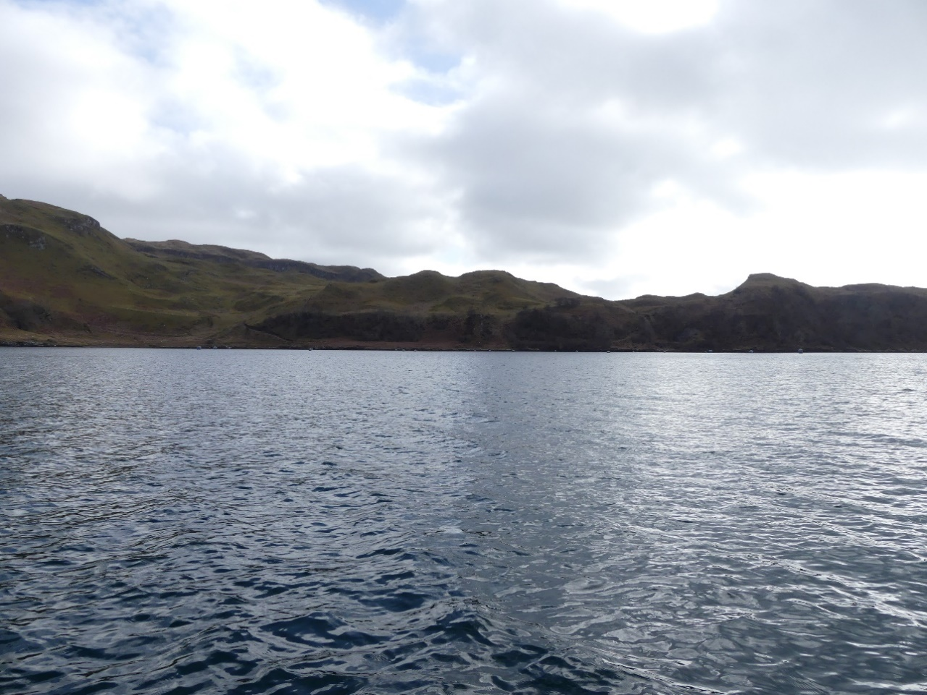
This is a view of a fallow finfish site in Cuan Sound with larger grey floats. Image take from 1km away, which is half the distance of Barnacarry Beach from the proposed Aird na Cuille site.
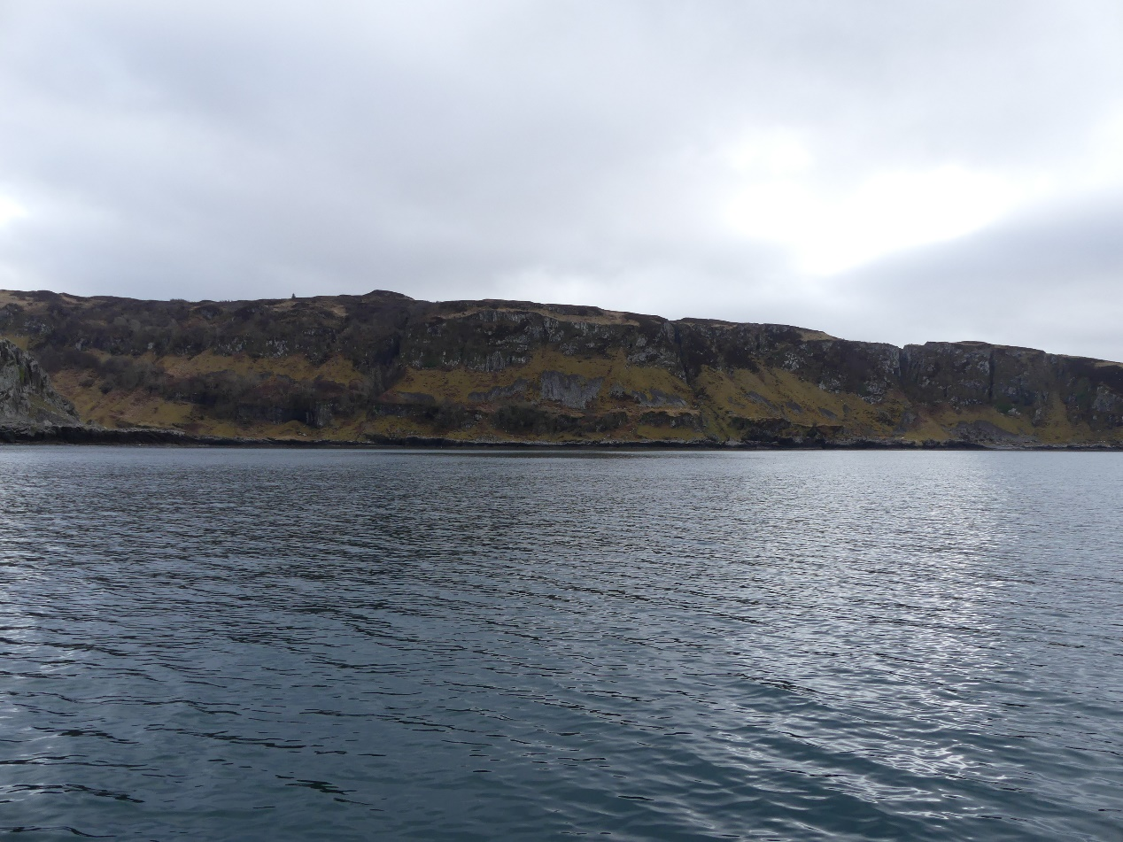
This is the proposed Aird na Cuille site from 0.75km at sea.
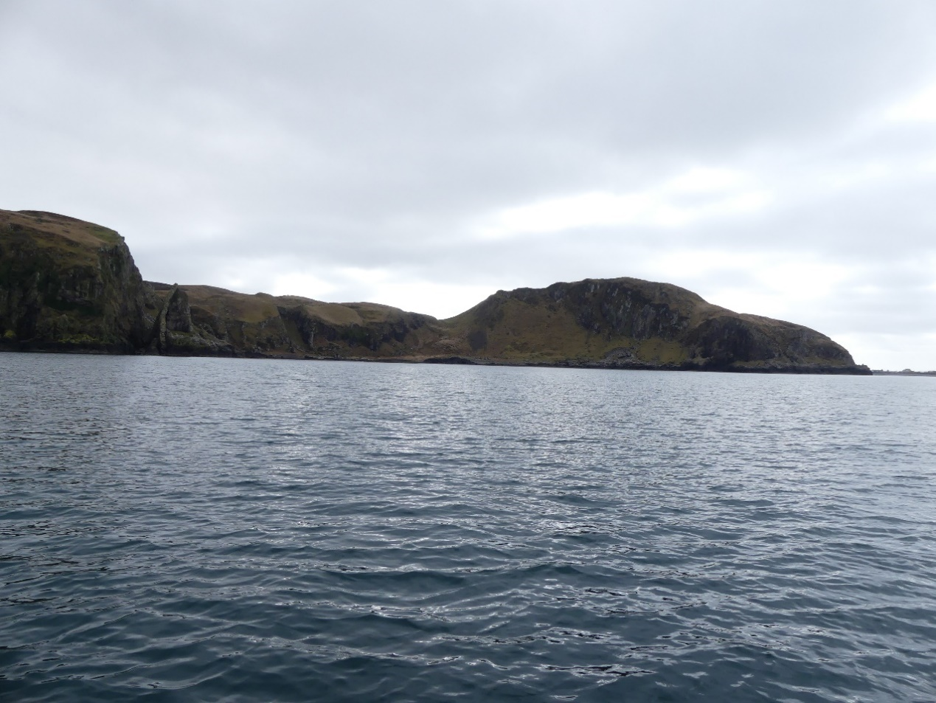
This is the proposed Sound of Insh site from 0.75km at sea
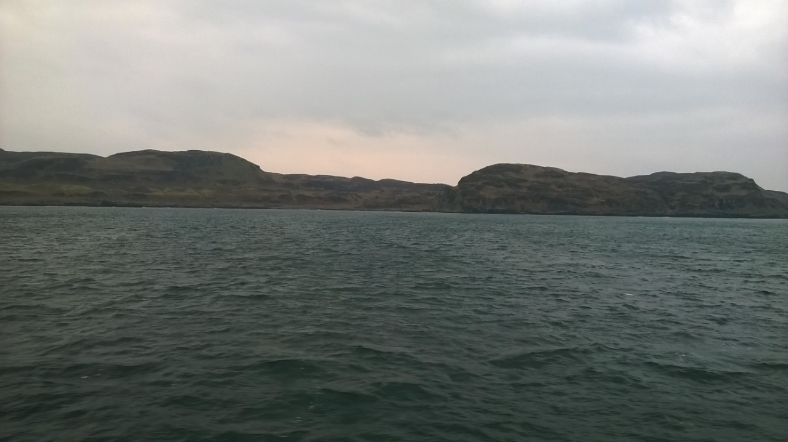
This is the proposed West of Kerrera site from 1.5km at sea.
As can be seen, not to be flippant, one part of the coast here looks much like the next. We could swap these photos around and it is unlikely anyone would be able to tell, which site was which.
It is our view, that the image of the fallow finfish site in Cuan gives the reader a good idea what Seaweed Reefs will look like. We have demonstrated that the floats will be very hard to see from any distance beyond 1km without binoculars or zoom cameras. The background shoreline and land is similar at Cuan and the 3 proposed sites, with rough grass/heath with rocky outcrops and are used for grazing of sheep. There are no paths along the coastline at any of the sites.
We feel the Cuan view gives a fair example of what the other 3 sites will look with a Seaweed Reef installed.
The most obvious visible thing about the sites will be the special marks for the safety of marine navigation, which will be insisted upon by Northern Lighthouse Board as they are at every aquaculture site in Scotland.
Economic and Social Case for approval
New Wave Foods wish to prove that the development of a new Seaweed Cultivation industry will not be a negative impact on the environment or the wildlife within it. We also wish to prove that the visual impact will not have likely significant effect on the sites.
We do not wish to win the argument with promises of substantial inward investment and sustainable employment opportunities. We wish to show these as additional benefits beyond satisfying the impact argument.
New Wave Foods have already invested heavily in scaled trials of seaweed cultivation at various sites in Argyll over the last 2 years. Existing local infrastructure and resources have been utilised to gain invaluable technical and logistical knowledge.
Over the next 4 years, New Wave Foods are ready to invest over £2 million directly in the Argyll area to develop Seaweed Reefs at sea, build or modify vessels and shore base facilities for their operations and to establish a processing facility in Argyll for the cultivated harvest.
The projections for turnover suggest that this investment will be made good by year 5 and provide up to a dozen full, part-time and casual jobs at the shore side and the same at the onshore processing facility.

EPS and Breeding Birds
SNH have concerns that disturbance to otters (EPS) and breeding birds may be an issue during the construction and operation of the site. This Method Statement submitted with the application takes into account these concerns.
Otters (EPS)
Otters are regularly seen on in most parts of the Argyll coast, including in busy towns such as Oban (see photo below). They can be remarkably tolerant of people, vehicle and vessel movements.
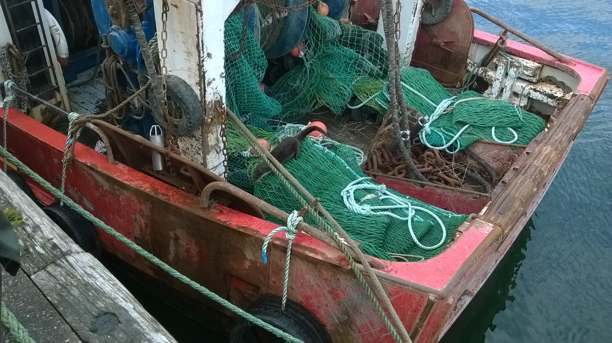
Otter eating fish from fishing boat net in Oban Harbour, watched by dozens of tourists.
Otters are European Protected Species (EPS) and as such have legal protection from harm, disturbance and habitat interference. Nothing in the development or operational phases of the Seaweed Reefs will constitute a threat to the life of an otter. Nor will any part of our operation touch land to damage or destroy their holts or holes. What we must look at is whether our activities would constitute a disturbance to otter in their hunting or breeding patterns.
The discussion on potential sources of disturbance can be split into 3 parts;
1/ development phase disturbance
Our development phase at each site will last only (est) a week. It will require a 16m to 22m vessel to lay the advanced anchors into the seabed 100m plus from the shoreline. Cables will then be strung between the anchor lines and floats attached.
SNH guidance suggests that “If otters are known or suspected to be breeding, the exclusion zone should normally be at least 200m radius. However, it could be reduced to 100m depending on the nature of the works, topography and natural screening. For shelters, or holts where otters are not breeding, the boundary of the exclusion zone should be a minimum of 30m.”
These exclusions zones are nominally looking at physical changes to the land near otters. As the Seaweed Reefs will be sited off from the coastline and will not physically touch or alter the holt or hole of any otter, we would hope that the 100m rule would apply as a maximum. It could be argued that the most direct disturbance to the otters could be the presence of any surveyor conducting an survey on the shoreline.
A male otter’s territory can be huge, using 20 km of rivers and coastline to hunt and defend up to 3 females against intrusion by other males. The female otters form sub-territories within, in which they produce up to 3 cubs, usually in early summer. The mother will rarely leave them for the first 10 weeks from birth at which point the cubs will begin to become mobile. They will then follow their mother as she hunts and suckles the young. She will use multiple holts and holes to dry off (otters don’t like being wet!) and to sleep (which they do for more than half the day). They will nurture the cubs for a year up to 18 months to teach them to fish by catching and releasing live fish for the cubs to re-catch.
It is very difficult (without the aid of photo traps) to assess whether otter shelters or holts are being used by a breeding otter or not as females with cubs reduce sprainting to avoid detection. Indeed, it is a crime to do so, without appropriate licenses.
No works that are proposed will fall within the minimum 30m exclusion zone. Indeed the minimum distance from the high water mark at all the sites appears to be around (est) 100m to avoid encroaching into Rocky Reefs.
The predicted timing of the installation of the Seaweed Reefs is late August, which will hopefully coincide with any otter cubs becoming fully mobile.
2/ operational phase disturbance
All operations will take place in daylight. Deployment periods will be Oct to Nov. Harvesting periods will be in April through into May. The mainly nocturnal nature of otters will hopefully allow us to present no disturbance to feeding patterns.
3/ ongoing presence and its effects
For the greater part, the Seaweed Reef will be left unattended by vessels. Outwith the operational phases (including all evenings, nights and weekends during the operational phases) little or no activity will take place over the months of June, July, August or September (aka the summer fallow period) and after the Oct/Nov deployment, the Seaweed Reefs will be left unattended in December, January, February and March (aka the winter slow growing period).
A brief diurnal phase of otter feeding during the shortest days of the year will coincide with the winter slow growing period, where the Seaweed Reefs left mostly unattended save for occasional visits by rib to check condition of the Seaweed Reef structure (a condition of consent) and to take samples of the seaweed for quality and growth monitoring. We will ensure we do not visit the sites near to dawn or dusk to prevent disturbance to otter feeding times during the hard winter months. Similarly, the summer fallow period will see the Seaweed Reefs left mostly unattended save for occasional visits by rib to check condition of the Seaweed Reef structure (a condition of consent).
Shorelines of proposed Seaweed Reefs
Some of the coastline rises sheer from the water and as such would be too dangerous to land. These sections of coast, would by their nature not be suitable for otters either.
The land directly behind the shore on this coast rise sharply as “raised beach” formations due to isostatic uplift. This creates a secondary sea cliff visual barrier between the shoreline and inland sites. This may present additional danger to anyone trying to cross the site. These areas, with their rock strewn scree surfaces may, along with the rocky coastline, provide suitable holes and caves that otter could use as holts and shelters.
It is very difficult (without the aid of photo traps) to assess whether otter shelters or holts are being used by a breeding otter or not as females with cubs reduce sprainting to avoid detection. Indeed it is a crime to do so, without appropriate licenses.

Breeding Birds
SNH raise concern that the development and operation of the proposed Seaweed Reefs may cause disturbance to priority bird species (Wildlife & Countryside Act 1981 (as amended in Scotland) Schedule 1, https://www.nature.scot/sites/default/files/B469673%20-%20Protected%20species%20list%20-%20WCA%20schedules%201A%2C%20A1%20%26%201-4.pdf).
It is unlikely that any priority bird species which breed in Scotland will nest in the areas where the Seaweed Reefs are being sited. There are cliffs and rocky ledges at the 3 proposed sites that will be used as nesting sites for seabirds.
Wildlife & Countryside Act 1981 makes it illegal to intentionally or, in Scotland and Northern Ireland, recklessly injure or kill any wild bird or damage or destroy an active nest or its contents. This is fairly clear and we can assure that none of our operations will interfere with the nest sites and our Seaweed Reefs will be a minimum of 100m away from the coastline nest sites.
The law on disturbance of non-schedule 1 birds is not so clear.
The “Scottish Marine Wildlife Watching Code” and the more detailed “Guide to Best Practice for Watching Marine Wildlife”, produced by SNH and are described by them as “a concise code of conduct… of broad Principles.. On the coast, On the sea, and In the sea… this guidance applies equally to everyone”. These state that no legislation provides an actual safe distance from breeding birds but rough advice suggests from 50-150 metres and up to 300 metres for very sensitive species (such as terns, which do not nest near the proposed sites).
The waters around Argyll are regularly crossed by commercial and pleasure vessels of all sizes and power methods. With the ever increasing number of vessels and people who venture out on the water it is difficult to say where near Oban any site can be considered isolated. Many seabirds are accustomed to the presence of humans and live in harmony with us. The inaccessible cliffs of seabird colonies near the proposed sites give added security to nesting seabirds.
There is anecdotal evidence that suggests even the most sensitive species of bird and other animal, can become very tolerant, even cohabiting with humans eg common terns mating in the rigging of fishfarm boats, otters feeding on fishing boats in busy harbours and otters sunbathing in waterside gardens, oblivious to human presence.
The proposed Seaweed Reefs will be sited away from the shoreline (est 100m) which will place them even further from cliff nest sites of the breeding seabirds of the area.
The Wildlife and Countryside Act 1981 (as amended) also states in Bylaw 37 (3a+b) that there can be no restriction of passage of a vessel through a marine nature reserve (MPA).
Since the marked outer areas of the proposed Seaweed Reefs will extend an area of exclusion to all shipping (except our vessels) to 1km it could be argued that the Seaweed Reefs existence will enhance the protection of nesting seabird colonies from disturbance from commercial and pleasure vessels for the greater part of the year.
The development phase vessels will only be within the area of the seaweed reefs for (est) a week in late August. A point at which many of the nest sites will either have been abandoned or the chicks near to fledging and adult birds less spooked by vessel movements
Our operational vessels shall only be within the area of the Seaweed Reefs for late Autumn deployment periods and late Spring harvesting periods, with rib visits for sampling and maintenance checks.

