Risk Assessment in relation to European Protected Species and use of Deterrent Devices at a Marine Farm – Kames

As set out in a communication from Scottish Government to marine farm operators in July 2020, Kames Fish Farm have engaged with Marine Scotland in a process to assess the use of underwater sound-producing predator deterrents in relation to cetaceans as European Protected Species (EPS).
While some evolving scientific evidence suggests cetaceans may be affected by such devices, as acknowledged in Marine Scotland ‘Guidance for Scottish Inshore Waters’ (July 2020) it is difficult to ascertain a causal link between the use of devices at a specific site and possible impacts for many reasons, including other anthropogenic pressures and inherent natural variability in cetacean presence.
In the interests of ensuring protection of EPS, and following guidance provided by Marine Scotland, a precautionary approach has been adopted. The following document summarises the steps undertaken to assess potential impacts, identify mitigation and carry out quantitative risk assessment.

1. Baseline Information – cetacean distribution
As advised by Marine Scotland (MS), information on the presence, density and abundance of cetaceans has been derived from SCANS-III aerial and shipboard study, 2016 (as reported in Hammond et al. 2017). The focus of this assessment is Harbour porpoise (Phocoena phocoena) and Minke whale (Balaenoptera acutorostrata), similarly as advised by MS (November 2020).
The relevant SCANS-III survey block for Kames’sites is Block G and I.
Both Harbour porpoise, bottlenose dolphins and Minke whale are identified as present within Block G and I, at densities of 0.336 & 0.397 (porpoise); 0.121 and 0 (dolphins); and 0.027 and 0.02 (minke whale) individuals per km² respectively and a total respective abundance of 5,556 & 285.
While there are concerns regarding the application of data from such a large study area to the very localised scale of marine farms the SCANS-III data has been taken to indicate potential presence of both Harbour porpoise, dolphin and Minke whale in the general farm area, and density/abundance data used as a worst-case figure in terms of impact assessment. Given the farm’s locations close to island shorelines within an enclosed bay it is expected that actual cetacean densities would be lower than that estimated for Block I as a whole.
In the document ‘Guidance for Scottish Inshore Waters’ gathering of supplementary cetacean information is referenced. Due to constraints in terms of timescale set out for the current process this has not been feasible, however, resource allowing it may be an area for future work especially given the issues highlighted above.

2. Mitigation measures
As set out in EPS guidance alternatives and mitigation measures have been considered, as follows -
Alternative siting of activity: The location this application relates to is an existing marine farm facility, located outwith areas specifically designated for cetaceans (MPA/SAC). Development of farm facilities takes into account many factors including hydrographic suitability, fish health management, environmental interactions and other marine users. The site is suggested to be suitable in these respects, having operated for many years. To relocate farming activity to an alternative site would not be preferable on many counts (including fish health management and benthic impacts) and would displace activity to locations potentially closer to protected areas (Inner Hebrides & the Minches SAC) and more likely frequented by EPS. As such, alternative sites for the activity have not been considered further.
Alternative methods for carrying out the work: The purpose of underwater sound-producing devices is to deter seal interaction with farm livestock. Their use is part of a suite of predation-mitigation measures which include regular removal of fallen/moribund stock, low stocking densities, tensioned HDPE pen-nets and top-nets to reduce seal interest in the farm from the very start of the production cycle. These additional methods do not however provide a satisfactory alternative, rather they are complementary measures which help minimise the level of acoustic device use. As an audible deterrent to seals these devices have a different mode of action to physical barriers and reduction of attractants (stocking density & removal of fallen/moribund stock), and function to help keep seals away from pen nets. This is a critical function, which as well as preventing direct predation events and reducing the likelihood of seals establishing a pattern of interaction with a farm, also mitigates the sub-lethal effects on livestock from seals. These sub-lethal effects are due to stress and flight behaviour caused by seal presence around a farm - even if direct predation does not occur - and have significant negative impacts on farm productivity (reduced feeding, growth & survival), fish health (physical damage, disease and parasite risk increased), fish welfare and ultimately sustainability through reduced productivity and challenging fish health management. As such, no satisfactory alternative to underwater sound-producing devices is considered to be available.
Alternative dates/timings: To function effectively in deterring seal interaction devices need to be available for use whenever livestock are present on a farm. Kames’ stocking cycle runs on a 2-year basis. During the fallow periods the device will never be used. Within stocked periods the overall suite of predation-mitigation measures, as outlined above, will allow for use to be minimised. Further details are provided below regarding device settings and operational measures implemented to minimise use.
Frequency: Two device types have currently been assessed for the site, with frequency centred at 9.5kHz (US3) and at 1.5khz (RT1). Full details have been provided to MS by the supplier, Ace Aquatec. This does not reflect the full range of commercially available acoustic deterrents, and some device types/frequencies have been screened out of consideration in the interests of mitigating potential cetacean interactions.
Duty cycle: The proportion of time that sound is being emitted (i.e. duty cycle) is adjustable for the device, ranging from 0.1 – 5%. An Automatic Ramp-Down function is also available which ensures reduction of the duty cycle back to zero after a period of higher use following a predation event will be utilised.
Management and triggering: Seal deterrent measures are most effective where predation is prevented from the outset, and as such use of underwater sound-producing deterrents will be most effective (i.e. duty cycle minimised) if deployed prior to seal interaction with the farm becoming established. The triggers relevant to our sites are 1) site is stocked with fish and 2) seal predation (attacks and sub-lethal impacts) is a known occurrence at the site from input. Devices will only be used with complementary predation-mitigation measures which ensure duty cycle can be minimised i.e. regular removal of fallen/moribund stock, low stocking densities, tensioned HDPE pen-nets and top-nets to reduce seal interest in the farm. Devices will be deactivated in the following circumstances: site fallow; no seal interaction evident (application is to have equipment available for use during stocked periods; equipment may not be emitting sound if there are no cues such as seals swimming around farm, changes in fish behaviour or evidence of actual attack); emergency situation where a cetacean is present in the immediate area of the farm; evidence that devices have reduced efficacy in preventing seal interaction with the farm i.e. interactions are increasing over a period of time despite acoustic device use (note in such circumstances deactivation may not be immediate as an alternative device type will need to be put in place prior to deactivation and EPS Risk Assessment, sourcing and deployment of replacement equipment will have an associated lead time). Seal predation and predation-mitigation measures, including acoustic devices, are reviewed on a weekly and monthly basis and tracked as a Key Performance Indicator, and a cycle review performed at the end of each stocking cycle to evaluate effectiveness and establish any changes proposed.

The above measures have been developed as part of this assessment process, and we believe represent a responsible application of mitigation and good practice in relation to use of acoustic predator deterrents at the Sound of Harris site.

3. Quantitative assessment
Based on the above cetacean information and device parameters a quantitative assessment has been completed for the Sound of Harris site. This follows the method for determining cetacean disturbance and injury defined by MS with expert input from Dr Jeff Lines (Silsoe Livestock Systems Ltd).
Assessment has been completed for the Ace Aquatec US3 and RT1 device types, given specific source level, frequency, maximum duty cycle, number/siting of units and the relevant cetacean hearing sensitivities. The device criteria used in the assessment and the outputs are summarised below, with maps presented in the appendices of this document. A copy of the spreadsheet developed by Dr Jeff Lines and used to determine disturbance/injury threshold distances for Ace Aquatec devices has also been provided to MS by Ace Aquatec.

4. Conclusion
Based on the quantitative assessment detailed above it is not believed that any potential hearing injury (PTS) to any one individual Harbour porpoise or Minke whale may occur. While the system output may be within audible range of Harbour porpoise and Minke whale, as are many activities in the marine environment, use of the US3 and RT1 systems at Kames’ sites in the manner specified will not result in a sound level which is either injurious or disturbing to these species at a level relevant to conservation status. As such, an EPS license is not considered necessary, however to comply with the preference for all farms to submit for a license that use acoustic systems, we are happy to submit an application for an EPS license.
It is also important to note the very much worst-case approach that has been adopted for the purposes of the assessment:
- Coarse wide-scale data on cetacean presence, density & abundance (SCANS III) has been utilised for fine-scale purposes, with data considered relevant to an area ~14,000km² applied to a farm area one hundred-thousandths the size; the farm location – close to shore within an enclosed bay - is also characteristically different to the open sea area that makes up the majority of the area relevant to the cetacean data set, making estimation of cetacean density likely to be an overestimation
- When considering PTS injury, exposure is determined over a 24hr period; as cetaceans are highly mobile species, and the distances associated with PTS injury small (9 – 713m) it is unrealistic that a mobile cetacean would remain within such a small radius of a device for a whole 24hr period
- In both PTS and disturbance assessments the worst-case in terms of device settings and use patterns have been assumed; this represents the maximum potential use level, which in practice would be reduced through use of lesser duty-cycle settings (including Automatic Ramp-Down features) and periods when the system is not in use (i.e. fallow periods or device not switched on due to absence of cues/triggers)

References
Hammond et al. (2017). Estimates of cetacean abundance in European Atlantic waters in summer 2016 from the SCANS-III aerial and shipboard surveys.
Marine Scotland (July 2020). The Protection of Marine European Protected Species from Injury and Disturbance – Guidance for Scottish Inshore Waters.
Marine Scotland (December 2020). ADD disturbance and injury distances for use in EPS license application.
SCAN III block shapefiles: https://synergy.st-andrews.ac.uk/scans3/files/2017/04/Shapefiles-for-SCANS-website.zip

Appendix – Mapping completed with QGIS to calculate sonified sea areas relevant to disturbance & PTS
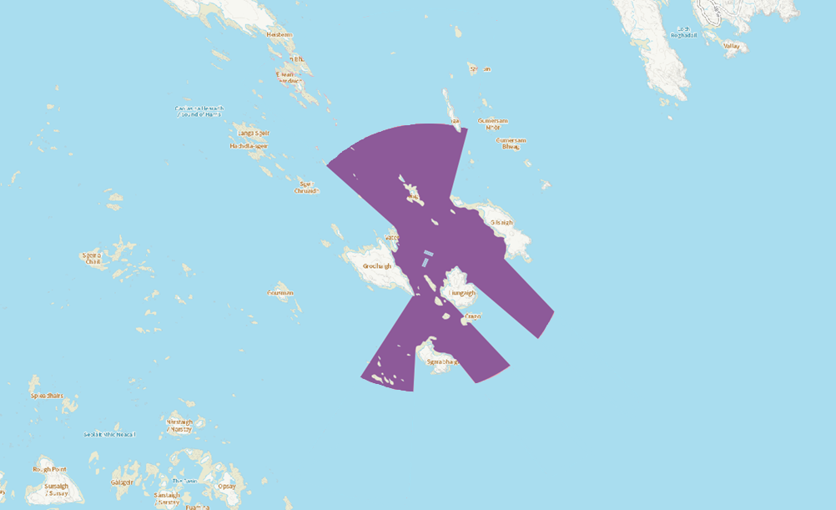
Assessment: | Disturbance | Area minus land & pen area: | 5.01km²
Distance: | 1899.7m

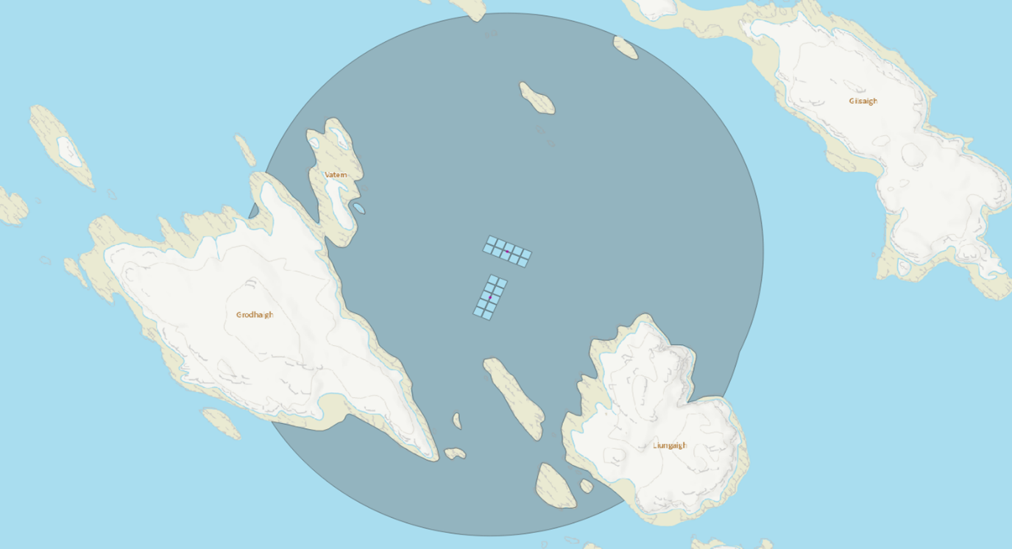
Assessment: | PTS Harbour porpoise | Area minus land & pen area: | 1.33km²
Distance: | 713m

Assessment: | PTS Minke whale | Area minus land & pen area: | 0.0025km²
Distance: | 9m
