Marine Scotland Licence
SHEPD

Scottish Hydro Electric Power Distribution
Fishing Liaison Mitigation Action Plan (covering all legitimate sea users)
Argyll: Jura/Islay

Contents
1 Introduction 3
2 Communications 4
3 Scheduling of liaison and information distribution 5
4 Formal Notifications 6
5 Communication Distribution List 8
6 The purpose of the Fishing Liaison Mitigation Action Plan for Jura/Islay 17
7 Commercial Fishing 17
8 Other Legitimate Sea Users Overview 24
9 Cable Asset Interactions: Commercial Fishing 30
10 Cable Asset Interactions: Other Legitimate Sea Users 32
11 Safety 33
12 UK Legislation, References and Guidance 35
Appendix A Standard Operating Procedures 37
Appendix B Company Fishing Liaison Officer Specification 37
Appendix C Marine Mitigation and Co-existence Planning 37
Appendix D Notice to Mariners Example Template 38
Appendix E Communication Programme 42
Appendix F Commercial Fishing Charts 50
Appendix G Other Sea Users Charts 64

Introduction
  - Scottish Hydro Electric Power Distribution (SHEPD) would like to make it easy for all stakeholders who have interests in the submarine electricity cable planning process to have a strong voice in helping us determine our installation and protection practices but also inform our inspection and maintenance works. We are committed to open, honest and transparent communication and engagement.

  - This Fishing Liaison Mitigation Action Plan (FLMAP) outlines how SHEPD will interact with all legitimate sea users, prior to and during any works relating to three submarine cables at the following locations; Bridgend, Islay, Jura to Islay and Mainland Jura.

  - The purpose of this Fishing Liaison Mitigation Action Plan (FLMAP) is to:
- Illustrate the associated risks to the commercial fisheries industry (and other legitimate sea users), address the potential effects (highlighted in the marine licenced evidence)
- Identify how to minimise and mitigate potential impacts on local communities.

  - Cable works which will be covered by this FLMAP include cable inspections, surveys and installations of cables. For each planned activity a specific programme delivery document is produced to be used in conjunction with the FLMAP.

  - This FLMAP describes how SHEPD will interact with all legitimate sea users, prior to, during and after the cable works. It also identifies the respective responsibilities of the Company Fishing Liaison Officer (CFLO), and the Fishing Industry Representative (FIR), and how the FIR and CFLO will operate. The FLMAP has been constructed to facilitate co-existence between SHEPD and other legitimate sea users.

  - A summary assessment of all the potential marine interactions and activities which could influence or affect the proposed cable works are as follows. (A more detailed breakdown of activities is given in Chapter 8);

    - Moderate to high levels of scuba diving, surfing and paddle boarding, canoeing/ kayaking, motor cruising, power boating, sailing and cruising and sea angling activity
    - There are low levels of aquaculture in the area
    - There are low to medium levels of shipping zones/cargo vessels in the area
    - A ferry service (Hebridean & Clyde Ferries) runs from Kennacraig to Port Ellen and Port Askaig in the vicinity of the cable locations.
    - Local ports in the area are Port Ellen, Port Charlotte, Port Askaig and Feolin
    - There are possible marine archaeology wreck sites in proximity to the cable works

  - The submarine electricity cables lie within the following conservation designations;

    - Bridgend (Islay) cable is located within the Bridgend Flats SPA and the Gruinart Flats
(Islay) RAMSAR site
    - Mainland to Jura cable is located within the Loch Sunart to Sound of Jura MPA and Firth of Lorn SAC

  - Commercial fishing activities operating near the cables are UK registered potting (creeling) vessels, scallopers and demersal trawlers. Due to the proximity of the cables to the shoreline, potting (creeling) is thought to be the primary gear type likely to interact with any cable works. There are moderate levels of larger scallop and nephrops trawler activity also seen in the vicinity of the Mainland to Jura cable.

  - As part of the marine licencing process, we undertake early engagement with the general public and any interested stakeholders and carry out Pre-Application Consultation for any construction work required within the marine environment. We state within the Pre-application Consultation (PAC) reports how the views of our stakeholders have been considered and influenced our approach to cable design, installation and protection.

Communications
  - Information regarding any cable works required will be issued to all fishing and other relevant legitimate stakeholders to ensure effective co-existence during the operations (this includes inspection surveys and any subsequent requirement for cable installation).

  - Survey contractors shall provide details of all vessel movements, works and co-ordinates to the Company Fishing Liaison Officer (CFLO) and the Fishing Industry Representative (FIR) who will disseminate this information.

  - The relevant stakeholders will be contacted before a planned work activity that has the potential to impact them and, depending on the progress of this activity; it would also be common practice for there to be regular contact throughout the work.

  - In addition to statutory stakeholder engagement, SHEPD also has a number of obligations where it is necessary to engage with non-statutory stakeholders prior to, during and/or upon completion of certain work activities.

  - In the event that an activity’s date or duration was to deviate from the work programme (detailed in the Works Information Package Cable Inspections 17/18 /Construction method statement), an update will be issued to the affected stakeholders. Similarly, if the scope or methodology of the planned works activity changes, then any stakeholder likely to be affected, including any relevant licensing authority would be consulted. Any change to associated timelines would be agreed prior to the works commencing.

Scheduling of liaison and information distribution
  - Dissemination of information to the fishing industry and other legitimate sea users will be issued as described in Table 1.
Table 1 Schedule for dissemination of information
Activity | Timescale for distribution
Inspection Programme | - Notice and information to be distributed at the earliest opportunity once information is available  - Regular liaison and updates by Fishing Industry Representative (FIR) with local fishermen of proposed timings with confirmations when operations are finalised.  - Regular liaison and updates by the Company Fishing Liaison Officer (CFLO) with other legitimate sea users of proposed timings with confirmations when operations are finalised.
Surveys (including any requirement for Pre-construction surveys) that have the potential to require gear relocation or have the potential to cause significant displacement to fishing activity | - Regular liaison and updates by FIR with local fishermen, well in advance of disruption, defining who might be affected, where and when. Liaison to take into account weather, number of creels to be moved, bait ordering etc.  - Notices and Information Distribution not less than 20 days prior to survey mobilisation, if possible, to allow inclusion in the Kingfisher Fortnightly Bulletin.
Specific construction activities i.e installation works | - Notice and information distribution not less than 20 days, if possible, for individual construction vessels mobilisations.  - Regular liaison and updates by FIR with local fishermen of proposed timings with confirmations when operations are finalised.  - Regular liaison and updates by CFLO with other legitimate sea users of proposed timings with confirmations provided when planned works are finalised.
Meetings with fishery stakeholders | - Meetings as required during all works ie the inspection surveys and any subsequent requirements for pre-construction and construction phases
Meetings with other legitimate sea users | - Meetings as required during all works ie the inspection surveys and any subsequent requirements for pre-construction and construction phases
Ongoing Liaison | - Additional unscheduled liaison and consultation will be undertaken by either the CFLO or the FIR as required to address issues or fishermen’s concerns as they arise

Formal Notifications
  - Details of the cable works will be distributed to appropriate maritime users. The proposed formal communications are set out in Table 2.
Table 2 Formal notifications
Type | Function | Distribution
Submarine electricity cable flyer | - It is intended that flyers will be issued for specific cable works.  - This is not a requirement set out in the marine licences  - It is a proactive initiative taken by SHEPD to provide as much advance warning of the forthcoming works as possible. | - Flyers will be published through Kingfisher Information Service Offshore Renewables and Cable Awareness (KISORCA) and Fishing News.  - Flyers will be issued nominally at least 4 weeks, if possible, prior to commencing the operations to which they relate
Notices to Mariners (NtM) | - NtM and/or radio navigational warnings and publication in appropriate bulletins to comply with the conditions in the marine licences.  - Each NtM will contain full details of the vessel, location, activities, contact details etc.  - In the case of incidents or emergencies requiring notification, the NtM will be issued as soon as reasonably possible. Any actions required to notify an incident or emergency will go ahead even if there is not sufficient time for it to appear in the Kingfisher Fortnightly Bulletin. | - All NtM will be issued by the CFLO  - NtMs will be published through KISORCA  - Details of the works will be promulgated to all appropriate maritime users  - NtMs will be issued at least 20 days prior to an activity’s start date, if possible, to allow inclusion in the Kingfisher Fortnightly Bulletin.  - NtMs will be issued using the example NtM document at defined stages of the cable installation, for example:  - HDD works  - Relevant surveys  - Details of cable works being undertaken.
NtM updates | It is intended that the issued NtMs will comprehensively describe the planned activities. However, in the unlikely event that a significant change to these activities becomes apparent, an update will be issued. | If required, to be issued by email to the Source Data Receipt at the UK Hydrographic Office and copied to the distribution list set out in the NtMs.
Notices to static gear fishermen | Further specific liaison between SHEPD’s FIR and the fishermen who will be affected by the survey and installation operations will take place to agree the detailed arrangements for removal of static gear. This will include details of dates and numbers of creels. | The static gear fishermen will receive the NtMs.
Notices to mobile gear fishermen | Specific liaison between SHEPD’s FIR and the fishermen who will be affected by the survey and installation operations will take place to ensure that they are given a minimum of 24 hours notice that vessels of restricted mobility will be in the area. | The mobile gear fishermen will receive the NtMs.
Notices to other legitimate sea users | Specific liaison between SHEPD’s CFLO and the legitimate sea users who will be affected by operations will take place to ensure that they are given a minimum of 24 hours’ notice that vessels of restricted mobility will be in the area. | Other legitimate sea users identified through consultation will receive the NtM (the distribution lists are given in Table 3, and Table 4).

Communication Distribution List
  - Our key aim is to co-exist with sea users in the marine environment. We achieve this by actively engaging with legitimate sea users and those with consented development rights. The way we approach this differs on a cable by cable basis although we do have a generic set of Standard Operating Procedures to ensure our approach is consistent and fair to all sea users in the area.

  - The Jura/Islay submarine electricity cables have a discrete footprint in a small regional area. For simplicity, the communication distribution list has been separated into regional stakeholders, given in Table 3 and cable specific stakeholders in Table 4.

  - The communication distribution list provides the following information on each stakeholder:
- Stakeholder name
- SHEPD point of contact
- Role of the stakeholder in the consent procedure
- Details of specific contact to be made by SHEPD with a given stakeholder.

Table 3 Regional stakeholders roles and duties
Regional Stakeholder | SHEPD point of contact | Role | Details
Marine Scotland (MS) | Lead Engagement and Submarine Policy Manager | MS is the licensing authority for marine works and as such all consent conditions must be satisfied and evidenced as per the individual licence. | Specific contact with MS will be made  - Prior to commencement of the works:  - to submit and seek approval of a cumulative impact review, if necessary  - to notify the commencement of any cable works  - to submit and seek approval of any updates to the communication programme  - to submit and seek approval of The Construction Environmental Management Plan as detailed within FO-NET-CAB-405-E in the event of cable installation  - to provide updates as and when appropriate for the planned works  - to agree recipients of real-time data relating to the planned works  - During the works:  - to allow access for an authorised Enforcement Officer to inspect the works  - to notify any changes to the works that may affect the validity of the licence  - to submit and seek approval of plans to mitigate navigational dangers or risks, where required  - On completion of the works:  - to notify the completion of the works  - to submit an assessment of any risks posed by the installed cable
Scottish Natural Heritage (SNH) | Lead Engagement and Submarine Policy Manager | SNH is the Scottish public body responsible for natural heritage. SNH advises the Scottish Government regarding nature conservation requirements when deciding whether to consent activities. SNH are a consultee to Marine Scotland and as such they can influence licence conditions. | SHEPD will engage on matters related to the project as required.
Maritime and Coastguard Agency (MCA) | Up to work starting  Community Liaison Manager  During works -Project Manager | The MCA is an executive agency of the United Kingdom and is responsible for implementing British and international maritime law and safety policy.  The MCA are a consultee to Marine Scotland and as such they can influence licence conditions. | SHEPD will engage on matters related to the project as required.
Northern Lighthouse Board (NLB) | Up to work starting  Community Liaison Manager  During works Project Manager | The NLB are a consultee to Marine Scotland and as such they can influence licence conditions. | SHEPD will engage on matters related to the project as required.
Scottish Environment Protection Agency (SEPA) | Up to work starting  Community Liaison Manager  During works Project Manager | SEPA is Scotland’s environmental regulator. SEPA is a consultee to Marine Scotland and as such they can influence licence conditions. | SHEPD will engage on matters related to the project as required.
Royal Society for the Protection of Birds (RSPB) | Lead Engagement and Submarine Policy Manager | RSPB are a consultee to Marine Scotland and as such they can influence licence conditions | SHEPD will engage on matters related to the project as required.
Scottish Fishermen’s Federation (SFF) | Company Fishing Liaison Officer (CFLO) | The SFF represent predominately the mobile commercial fishing fleet that operate in deeper waters outside of where the cables will be replaced. | Specific contact will be made with the SFF and the associations that are represented by the SFF. Regular liaison and updates by CFLO will be undertaken with meetings as required. As part of ongoing regular liaison with the SFF, SHEPD will keep the SFF apprised of the installation as it proceeds, specifically in relation to the presence of support vessels.
West Coast Regional Inshore Fisheries Group (WCRIFG) | Company Fishing Liaison Officer (CFLO) | The organisation is legally authorised to impose restrictions and regulations, to issue licences and the right to set tolls. | Specific contact will be made with the WCRIFG. Regular dialogue between the CFLO and the OSF will be maintained prior to and during the survey work (and any subsequent requirement for cable installation), noting that both mobile and static gear commercial fishing operations are present in the area.
Scottish Creel Fishermen's Federation (SCFF) | Company Fishing Liaison Officer (CFLO) | SCFF is the national trade association for the creel fishing industry. It is comprised of ten fishermen’s associations including the Scottish Scallop Divers Association and Scottish Creelers and Divers. | Specific contact will be made with the SCFF. Regular dialogue between the CFLO and the SCFF will be maintained prior to and during any installation work.
Unaffiliated commercial fishermen | Company Fishing Liaison Officer (CFLO) | There are independent commercial fishing operators who are not affiliated with the RIFG. | Specific contact will be made with relevant unaffiliated commercial fishermen. The CFLO and FIR will identify these individuals and maintain liaison with them, particularly in relation to the requirement to remove creels to allow the works to be carried out.
The Crown Estate (TCE) | Wayleaves Project Manager | TCE manage property belonging to the Sovereign. Part of the HDD installation (seaward of MHWS) is located within Sovereign territory and, as such, SHEPD is required to obtain permission via survey licences and wayleave consent in terms of the Master Wayleave Agreement from TCE. | SHEPD will engage on matters related to the project as required.
United Kingdom Hydrographic Office (UKHO) | Project Manager and Company Fishing Liaison Officer (CFLO) | The UKHO is the UK's agency providing hydrographic and geospatial data to mariners and maritime organisations across the world. | SHEPD will maintain contact with the UKHO to provide regular updates on progress of the works provide a copy of the marine licence and provide as-built details upon completion.  The CFLO will maintain contact with the UKHO via NtMs or Hydrographic notes.
Kingfisher Information Service Offshore Renewables and Cable Awareness (KISORCA) | Company Fishing Liaison Officer (CFLO) | Kingfishers work with all the offshore industries, including oil & gas, subsea cable, renewable energy and marine aggregates to provide the latest news and most accurate information to the fishing industry. Information is in relation to the latest hazards, planned developments, new structures being installed and zones created. | SHEPD will maintain contact with KISORCA to provide regular updates on progress of the works and provide as-built details upon completion.  The CFLO will maintain contact with KISORCA via NtMs for the Kingfisher bulletin.
Ministry of Defence (MoD) | Company Fishing Liaison Officer (CFLO) | The MoD is the British government department responsible for implementing the defence policy set by Her Majesty's Government and is the headquarters of the British Armed Forces. The MoD has access to training areas and ranges in marine areas. | SHEPD and CFLO will engage on matters related to the project as required
Royal Yacht Association (RYA) | Company Fishing Liaison Officer (CFLO) | The RYA is the national governing body for certain water sports in the United Kingdom. Activities it covers include Sailing, Windsurfing, Motor cruising, Powerboating and Personal watercraft | Specific contact will be made with the RYA. Regular dialogue between the CFLO and the RYA will be maintained prior to and during the installation work that may affect recreational activities in the area.
Community Councils | Company Fishing Liaison Officer (CFLO) | The CC will keep the local community up to date on proposals. | CFLO will engage on matters related to the project as required.
NAFC Marine Centre | Company Fishing Liaison Officer (CFLO) | The NAFC marine centre is an educational and scientific institute. Research and development in subjects relevant to the fishing and aquaculture industries and marine spatial planning. | We will engage on matters related to the project as required.

Table 4 Jura/Islay specific stakeholders
Cable specific stakeholder | SHEPD point of contact | Role | Details
Argyll and Bute Council | Company Fishing Liaison Officer (CFLO) | Argyll and Bute Council is the local authority for Jura/Islay. | CFLO will engage on matters related to the project as required.
Scottish Creel Fishermen Federation | Company Fishing Liaison Officer (CFLO) | SCFF represents creel Associations working around the Scottish coastline. | Specific contact will be made with the SCFF. Regular dialogue between the CFLO and the SCFF will be maintained prior to and during the installation.
Clyde Fisherman’s Association (CFA) | Company Fishing Liaison Officer (CFLO) | The CFA have 65 members with vessels around the Clyde coast. The area covered by the association includes Islay. | Specific contact will be made with the CFA. Regular dialogue between the CFLO, Offshore Fisheries Liaison Officer (OFLO) will be maintained prior to and during the cable works, noting that both mobile and static gear commercial fishing operations are present in the area.
Northern Ireland Fish Producers  (NIFPO) | Company Fishing Liaison Officer (CFLO) | There are nomadic vessels operating from Ulster ports which operate near the cables | CFLO will engage on matters related to the project as required
Islay Ferries (operated by Caledonian MacBrayne) | Company Fisheries Liaison Officer (CFLO) | The operator of the Islay ferries. Most car, freight and passenger traffic to and from Islay goes by ferry using the route from Kennacraig on West Loch Tarbert to Port Ellen or Port Askaig. | CFLO will engage on matters related to the project as required
Clyde Cruising Club | Company Fisheries Liaison Officer (CFLO) | A sailing club which operates across Scotland, including Clyde and Firth of Clyde. | CFLO will engage on matters related to the project as required
Royal Gourock | Company Fisheries Liaison Officer (CFLO) | A sailing club which operates around the Clyde | CFLO will engage on matters related to the project as required
Toward Sailing club | Company Fisheries Liaison Officer (CFLO) | A sailing club which operates around the Clyde | CFLO will engage on matters related to the project as required
Largs Ardrossan | Company Fisheries Liaison Officer (CFLO) | A sailing club which operates in the southern portion of the Clyde | CFLO will engage on matters related to the project as required
West Coast Shellfish (Scotland) Ltd | Company Fisheries Liaison Officer (CFLO) | An aquaculture site within 20 km of the cable works | CFLO will engage on matters related to the project as required
Kayak Wild Islay | Company Fisheries Liaison Officer (CFLO) | Sea kayaking trips around Islay, based in Port Ellen | CFLO will engage on matters related to the project as required
Islay Sea Adventures | Company Fisheries Liaison Officer (CFLO) | Wildlife and fishing boat trips on a 38ft revenge charter | CFLO will engage on matters related to the project as required
Fyne Pioneer | Company Fisheries Liaison Officer (CFLO) | Dive charters operating around Jura and Islay and the Clyde | CFLO will engage on matters related to the project as required
The Majestic Line – West Coast Cruises | Company Fisheries Liaison Officer (CFLO) | A luxury cruise liner which operates a 10 night cruise from Islay, Jura and the Southern Hebrides and a 6 day cruise for the isles of Clyde and Southern Hebrides | CFLO will engage on matters related to the project as required
Hebridean Island Cruises | Company Fisheries Liaison Officer (CFLO) | Offers luxury cruises across the Hebrides including visiting Jura and Islay | CFLO will engage on matters related to the project as required
Peel Ports | Company Fisheries Liaison Officer (CFLO) | Peel Ports manage all commercial/container traffic in and out of Ocean Terminal Greenock. | SHEPD and CFLO will engage on matters related to the project as required and will notify with the NtM as cables may be in locations where vessels transit on route to the port
HM Naval Base Clyde | Company Fisheries Liaison Officer (CFLO) | Naval base Clyde covers Fasland and Coulport | SHEPD and CFLO will engage on matters related to the project as required and will notify with the NtM as cables may be in locations where vessels transit on route to the port

The purpose of the Fishing Liaison Mitigation Action Plan for Jura/Islay

  - This plan describes how SHEPD will interact with all legitimate sea users and the fishing industry prior to and during submarine electricity cable works. The aim is to facilitate co-existence between all parties as recommended in the FLOWW and ESCA (previously SCUK) guidelines. SHEPD has also developed the Marine Mitigation and Co-existence Planning document which should be used in conjunction with this FLMAP and can be found at Appendix C Marine Mitigation and Co-existence Planning.

  - The following areas are covered within the document:
- The responsibilities of the Company Fishing Liaison Officer (CFLO), and the Fishing Industry Representative (FIR), and how the FIR and CFLO will operate. The roles of the CFLO and FIR are detailed in Appendix B Company Fishing Liaison Officer Specification.
- Overview of the fishing and legitimate sea user consultation
- Communication and liaison and engagement strategy
- Safety issues and mitigation strategies

  - The FLMAP will form an audit trail, documenting communication and liaison activities between SHEPD and legitimate sea users during specific cable works. As such, it will be developed and updated accordingly.

  - Some activities such as cable installations works require additional information which will inform the potential interactions with legitimate sea users. When required SHEPD will provide the Project Description and other necessary documents.

Commercial Fishing
  - This section summarises the existing commercial fishing baseline in relation to the submarine electricity cable assets. Commercial fishing activity is defined as the activity undertaken by licensed fishing vessels undertaken for the legitimate capture and sale of finfish and shellfish. The baseline evaluation will focus specifically on those fleets which are active in the vicinity of the cable corridors. The commercial fisheries charts are given in Appendix F Commercial Fisheries Charts from Figure 1 to Figure 14.

  - Commercial fishing in European Union (EU) waters is subject to numerous controls and regulations at European, national and local levels. Such measures may have a direct impact on fishing effort, landings weights and values. Many of these measures are implemented at short notice with limited consultation, which limits confidence in predicting future trends. The main bodies regulating fishing in sea areas in which the cables are located are the EU through the Common Fisheries Policy (CFP), Marine Scotland (MS) and the Inshore Fisheries Management and Conservation (IFMAC) through national and regional regulations, and regional Inshore Fisheries and Groups (rIFGs).

  - The three cables are located within International Council for the Exploration of the Sea (ICES) IVa (North Eastern Atlantic Sea) area. Pressure stocks are managed by ICES Division and quota is also allocated at this scale. Fishing data are recorded, collated and analysed by ICES rectangles within each division. ICES rectangles are the smallest spatial unit available for the collation of fishing data and have therefore been used to define the analysis areas for the proposed cable replacements. Fishing data are recorded, collated and analysed by ICES statistical rectangles within each ICES division and these rectangles are the smallest spatial unit for which fishing data is available. The cables that will be inspected are located within ICES rectangles 41E4 and 40E3 around Jura and Islay.

  - The three submarine electricity cables on Jura and Islay are situated within the 6nm limit, in which the UK has exclusive fishing rights. The territorial fishing limits of EU member states extend out to 12nm, within which only the vessels of a state or vessels from other states with historical rights are entitled to legally fish.

  - There is no single data source or recognised model for establishing a baseline of commercial fishing activity within discrete sea areas such as those encompassed by the footprint of submarine electricity cables. The overview has therefore been derived using data and information from a number of sources. In addition to analysis of fisheries statistical datasets, emphasis has been placed on undertaking direct consultation with the relevant national fishermen’s federations, local associations and skippers whose fishing grounds are located within the vicinity of the cable corridor.

  - The key data sources used to characterise the baseline of the commercial fishing receptors are summarised in Table 5. It should be noted that Vessel Monitoring Systems (VMS) datasets show fishing activity for the over-15m fleet only and will therefore underrepresent total fishing activity. It is considered that the surveillance sightings and effort data will be more representative as vessels working in the vicinity of the cable corridors will often be under 10m vessels.

Table 5 Commercial fishing key data sources
Data | Year | Coverage | Confidence | Notes
UK Marine Management Organisation (MMO) Fishing Statistics (landings values and fishing effort data) | 2012 to 2016 | UK vessels landing into UK and European ports. Non-UK vessels landing into UK ports. | High | Landings data provided by value (£).
UK MMO Surveillance Sightings | 2012 to 2016 | Sightings of vessels by gear type (all nationalities) recorded in UK waters on weekly surveillance fly overs during daylight hours. | Medium to high | May underestimate total extent of fishing activity due to flyover frequency and timing.
UK MMO Satellite Tracking (VMS) Data | 2012 to 2016 | Aggregated VMS pings recorded in 0.05° by 0.05° grids from UK vessels only in European waters.  Only vessels over 15m. | High | VMS provided by value (£).  As this dataset is limited to vessels over 15m this will not be indicative of the inshore fleet.

  - The potential fishing activity in the vicinity of the Jura/Islay submarine electricity cable routes (Bridgend, (Islay), Jura-Islay and Jura-Mainland; Figure 1) are reviewed in order to assess possible interaction scenarios.

  - Surveillance sightings by method have recorded predominately potting (creeling) vessels and scallop dredging in the vicinity of the Jura/Islay cables, with and demersal trawling also observed (Figure 2). Fishing vessel observations have been recorded near the mainland to Jura and Jura to Islay cables. Surveillance sightings by nationality show that 100% of all sightings between 2012 and 2016 were from UK registered vessels (Figure 3).

  - The main commercial species caught within the ICES rectangles (41E4 and 41E3), where the cables are located are Nephrops, scallops and edible crabs. Pelagic species are less important to the region. Nephrops and scallops account for the majority of value and weight in the total regional catches (Figure 4 and Figure 5), MMO method by effort (Figure 6) shows the majority of fishing activity/effort within the region can be attributed to potting (creeling).

  - MMO VMS value for all gears (Figure 7) indicates that both the Jura-Islay and Bridgend, Islay cables have low fishing effort recorded in the vicinity of these cables with the area around the Mainland to Jura cable recording a value of £10,000 to £20,000. Dredging effort in the vicinity of the Mainland to Jura cable, peaked at 50-100 hours of effort and a value of £10,000 to £20,000 (Figure 8 and Figure 9). The highest recoded dredge value (over £35,000) was recorded south of the Mainland-Jura cable.

  - As previously indicated VMS data only shows data regarding vessels over 15m in length, therefore it does not show the true extent of the smaller vessel activity (under 10m fleet) such as potters. This is demonstrated when looking at VMS value and effort for potting (creeling), shown in Figure 10 and Figure 11, where no effort is recorded.

  - VMS value by mobile gear shows that the peak of value is observed south of the Mainland-Jura cable (over £35,000), with values of £10,000 to £20,000 seen in the vicinity of the Mainland-Jura cable (Figure 12). Effort by mobile gear shows that the Islay/ Jura is an area of intensive activity, with the peak recorded east of Jura (up to 100 hours), with activity of up to 50 hours recorded in proximity to the Mainland-Jura cable (Figure 13). Low levels of effort are recorded in the vicinity of the Jura to Islay and Bridgend cables.

  - Landings data by vessel length shows that ICES 40E3 is predominately fished by vessels over 15m, whereas ICES 41E4 is predominately fished by vessels under 10m. The landings weight by vessel lengths show that a significant proportion of under 10m vessels operate within the Jura/ Islay area. The differing composition of vessel size is likely a function of geographical location, with ICES 40E3 containing significantly more offshore waters than 41E4. A range of both larger (over 15m) and smaller (under 10m) fleets will operate in proximity to the Mainland-Jura and Jura-Islay cables. The exception will be the Bridgend, (Islay) cable where it is within shallow waters unsuitable for larger vessels of the fleet.

  - A brief characterisation of the fishing methods identified in the area of the submarine electricity cables, including a description of the gear and photographic examples of the types of vessels are given in Table 6.

Table 6 Characterisation of the fishing methods in the area
Fishing gear | Description | Pictorial representation
Creeling (potting) | Within the Jura/Islay region the shellfish sector is the main fishery and forms an important part of the local economy. Principal landing locations around Jura/Islay are Port Askaig, Port Ellen and Portnahaven.  Creels (pots) are static traps commonly baited with low value fish such as mackerel, herring, and dogfish. Creels are the principal method used to target active scavenging crustaceans such as brown crab, velvet crab, lobster, Nephrops, green crab and whelks. A number of pots are set on a main line anchored to the seabed and marked with a buoy or a ‘dhan’ (flag and buff) at either end. The number of pots per string can vary from 5-50. Vessels generally work between 200-500 pots at sea, which are fished on a continuous cycle to maintain cover of the ground.  Fishing effort follows a seasonal pattern with activity varying to shelter from adverse weather conditions, react to seasonal changes and exploit target species. | A small flotilla of fishing boats moored off the slipway of the boatyard in Portnahaven Source:( http://www.islay.org.uk)
Scallop Dredging | A small local fleet and nomadic vessels (vessels that fish all around the UK, whose movements are influenced by season, management restrictions and spawning times) target scallops around Islay and Jura.  Each dredge consists of a ruggedly constructed triangular steel frame and a tooth bar, behind which a mat of linked steel rings is secured. Heavy netting is laced into the frame to form a bag into which the catch is retained. As scallops usually lie recessed in sand and fine gravel, they are raked out by the teeth and swept into the bag.  A number of dredges are attached to a bar fitted with bridles and is towed using a single warp. The dredges are usually deployed from outrigger booms. The number of dredges deployed varies with the size of the vessel, with the maximum number permitted being eight aside (16 in total). | 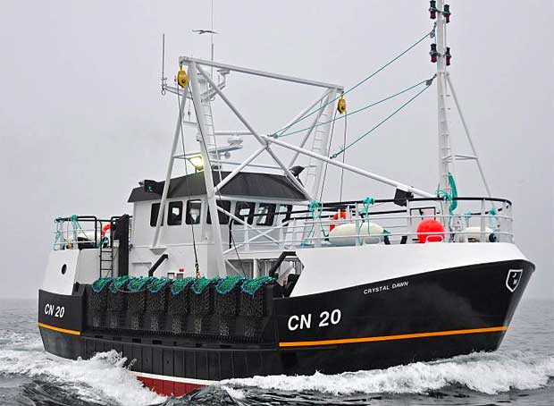  Source: (above) from Islay blog (Port Ellen)
Demersal Otter Trawling | Otter trawls are a basic funnel shaped net tapering towards the cod-end, with the sides of the net extended to form wings which herd the fish into the net. The net is held open by trawl doors which are designed to flow through the water at an angle causing them to spread away from each other and therefore opening the net horizontally. The net is held open vertically by the ballooning effect of the net and by a series of floats attached to the headline. The ground lines of nets are weighted to maintain contact with the seabed and can vary in design depending on the type of ground fished.  The trawling activity in the area around Islay and Jura is principally targeting nephrops.  Nephrops trawls tow a long winged low net, with light weight gear over predominately soft muddy grounds.  This net is designed so that the relatively fragile bottom of the net (known as the fishing line) skims a few inches off the seabed with the leaded bights of grass rope trailing on the seabed encouraging nephrops into the net. These nets differ little from white fish gear apart from being lighter rigged with a smaller mesh size. | 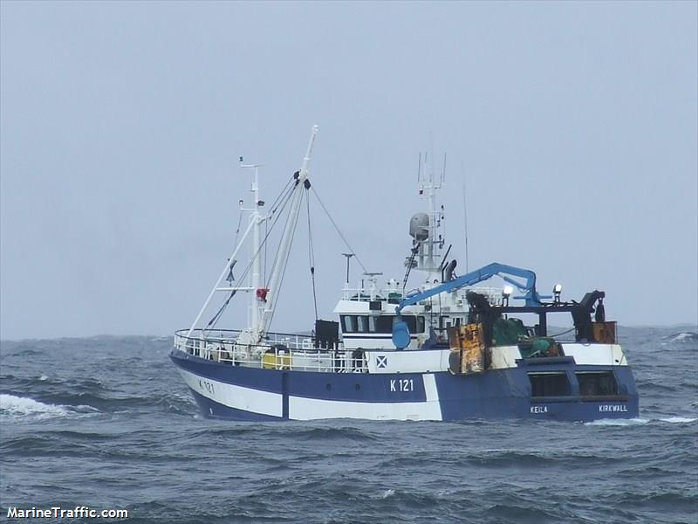  Source: Marine Traffic (above)  Source: Seafish – Demersal trawl – Nephrops trawl (below)  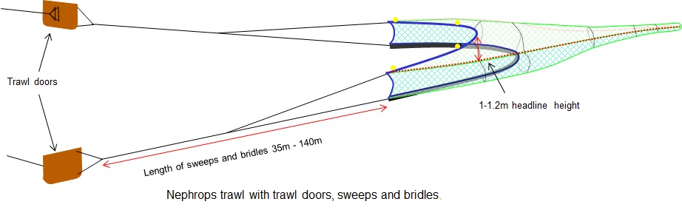

Other Legitimate Sea Users Overview
  - This section of the report provides a brief overview of other legitimate sea users in relation to the submarine electricity cable assets. Other legitimate sea users that may be affected by cable replacement works include:
- Aquaculture
- Marine Archaeology
- Wave and Tidal developments
- Ferries
- Shipping
- Sailing
- Recreational: sailing, diving, boating, angling, canoeing/kayaking, surfing
- Conservation sites/areas
- Telecommunications

  - There is no single data source or recognised model for determining the activity of all other legitimate sea users within discrete sea areas such as those encompassed by the footprint of sub-sea cables. It is beyond the scope of this report to produce a complete baseline overview for all other legitimate sea users therefore data and information are derived from assessments utilised by regional marine spatial plans and the Pre-application consultation report.

  - The Scottish Marine Recreation and Tourism Survey (SMRTS) 2015 and the Marine Scotland interactive Marine Plan have been the main sources of reference for legitimate sea users listed in Table 7. Where information is available, charts of spatial activity are provided for each of the legitimate sea users defined above.
Table 7 Other legitimate sea users’ data sources
Data | Year | Coverage | Confidence | Notes
Marine Scotland National Marine Plan Interactive | Varied | Overall Assessment  Physical Characteristics  Clean and Safe  Healthy and Biologically Diverse  Productive  Climate Change  Administrative  Regions  National Marine Plan  Aerial Photography  Base Layers | Low - High | National Marine Plan interactive (NMPi) allows you to view different types of information and, where appropriate, links have been provided to the related parts of Scotland's Marine Atlas and will also be provided to the National Marine Plan in due course.
Scottish Marine Recreation and Tourism Survey (SMRTS) 2015 | 2015 | SMRTS survey was carried out between August and October 2015. The survey provides baseline information to inform marine planning in Scotland. More than 2100 individuals, 137 clubs and 279 businesses completed the survey, indicating areas where people conducted different activities. | Low-High | Commissioned by the Scottish Government, the Firth of Clyde Forum, The Crown Estate and Scottish Coastal Forum. Aim to gather robust information on marine recreation and tourism activity around Scotland.

  - The main water sports undertaken in around Jura and Islay are motor cruising, power boating, sailing and cruising, surfing, paddle boarding, diving, private charter fishing and canoeing and kayaking. A heat map using the data collated from the Scottish Marine Recreation and Tourism Survey (SMRTS) is used to summarise all recreational activity around the Jura and Islay region. The recreational activities recorded in the vicinity of the submarine electricity cable assets are:
- Diving
- Surfing/Paddle Boarding
- Canoeing or Kayaking
- Motor Cruising
- Power Boating
- Sailing and Cruising
- Sea Angling for Private Charter

  - Recreational activity has been assessed using regional datasets as there is little information on discrete sea areas such as those encompassed by the footprint of the three submarine electricity cables.

  - Therefore, each activity was subdivided and analysed independently to assess possible interactions with engineering works based on the information provided by the SMRTS 2015 survey.

  - A total of 106 people provided spatial information on scuba diving in the SMRTS 2015 survey around Scotland. From that data a heat map was produced highlighting areas where diving occurs in the Jura/Islay region. The diving activity in the vicinity of the cable is summarised in Table 8 below and shown in Figure 15.
Table 8 Scuba Diving
CABLE NAME | Interaction on chart | Notes
Bridgend, Islay | No
Jura to Islay | Possible | Close to some localised intensive scuba diving activity
Jura to Mainland | Yes | Some localised activity in the vicinity of the Jura to Mainland cable

  - A total of 201 people provided spatial information on surfing/paddle boarding and in the SMRTS 2015 survey around Scotland. From that data a heat map was produced highlighting areas where these activities occur in the Jura/Islay region. These activities are summarised in Table 9 and shown in Figure 16.
Table 9 Surfing and paddle boarding
Cable name | Interaction on chart | Notes
Bridgend, Islay | No
Jura to Islay | Yes | High levels in the vicinity of the Jura to Islay cable
Jura to Mainland | Yes | Low levels in the vicinity of the Jura to Mainland cable

  - A total of 418 people provided spatial information on canoeing and kayaking in the SMRTS 2015 survey around Scotland. From that data a heat map was produced highlighting areas where these activities occur in the Jura/Islay region. This activity and possible interaction is summarised in Table 10 below and shown in Figure 17.
Table 10 Canoeing and Kayaking
Cable name | Interaction on chart | Notes
Bridgend, Islay | No
Jura to Islay | Yes | High levels in the vicinity of the Jura to Islay cable
Jura to Mainland | Yes | Moderate levels in the vicinity of the Jura to Mainland cable

  - A total of 163 people provided spatial information on motor cruising in the SMRTS 2015 survey around Scotland. From that data a heat map was produced highlighting areas where these activities occur in the Jura/Islay region. This potential for motor cruising to interact with the cables is summarised in Table 11 and shown in Figure 18.
Table 11 Motor Cruising
Cable name | Interaction on chart | Notes
Bridgend, Islay | No
Jura to Islay | Yes | Low levels of activity in the vicinity of the Jura to Islay cable
Jura to Mainland | Yes | High levels of activity in the vicinity of the Jura to Mainland cable

  - A total of 204 people provided spatial information on power boating in the SMRTS 2015 survey. From that data a heat map was produced highlighting areas where these activities occur in the Jura/Islay region, with low to moderate levels observed in proximity to the cable. This activity is summarised in Table 12 and shown in Figure 19.

Table 12 Power Boating
Cable name |  | Interaction on chart | Notes
Bridgend, Islay |  | Yes | Low levels in the vicinity of the Bridgend, Islay cable
Jura to Islay |  | Yes | Low levels in the vicinity of the Jura to Islay cable
Jura to Mainland |  | Yes | Moderate levels in the vicinity of the Jura to Mainland cable

  - A total of 542 people provided spatial information on sailing and cruising in the SMRTS 2015 survey. From that data a heat map was produced highlighting areas where these activities occur in the Jura/Islay region. This activity is summarised in Table 13 and shown in Figure 20.
Table 13 Sailing and Cruising
Cable name | Interaction on chart | Notes
Bridgend, Islay | Yes | Low levels in the vicinity of the Bridgend, Islay cable
Jura to Islay | Yes | Moderate levels in the vicinity of the Jura to Islay cable
Jura to Mainland | Yes | High levels in the vicinity of the Jura to Mainland cable

  - A total of 353 people provided spatial information on chartered angling in the SMRTS 2015 survey around Scotland. From this data a heat map was produced highlighting areas where charted angling occurs in the Jura/Islay region. This activity is summarised in Table 14 and shown in Figure 21. There is one company (Islay Sea Adventures) offering fishing tours in the region. The main season is over the summer months when the weather is more suitable.
Table 14 Chartered Angling
Cable name | Interaction on chart | Notes
Bridgend, Islay | No
Jura to Islay | Yes | Low levels of activity in the vicinity of the Jura to Islay cable
Jura to Mainland | Yes | Moderate to high levels in the vicinity of the Jura to Mainland cable

  - There has been no activity recorded for kite surfing, yacht racing, coasteering, dingy racing, sea swimming, jet skiing, water skiing/ wakeboarding or rowing and sculling in the location of the 3 cables.

  - Although shellfish and finfish farming are a significant and growing aquaculture sector in Scotland, there is minimal aquaculture development in this region. There is a low presence of aquaculture activity in the vicinity of each of the cable assets. The sites are summarised in Table 15 and shown in Figure 22.

Table 15 Aquaculture Sites
Cable name | Interaction on chart | Notes
Bridgend, Islay | No
Jura to Islay | No
Mainland to Jura | Possible | There is one shellfish aquaculture site, Scallop Kings within 20km of Mainland to Jura cable and survey vessels may transit past this location

  - The overlap of the cable locations and designated conservation areas is summarised in Table 16. The Mainland to Jura cable sits within an MPA where fishing activity by dredge, demersal trawl or demersal seine net, set nets or longlines is prohibited. The Bridgend to Islay cable sits within a RAMSAR site and SPA. The interaction of cable locations and conservation designations is shown in Figure 23.
Table 16 Conservation Zones
Cable name | Interaction on chart | Notes
Bridgend, Islay | Yes | The cable is within Bridgend Flats SPA and Gruinart Flats (Islay) RAMSAR site
Jura to Islay | No
Mainland to Jura | Yes | The cable is located within the Loch Sunart to Sound of Jura MPA and Firth of Lorn SAC MPA

  - AIS shipping traffic shows average weekly density of vessels between 2012 and 2015 for the Jura/Islay region. The activity levels near the cable locations is summarised in Table 17. No tankers were within the vicinity of the cables. Medium to low levels of cargo vessel activity was seen over the Mainland-Jura and Jura Islay cables. Bridgend to Islay cable has no shipping activity in the area. This activity is summarised in Table 17 can be seen in Figure 24.
Table 17 Shipping Zones/Cargo vessels
Cable name | Interaction on chart | Notes
Bridgend, Islay | No
Jura to Islay | No | Medium levels of activity recorded in the vicinity of the Jura to Islay cable
Mainland to Jura | Yes | Low to Medium levels of cargo vessel activity recorded in the vicinity of the Mainland to Jura cable

  - There is a ferry service operated by Caledonian MacMrayne (Hebridean & Clyde Ferries) which runs from Kennacraig to Port Ellen and Port Askaig. The presence of ferries in the vicinity of each of the cable assets is summarised in Table 18. This can also be seen in Figure 25.
Table 18 Ferry/Passenger Vessels
Cable name | Interaction on chart | Notes
Bridgend, Islay | No
Jura to Islay | Yes | High levels of ferry activity recorded in the vicinity of the Jura to Islay cable
Mainland to Jura | No

  - The local ports in the Jura/Islay area are Port Ellen, Port Charlotte, Port Askaig and Feolin (small ferry port). The proximity of the ports to the cables is given in Table 19.
Table 19 Local ports
Cable name | Interaction on chart | Notes
Bridgend, Islay | No
Jura to Islay | Possible | The ferry route from Port Askaig to Feolin is close to the Jura to Islay cable
Mainland to Jura | No

  - Canmore online database, encompassing a record of Scotland’s maritime heritage has been used to verify any possible interaction with the Jura/Islay submarine electricity cables and any current or scheduled archaeological sites of national importance, legally protected under the Ancient Monuments and Archaeological Areas Act 1979. This dataset provides archaeological sites that are not documented by historic Scotland (HS) as sites of national importance but may cause an obstruction or impede navigation during cable works. Please note maritime data on Canmore is derived from a variety of sources and some sites will be more accurately reported than others. The presence of marine archaeology sites in the vicinity of each of the cable assets is summarised in Table 20.
Table 20 Marine Archaeology Wreck Sites
Cable name | Interaction on chart | Notes
Bridgend, Islay | Possible | Possible wreck sites in the vicinity of Bridgend, Islay cable
Jura to Islay | Possible | Possible wreck sites in the vicinity of Jura to Islay cable
Mainland to Jura | No

  - An overall summary of the potential interactions between the Jura/Islay region submarine electricity cables and other legitimate sea users is given in Table 21.

  - The key points of contact for these legitimate sea users are identified in Appendix E: Communications Strategy.
Table 21 Summary of other legitimate sea users interactions
Activity |  | Interaction on chart | Notes
 | Scuba diving | Yes | Some localised scuba diving activity in the vicinity of the Jura to Mainland cable
 | Surfing/paddle boarding | Yes | High levels of activity in the vicinity of the Jura to Islay cable  Low levels of activity in the vicinity of the Jura to Mainland cable
Recreational | Canoeing/  kayaking | Yes | High levels of canoeing/kayaking in the vicinity of the Jura to Islay cable  Moderate levels of canoeing/kayaking in the vicinity of the Jura to Mainland cable
 | Motor cruising | Yes | Low levels of motor cruising activity in the vicinity of the Jura to Islay cable  High levels of motor cruising activity in the vicinity of the Jura to Mainland cable
 | Power boating | Yes | Low to moderate levels around all cables
 | Sailing/cruising | Yes | Low levels in the vicinity of the Bridgend, Islay cable  Moderate levels in the vicinity of the Jura to Islay cable  High levels in the vicinity of the Jura to Mainland cable
 | Chartered angling | Yes | Low levels of activity in the vicinity of the Jura to Islay cable  Moderate to high levels in the vicinity of the Jura to Mainland cable
Aquaculture |  | Possible | Low aquaculture activity in the region (1 shellfish site)
Conservation Sites |  | Yes | Both the Mainland–Jura and Bridgend (Islay) are within conservation sites
Shipping |  | Yes | Moderate cargo ship activity associated with the Jura-Islay cable and low activity associated with the Mainland-Jura cable.
Wave/Tidal |  | No | There are no renewable energy projects within the vicinity
Ferries |  | Yes | High levels of ferry activity recorded in the vicinity of the Jura to Islay cable
Marine Archaeology |  | Yes | Wrecks possible near Jura-Islay and Bridgend (Islay) cables.

Cable Asset Interactions: Commercial Fishing
  - The main gear types within the Jury/Islay region are potting (creeling), scallop dredging, and trawling. However, potting vessels represent the most days at sea within the region and due to the nearshore location of the cables, it is likely to be the primary fishery that may interact with the cable locations. With this being said there is moderate levels of demersal trawling and scallop dredging, including vessels >15m operating in the immediate vicinity of the Mainland to Jura and Jura to Islay cables.

  - While fishermen will be kept up to date with survey areas by Notice to Mariners (NTMs) and update emails from the developer and their subcontractors, there is scope for conflicting demands on the same area of sea. Inspection schedules are fluid and dependent upon many factors and fishermen may not regularly read emails, if they have access to the internet at all and therefore may not be aware of recent updates.

  - In most cases the presence of a FIR on board the survey boats should prevent fishing gear interactions by survey vessels. However, it may not be feasible for all vessels to have an offshore FIR on board therefore a standard operating procedure (SOP) has been created for the FIR and crew of the survey vessels to follow (Fishing Gear Interaction SOP), given in Appendix A Standard Operating Procedures.

  - The potential interactions between fishing stakeholders and survey vessels are dependent on the survey and installation methods to be used. Inspections will be carried out on SHEPD’s submarine electricity cables as part of the 17/18 programme of works. These inspections will identify the behaviour and integrity of the cable. This will inform the ongoing maintenance plan and influence cable replacement decisions. Survey information obtained along the cable route will include ROV mountable magnetometer, MBES and SSS, and a gradiometer array for a minimum corridor width of +/-7.5m, centred on the existing cable route.

  - The potential interactions to fishing stakeholders, based on the site specific proposed inspection methods, are given in Table 22 and specified in the Cefas and MCEU (2004) guidelines. It should be noted that fishing stakeholders will vary in their sensitivity to socio-economic pressures depending on:
- Spatial adaptability based on operational range, and
- Spatial tolerance based on dependency on fishing grounds

Table 22 Summary of potential impacts to fishery stakeholders
Category | Type | Detail of impact | Cost Benefit Analysis Model Impact Number
Health and safety impacts | Snagging risk | Anchor mounds from proposed anchor mooring systems | 1
 | Snagging risk | Presence of obstacles (dropped objects) on the seabed | 1
 | Access to shelter | Reduced access to shelter in adverse weather conditions | New
Socio-economic impacts | Collision risk | Increased collision risk at sea (and during any cable installation works required following inspection surveys) | 3
 | Loss of earnings | Loss of access to fishing grounds during surveys (and during any cable installation works required following inspection surveys) | 7
 | Additional costs | Obstruction of navigation routes resulting in increased steaming distances/times during cable installation | 7
 | Additional costs | Increased fuel consumption due to increased steaming times/distances during cable installation | 7
 | Loss of earnings | Increased competition for commercially exploited fish and shellfish due to displacement of vessels into other fishing grounds during cable installation (if required) | 7
 | Loss of earnings | Interference to normal fishing activities during cable maintenance | 7
Environmental impacts | Loss of earnings | Adverse impacts on commercially exploited fish and shellfish populations | New

Cable Asset Interactions: Other Legitimate Sea Users
  - Potential interactions between survey vessels and other legitimate sea users are given in Table 23. It should be noted that other legitimate stakeholders will vary in their sensitivity to socio-economic pressures depending on:
- Spatial adaptability based on operational range and
- Spatial tolerance based on dependency on cable area

  - Due to the range in levels of activity for all other legitimate sea users there is scope for conflicting demands on the same area of sea. It is anticipated that the formal notifications such as NtMs, COLREGS and the code of good practise for all vessels will provide sufficient mitigation for potential interactions.
Table 23 Summary of potential impacts to other sea user stakeholders
Category | Type | Detail of impact | Cost Benefit Analysis Model Impact Number
Health and safety impacts | Access to shelter | Reduced access to shelter in adverse weather conditions | New
Socio-economic impacts | Collision risk | Increased collision risk at sea during cable installation | 3
 | Loss of earnings | Loss of access to sea areas during surveys and cable installation during cable installation e.g. ferries/sailing/scuba diving/kayaking | New
 | Additional costs | Obstruction of navigation routes resulting in increased steaming distances/times and fuel consumption | New
 | Loss of earnings | Interference to normal sea user activities during maintenance e.g. aquaculture sites | New

Safety
  - Safety management is a key aspect of the FLMAP. With regards to commercial fishing, the Safety Management Plan for submarine cable replacement will include the following elements that mitigate the identified risks:
- Code of Good Practice for all Vessels
- Procedures in Relation to Gear Fastening or Loss
- Safety Zones (500m) around any required Active Construction Areas
- Appendix E: Communication programme

  - When we employ contractors for the surveys required for the Jura/Islay cable inspections, they will outline certain obligations to which the contractors must follow in order to ensure external communication is accurate and to aid coexistence with legitimate sea users. These may include ensuring:
- Any debris accidently dropped during any construction and maintenance activities (if required following inspection surveys) is removed if practicably feasible and safe to do so
- All vessels under contract with us adhere to COLREGS and SOLAS requirements
- All vessels under contract with us do not engage in any commercial or recreational fishing activities whatsoever
- All vessels under contract with us will maintain polite, proactive and professional communications with fishing vessels and other legitimate sea users during offshore operations
- All vessels under contract with us will monitor the required VHF channels at all times so as to receive communications directly from fishing vessels and other legitimate sea users
- All vessels contracted to undertake project specific work will have undertaken appropriate risk assessments in respect of potential interactions with commercial fishing vessels and their gears
- Where appropriate, for vessels using anchored positioning, contractors will be obliged wherever possible to adopt anchor release procedures to minimise the size of anchor mounds and where necessary undertake remedial actions to level any significant anchor mounds
- All vessels contracted with us will have on board approved fishing liaison/interaction manuals
- Where appropriate, suitably qualified and certified offshore FIRs will be on board certain project vessels
- Standard transit routes for vessels engaged by us will be discussed with fishing stakeholders prior to operations commencing and vessels transiting to the site shall follow these where possible.

  - The following procedure outlined below replicates that which has been in place in respect of the UK offshore oil and gas industry and describes the steps that should be undertaken in the event of fishing gear becoming fastened on or in the vicinity of a submarine electricity cable:
- If the fastened gear is not easily retrieved, fishermen should not apply excessive winch, line or net hauler loads or engine powers in attempts to retrieve fastened gear
- Fishermen are to advise the coastguard and the CFLO/FIR immediately, giving an accurate position of the vessel and/or lost gear
- If the coastguard or CFLO/FIR confirms that the vessel is in the immediate vicinity of a cable, serious consideration will be given to the slipping of the gear and buoying and recording of its position;
- If the gear is slipped, after buoying off the gear, the position should be confirmed with the coastguard and the CFLO/FIR
- On return to port, the skipper is to contact the local Fishery Office and register the incident in the normal manner
- On no account should skippers grapple in an attempt to recover fishing gear lost or cut away in the vicinity of a submarine electricity cable.

  - The purpose of a safety zone is to ensure the safety of other legitimate sea users by communicating a safe distance between other users and any construction, operation and maintenance activities related to the submarine electricity cables.

  - Whilst 500m is the maximum permissible size for a safety zone, it could be that during any required construction phases, the safety of other users is better served through an additional precautionary area communicated by Notice to Mariners in which it is recommended other legitimate sea users do not enter. If entry is unavoidable, then navigation with extreme caution is advised.

  - We will aim to organise any required construction schedules as far as is practicably possible with the aim of reducing potential combined loss of fishing area during this phase.

  - Fishing stakeholders will be informed of all the cable works throughout the inspection surveys (and any subsequent pre-construction or construction phases).

  - SHEPD will, in consultation with commercial fishing stakeholders, work towards identifying acceptable and feasible mitigation options with the aim of minimising any potential effects on commercial fishing associated with the replacement of submarine electricity cables. There are various options available to mitigate the risks describe previously, including:
- Continuing effective positive liaison with commercial fishing stakeholders through the pre-construction, construction and operational phases of any cable replacement
- Continued employment of CFLO/FIR services until the completion of the replacement works
- Ensuring contractors comply with the contractor’s obligations outlined above so as to minimise any interference to commercial fishing activities
- Managing the cable replacement works so as to minimise any potential effects on the marine environment, habitats and commercial fishing
- Raising awareness of the danger of fishing in the vicinity of submarine cables
- Adopting a hierarchical approach to submarine cable protection, taking account of legitimate sea users concerns
- Organising a construction phasing workshop (if new cable is required) to inform commercial fishermen of planned activities
- Organising construction schedules (if new cable is required) as far as is practicably possible in order to reduce the combined loss of fishing area associated with safety zones
- Distributing weekly notice of operations
- Providing information in plotter format to enable fishermen to easily interpret the information
- Scouting surveys to identify potting areas and any other relevant static gear areas.

UK Legislation, References and Guidance
  - Damage to submarine cables is expensive to repair and can cause disruption to power distribution to often sparsely populated islands. There is applicable legislation in respect to safety zones (Energy Act 2004), navigation (International Regulations for Preventing Collisions at Sea 1972; COLREGS) and submarine cable protection (United Nations Convention on the Law of the Sea (UNCLOS) Article 113, 1982, and UK 1964 Continental Shelf Act)). It is an offence to wilfully damage submarine cables (UNCLOS, 1982; UK 1964 Continental Shelf Act).

  - The legal implication of damaging a submarine cable is summarised in the International Cable Protection Committee (IPCC) booklet “Fishing and submarine cables” (2009):

“Under UNCLOS and the earlier 1884 International Convention for the Protection of Submarine Cables, if a mariner damages a cable and the damage could be avoided by taking reasonable care as a prudent seaman, then the person causing the damage is liable. If a mariner damages a cable with fishing gear or an anchor, when he could have seen that cable on a chart and avoided it, he may be liable for the damage. In addition to civil liability for damages, the mariner may face criminal sanctions for culpable negligence or wilful injury to a cable.

However, international law recognises an exception. If the mariner’s damage to the cable is caused by taking necessary actions to save the vessel or crew, there is no liability. An example would be a ship without power being set upon a shoal that is saved by anchoring and in the process a cable is damaged.

International law also requires that a vessel that has gear or an anchor caught on a cable is required to sacrifice the gear or anchor to avoid injury to the cable. Provided the mariner was not negligent in contacting the cable in the first place, the mariner is entitled to indemnity for the cost of the sacrificed gear or anchor by the owners of the cable”.

  - In regards to navigation, in normal circumstances, the provisions laid down by COLREGs are sufficient to ensure that actions taken by fishing vessels and those restricted in their ability to manoeuvre when two vessels are approaching allow both to continue operating with minimum disruption.

  - There is no legal obligation on a SHEPD to pay co-operation payments to fishermen in respect to offshore works.

- Standard Operating Procedures
See separate document.

- Company Fishing Liaison Officer Specification
See separate document.

- Marine Mitigation and Co-existence Planning
See separate document.

- Notice to Mariners Example Template
Notice to Mariners
Scottish Hydro Electric Power Distribution (SHEPD) – Notice to Mariners [Month Year].
Issued [Date].
Please be advised that [Contractor] (on behalf of SHEPD) will be undertaking a [description of works, e.g.: survey across the CABLE ROUTE submarine electricity cable corridor]. The survey will utilise four different vessels to complete survey operations:
- Vessel 1
- Vessel 2
- Vessel 3
- Vessel 4

The survey operations will commence during an appropriate weather window following [date] and will continue over a planned minimum period of [16 weeks], weather permitting.
The survey operations will be concentrated across the cable corridor within the boundary defined by the following coordinates.
[Chart of survey area]
[Coordinates of survey area boundary]
The survey operations will be undertaken by the [vessel 1, vessel 2, vessel3…..] pictured below. The vessels may not commence their activities at the same time but may operate simultaneously at times over the survey duration. The vessels may operate primarily from [Kirkwall] but may use other ports along the [island] coastlines, such as [port 1] or [port 2].
Vessel Photo | Vessel Description
[Photo of vessel 1] | [Description, contact details and call sign of vessel 1, e.g.: The M.V. [vessel name] is a multi-purpose survey vessel, 65.2 m in length with a beam of 14m and a draft of 5.3 m; transit speed of 12 kts and a survey speed of ~5 kts (geophysical survey). Operating on a 24-hour basis]
[Photo of vessel 2] | [Description, contact details and call sign of vessel 2]
[Photo of vessel 3] | [Description, contact details and call sign of vessel 3]
[Photo of vessel 4] | [Description, contact details and call sign of vessel 4]

Survey Description
The [survey/installation] will involve [the coverage of dedicated survey lines by the vessel(s) with a full suite of geophysical survey systems (Multi beam Echo Sounder, Side Scan Sonar and Magnetometer)] mounted on the vessel or towed from the stern of the vessel.
Other vessels should maintain an appropriate and safe distance of 500 m when passing the [survey] vessel(s) whilst undertaking survey operations and should pass at the lowest possible speed to avoid vessel wash effects. The vessel(s) will be working [24 hour operations] and will display appropriate day shapes and lights during reduced visibility and night operations. The vessel(s) will also monitor VHF Channels 16 and 12.
Primary Survey Equipment
Primary equipment | Towed / Hull mounted / Sampling | Approximate tow length (if applicable) | Vessel
Multibeam Echosounder | Hull mounted | N/A | Vessel 1, Vessel 2
Sidescan Sonar | Towed | 50-350m | Vessel 1, Vessel 2
Magnetometer Array | Towed | 50-350m | Vessel 1, Vessel 2
Remotely Operated Vehicle (ROV) | Tether Management System | N/A | Vessel 1
Subsea Crane Operations | Crane | WD 140 max | Vessel 1

Contact Details
The vessel contact details are given in the tables below
VESSEL 1
Call sign
Bridge
Offshore manager / Party Chief
Email
Onshore Site Manager

VESSEL 2
Call sign
Bridge
Offshore manager / Party Chief
Email
Onshore Site Manager

Fishing Liaison Officers
Fishing liaison for the [survey] will be co-ordinated by Brown and May Marine (BMM). For any commercial fishery queries please contact the Company Fishing Liaison Officer (CLFO) Alex Winrow-Giffin on 07760 160039 / 01379 872144, alex@brownmay.com and the local Fishing Industries Representative (FIR) George White, georgewhite0@gmail.com, 07761 873965 will also be in place to liaise with the vessel and fishing operations in the area. The vessel master will issue regular broadcasts whilst the survey vessel is operating to ensure minimal disruption and that vessels maintain an appropriate and safe distance.
Further Details
Further enquiries should be addressed to the following people in the following order:
Name | Contact Number | Email

Distribution List
The following contacts on the distribution list are taken from those listed in the main document (FO-NET-CAB-405-G).
Contact | Email
Kingfisher | kingfisher@seafish.org.uk
United Kingdom Hydrographic Office | sdr@ukho.gov.uk
UKHO Navigation Warnings | navwarnings@btconnect.com
Northern Lighthouse Board | navigation@nlb.org.uk
Trinity House | navigation.directorate@thls.org
Marine Scotland | MS.MarineLicensing@gov.scot
Maritime and Coastguard Agency | navigationsafety@mcga.gov.uk
Maritime and Coastguard Agency | nmoccontroller@hmcg.gov.uk
The Crown Estate | Darren.Hirst@bidwells.co.uk
Scotland Natural Heritage | David.Law@snh.gov.uk
Scottish Environmental Protection Agency | EPINorthernIsles@sepa.org.uk
Scottish Fishermen’s Federation | renewables@sff.co.uk
Scottish Creel Fishermen's Federation | info@scottishcreelfishermensfederation.co.uk
RYA Scotland | admin@ryascotland.org.uk
Argyll and Bute Council | allan.finlay@argyll-bute.gov.uk
Islay Sea Adventures | info@islay-sea-adventures.co.uk
Northern Ireland Fish Producers (NIFPO) | info@nifpo.co.uk
Islay Ferries (operated by Caledonian MacBrayne) | kenny.boyd@calmac.co.uk
Clyde Cruising Club | office@clyde.org
Royal Gourock Yacht Club | royalgourockyachtclub@hotmail.co.uk
Clyde Fisheries Association (CFA) | e.whyte@clydefish.com
Toward Sailing Club | towardsailingclub@gmail.com
West Coast Shellfish (Scotland) Ltd | TBC
Kayak Wild Islay | enquiries@kayakwildislay.co.uk
Islay Sea Adventures | info@islay-sea-adventures.co.uk
Fyne Pioneer | info@fynepioneer.co.uk
The Majestic Line – West Coast Cruises | info@themajesticline.co.uk
Hebridean Island Cruises | enquiries@hebridean.co.uk
Peel Ports | caroline.baxter@peelports.com
HM Naval Base Clyde | Clyde@qhm.mod.uk

- Communication Programme
An example standardised high level cable replacement communication plan is given in Table 24. (This is in the event that cable replacement is identified following inspection surveys). A programme of actions to be undertaken in the event of an unplanned outage is given in Table 25. Please note that the communication plan will need to be applied for each cable.
Table 24 Example of a communication programme for cable replacement
Time | What’s happening | What we want to communicate | Who we are speaking to and frequency
May 2018 | Cable inspection list created for 2017/18  We have developed a list based on a number of define factors and pervious cable history. This allows us to “guess future health” where the most vulnerable cables will be and their importance on the network. This includes roughly 150% of the cable projects we intend to deliver, so we make sure we capture the right projects. | No communications at this stage. | N/A
August 2018 | Mobilisation of inspection vessels for 2017/18 programme of cable replacement  Sending out inspection vessel, divers and/or ROV closely following cable to inspect cable condition and record it on film. This is then used to inform our health assessment of the cable. | Essentially a safety message to let mariners know that we will have vessels in the area. | - Mariners: the number of vessels, routes they are taking and activities they will be completing (daily)
December 2018 | Review inspections from 2 years ahead to create 1 year ahead survey list  From Inspection data we refine our project list to 125% of projects to make sure we survey as much as possible without wasting these works on cables which are healthy. | No communications at this stage, unless there has been engagement with stakeholders who have experienced wet outages. | Domestic and generation SHEPD customers to advise them that we will be replacing the cable (one off).
June 2019 | Survey 2017/18 Cable routes  With our 125% list we then issue instruction to survey the cable routes.  This uses a vessel dragging a sonar device across a wide area multiple times to build up an image of the sea bed. It may also include carrying out intrusive geotechnical investigations. | - Essentially a safety message to let mariners know that we will have vessels in the area.  - Messaging to highlight any environmental mitigation measures we have implemented to safeguard marine life (e.g. checking for dolphins before beginning sonar survey) | - Mariners: the number of vessels, routes they are taking and activities they will be completing (daily).  - Environmental groups: to highlight any mitigation measures (one off).
September 2019 | Select 2017/18 cable routes and advise Marine Scotland (licensing)  From our survey we will then define the project which is to be delivered.  Reducing our project list to 100% of what we are able to deliver. | - No external communications at this stage. | N/A
September 2019 – March 2020 | PAC events and license application  See separate communications plan please | See separate communications plan please | See separate communications plan please
Summer 2020 | Mobilisation of vessels for cable installation  With all cable projects now consented and licences approved, cable laying vessels are in the water. The boats(s) will collect all cables and fittings from our storage depot. | - Essentially a safety message to let mariners know that we will have vessels in the area. | - Mariners: the number of vessels, routes they are taking and activities they will be completing (daily).
Summer 2020 | Start – completion of installation works  - From there the vessel will transit to the cable installation location and begin works. Dependant on the projects the vessel(s) might do one of more than one cable installation during one voyage.  - Dependant on physical protection levels of cables there may be a number of extra vessels dispatched to complete the works.  - In parallel there will be onshore works which will be connecting the cable from the sea/shore end into the existing electrical network.  - All vessel(s) return to port(s) | - Essentially a safety message to let mariners know that we will have vessels in the area. | - Mariners: the number of vessels, routes they are taking and activities they will be completing (daily).  - Domestic and business customers to be advised of any planned outages to allow us to carry out works (as required).
18 months after installation | Post installation cable inspections  - Sending out inspection vessel, divers and/or ROV to inspect the cables most recently installed. This will allow us to decide what remedial works are required.  - The cable is inspected by closely following cable to inspect cable condition and record it on film. This is then used to inform our assessment. | - Essentially a safety message to let mariners know that we will have vessels in the area. | - Mariners: the number of vessels, routes they are taking and activities they will be completing (daily).
Remedial works following cable inspection (if required) | Remedial works  If required, we will send more vessels to complete any works which are required (from protection to complete cable replacement). | - Essentially a safety message to let mariners know that we will have vessels in the area. | - Mariners: the number of vessels, routes they are taking and activities they will be completing (daily).

Table 25 Example of unplanned outage due to wet fault in a cable
Time | What’s happening | What we want to communicate | Who we are speaking to
Day 1 | Declared a wet fault following testing at termination poles at both shore ends. This will give the distance to the fault location within the sea.  Depending on the severity of the fault and the demand of the island we may be able to restore power whilst still investigating the fault.  Embedded generation team will be deployed to operate the generators on the island. There will be someone on site 24 hours.  We formally notify Marine Scotland, Northern Lighthouse Board and Fishing Liaison Officer at this point. | - We are aware of a submarine electricity cable fault.  - Our engineers are on site and are connecting generators to restore your power. | Domestic and business demand and generation customers.
Day 2 -13 | We are mobilising our marine contractors (divers, vessels and crew). | - Power will have been restored from the customers’ perspective.  - Generation customers may be assisting islands in maintaining supply stability. We may wish to communicate this as a good news story. | Domestic and business demand customers if we want to share good news story.
Day 14 -17 | Locating the fault  If the cable is 30 m deep then divers visually inspect the cable to find the fault.  If it is deeper than this Remote Operated Vehicles are deployed to do the same job.  Visibility can be very poor so this will impact on how long this takes. | - We need to be sharing safety message with the marine community to beware that we have vessels operating in the area.  - This should highlight how many there are in the water and what they are doing.  - We may want to talk to the outside world about anyways we are mitigating our impact on either the environment or mariners. | Mariners: We will have vessels operating in and around the cables.  This should advise of specific movements.
Day 18 | Fault zone found  Fault zone found visually (probably a worn section of cable with splayed armour; or disruption on seabed; or orange deposits on the armour). There is still work to be done in actually pin pointing the fault. | - We need to be sharing safety message with the marine community to beware that we have vessels operating in the area.  - This should highlight how many there are in the water and what they are doing. | Mariners: We will have vessels operating in and around the cables.
Day 19 – 20 | Fault finding  - We cut the cable in the fault zone.  - Tie one end that will remain in the sea to the buoy. We will check this is healthy once we have checked the end that we think has the fault.  - The end we think has a fault will be recovered onto the cable vessel. Jointers will strip the cable ready for testing. We find the exact location of the fault by cutting 10 metre lengths until the tests show that the cable is healthy. Once we know cable is healthy we make it waterproof and tie it to a buoy to it. | - We need to be sharing safety message with the marine community to beware that we have vessels operating in the area. This should highlight how many there are in the water and what they are doing. Especially since there will a number of anchors temporarily in the area whilst we are looking for the fault and fixing it. | Mariners: We will have vessels operating in and around the cables.  This should tell mariners where the buoys are and that the cable is at this location.
Day 21 | Option A  We call this a piece in where we are able to re-joint the cable with a new section of cable.  Option B  Depending on the distance from shore, we may take at new section of cable from the shore end to the existing cable (only needing one joint)  Option C  If the cable is too deep (greater than 50 metres) we can’t repair the cable by traditional means we will have to replace the entire cable end to end.  Option D  If cable has faulted and is planned for replacement due to health of cable we will replace entire cable end to end. | We need to be sharing safety message with the marine community to beware that we still have vessels operating in the area.  This should highlight how many there are in the water and what they are doing.  Option A and B  Estimate how long we will be in the area mending the cable for and advise of vessel movements.  Option C and D  We need to apply for full marine licence.  Please refer to other communication plan from here on. | Option A and B  Mariners: We will have vessels operating in and around the cables and estimate when we will be away  Option C and D  Mariners and statutory consultees: We need to do a full cable replacement and so need to apply for a marine licence which gives us consent to carry out the work.
Day 22 | Option A  Take cable vessel to fault location and joint new piece in between the two ends. The cable is tested to make sure it is healthy and then lowered back onto the sea bed. We will then re-energise cable when safe to restore power.  Option B  Position the cable vessel close to the shore in line with the point of termination in land. We float the cable from the cable vessel to connection point on shore. The floats are removed when cable is in position and install the cable to the jointing location where it meets the cable which we left in the sea attached to a buoy (the original fault location) and joint the cable. We test the cable to make sure it is clear of all faults. We will then re-energise cable when safe to restore power. | We need to be sharing safety message with the marine community to beware that we still have vessels operating in the area.  This should highlight how many there are in the water and what they are doing. | - Domestic and business demand and generation customers: The submarine electricity cable has been repaired and mobile generators have been removed from the island.  - Mariners: We will have vessels operating in and around the cables and estimate when we will be away

- Commercial Fishing Charts
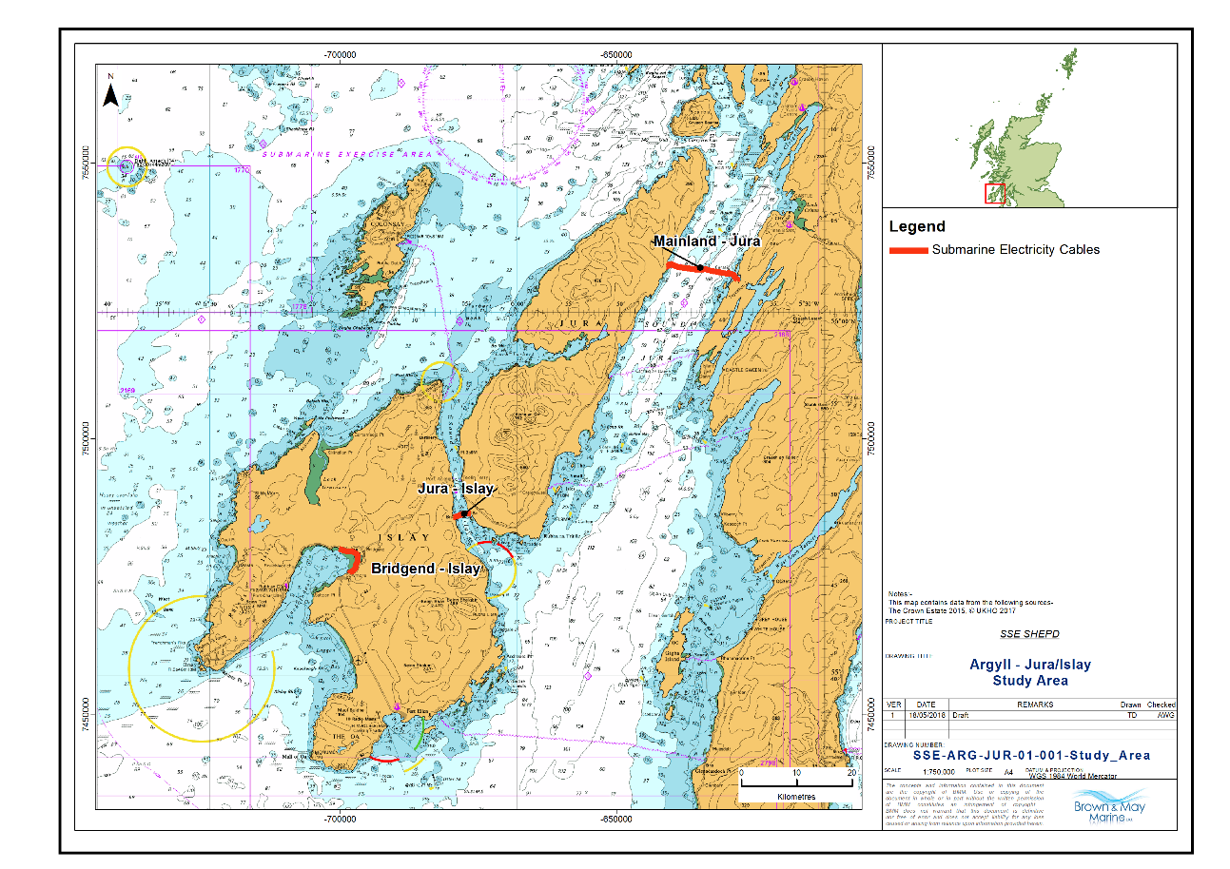
Figure 1 Submarine Electricity Cables in Jura/Islay Region
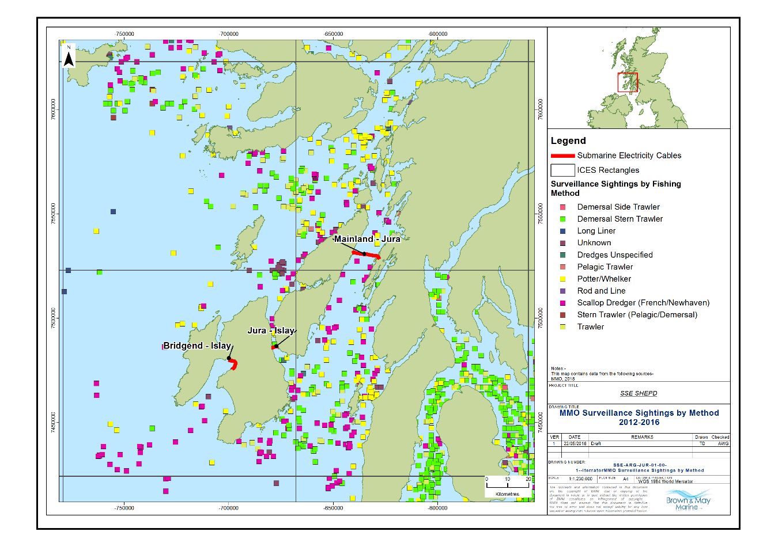
Figure 2 MMO Surveillance Data by Method (2012-2016)

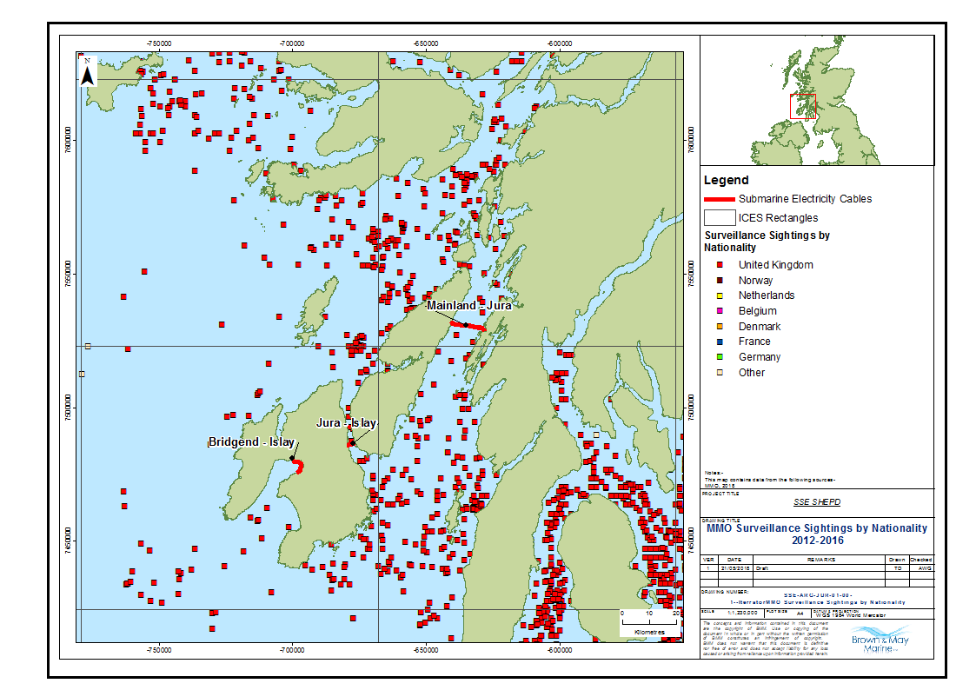
Figure 3 Surveillance Sightings by Nationality (2012-2016)

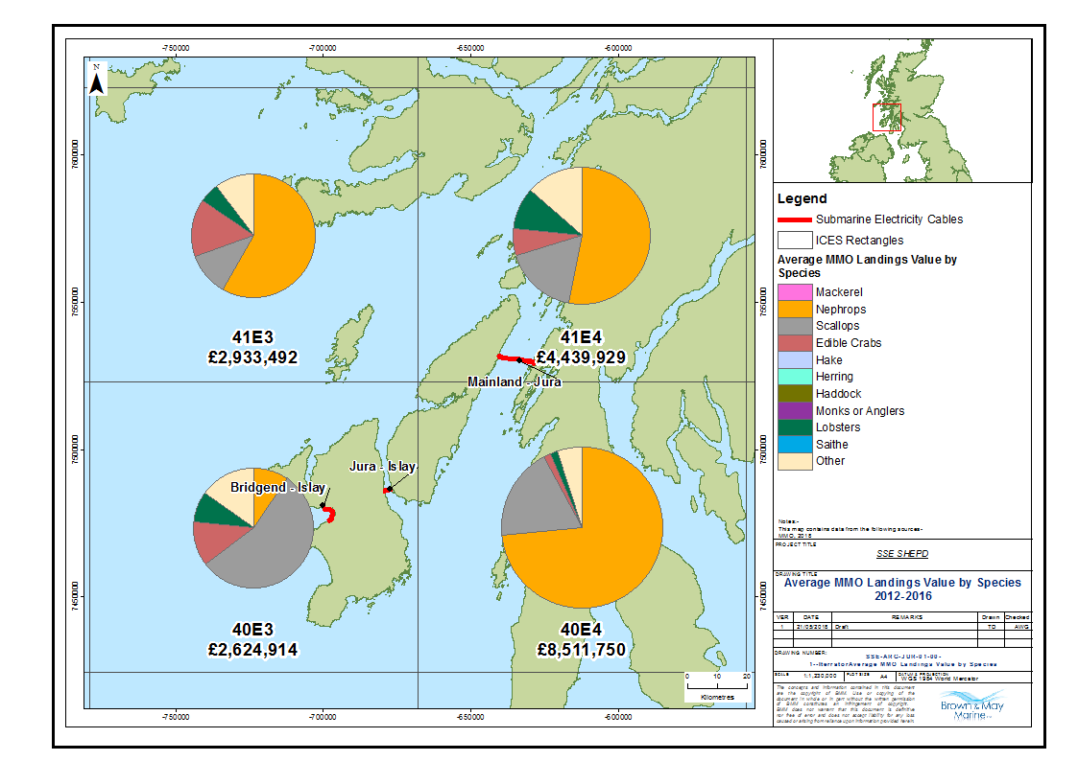
Figure 4 Average MMO Landings by Species (2012-2016)

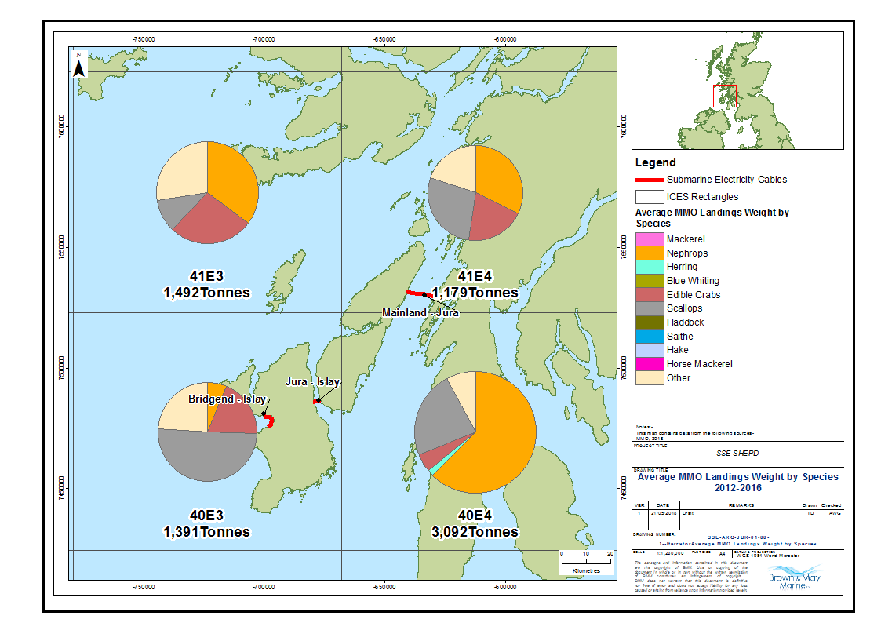
Figure 5 Average MMO Landings Weight by Species (2012-2016)
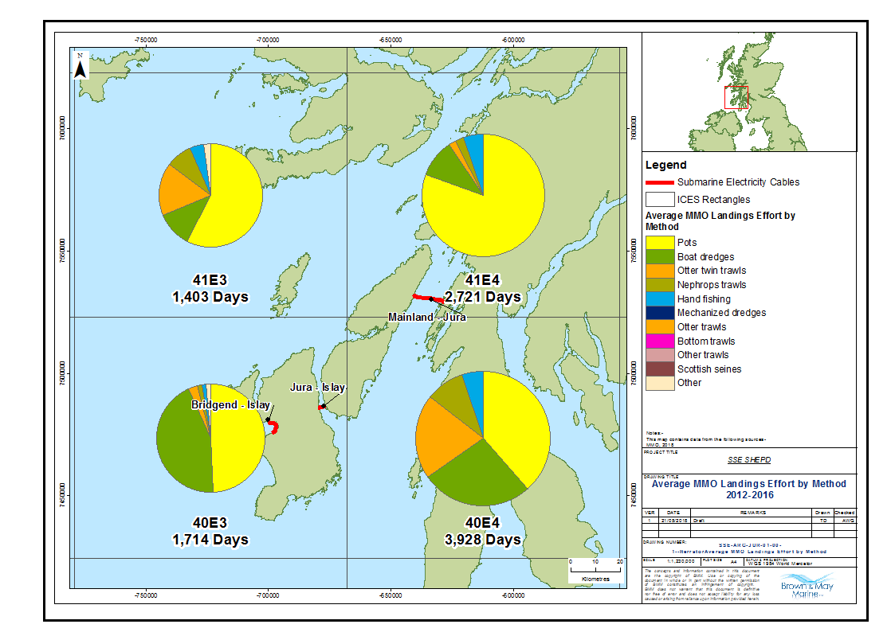
Figure 6 Average MMO Landings Effort by Method (2012 -2016)
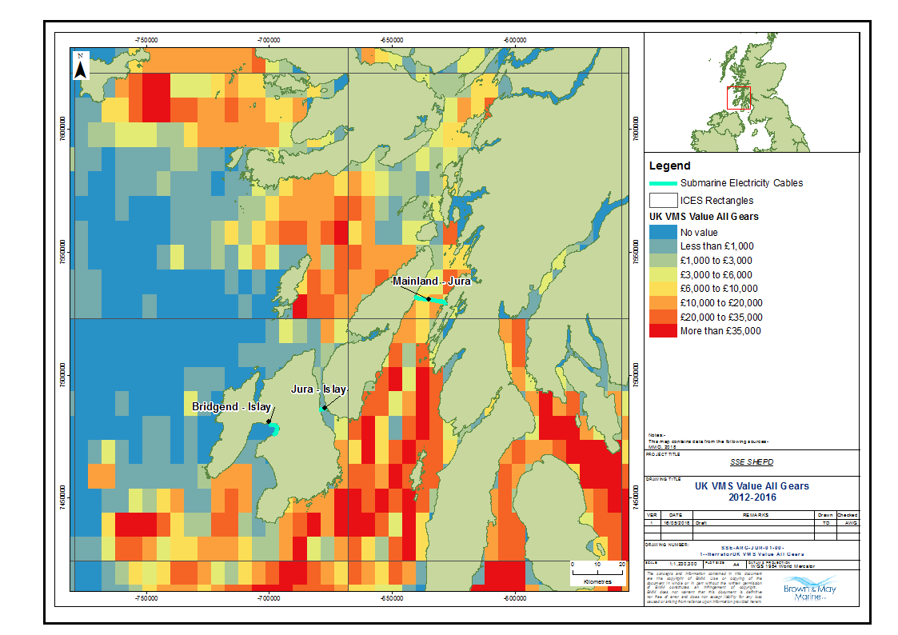
Figure 7 UK VMS Value all Gears Types (2012 - 2016)
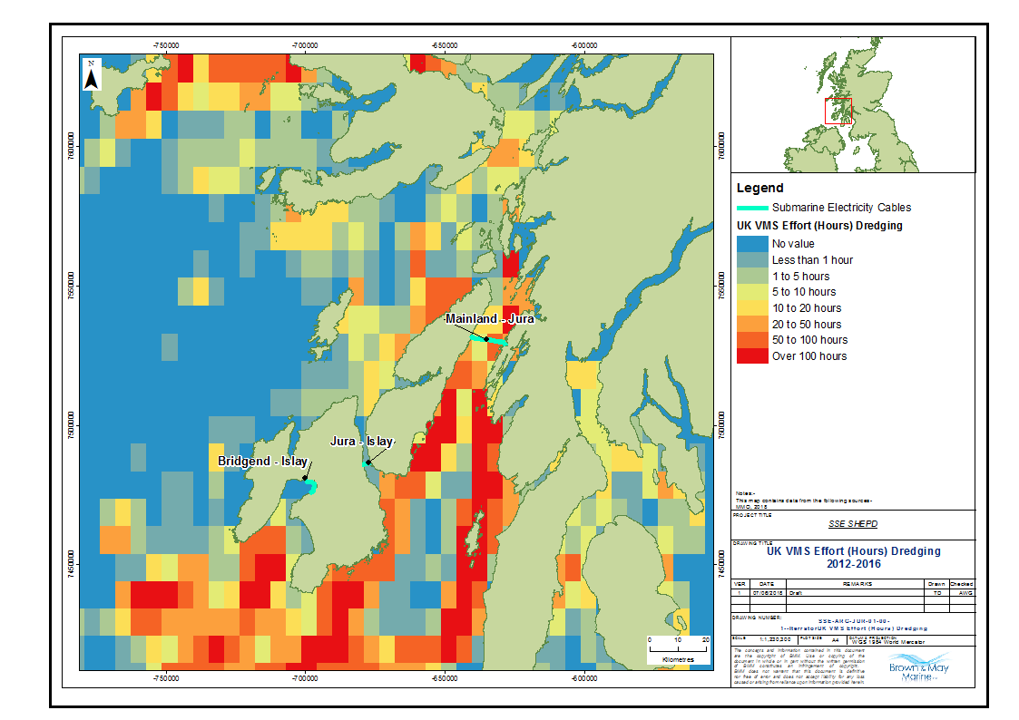
Figure 8 UK VMS Effort (Hours) Dredging (2012-2016)

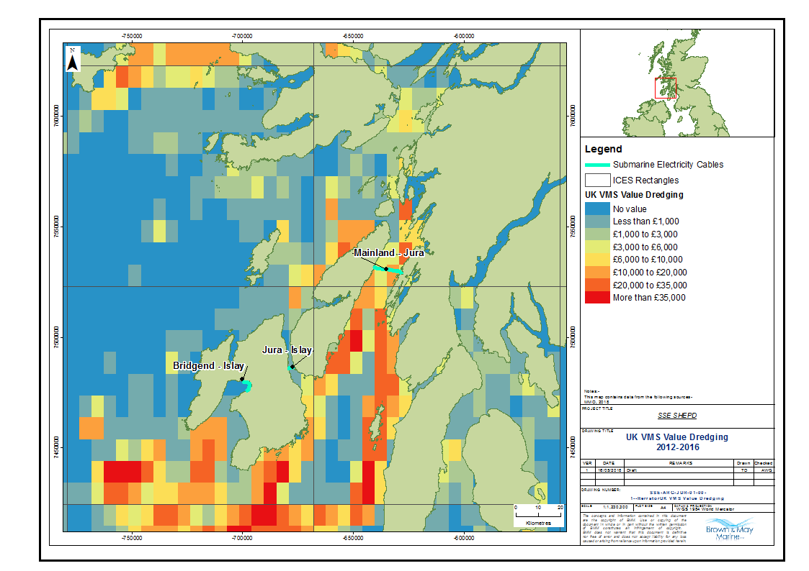
Figure 9 UK VMS Value by Dredge (2012-2016)

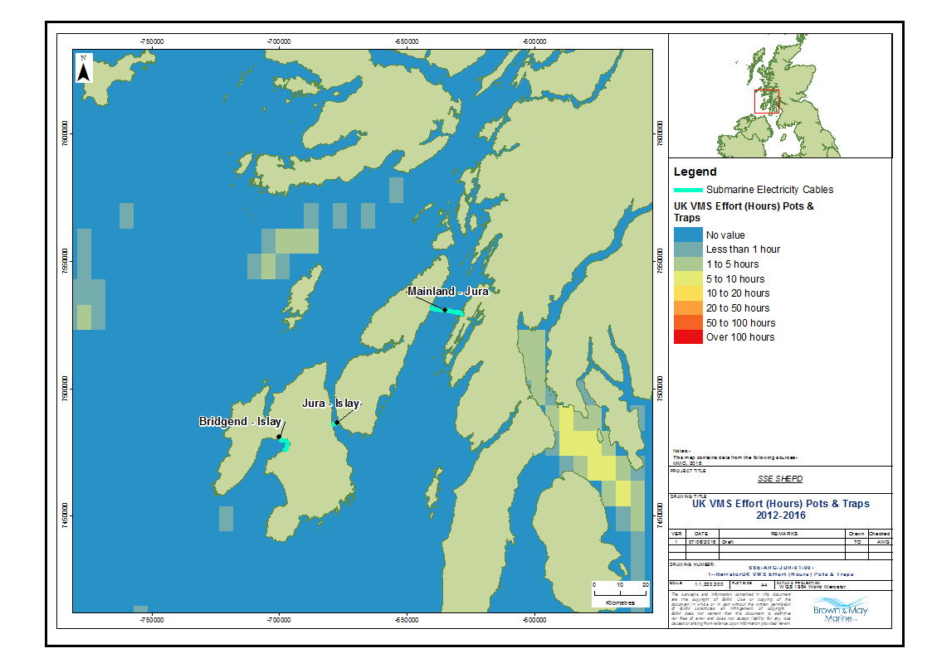
Figure 10 Average VMS Effort (Hours) for Pots and Traps (2012-2016)
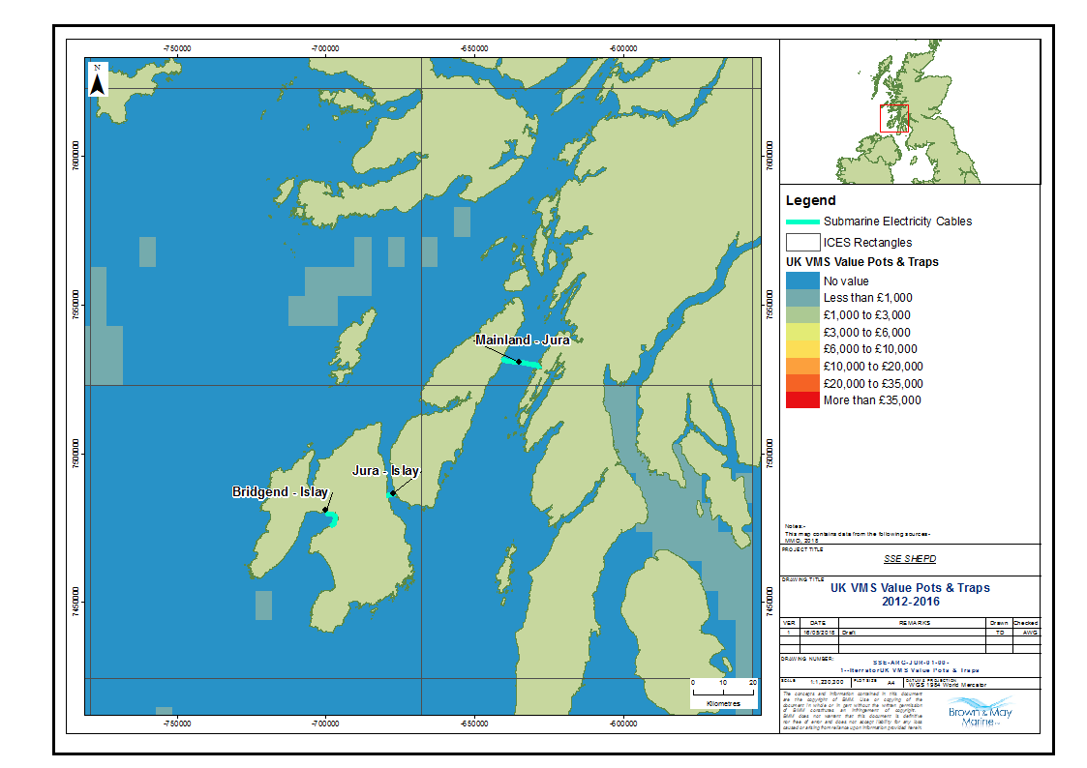
Figure 11 Average VMS Value for Pots and Traps (2012-2016)
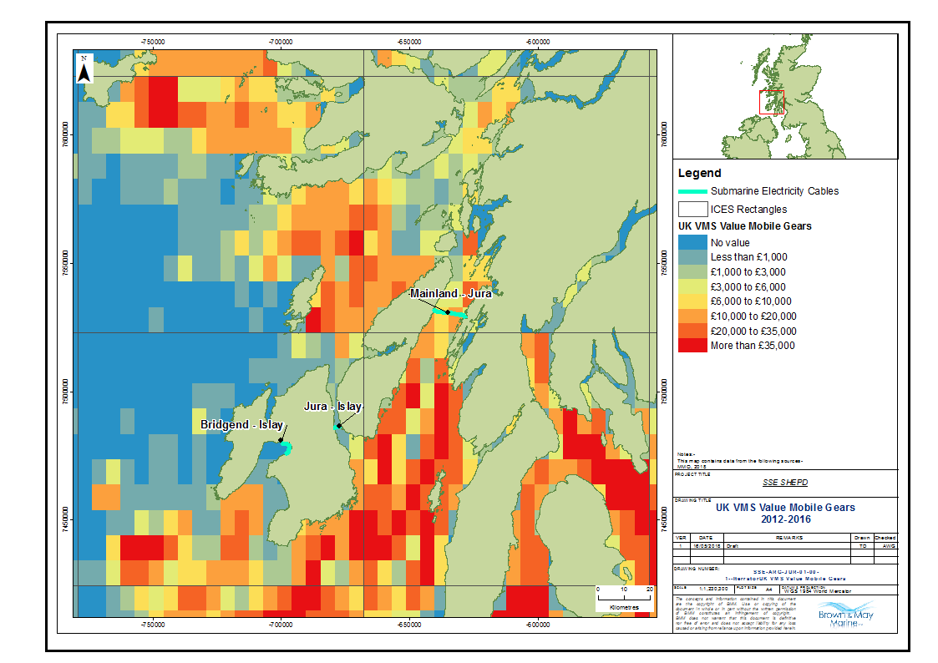
Figure 12 Average VMS Value for Mobile Gears (2012-2016)

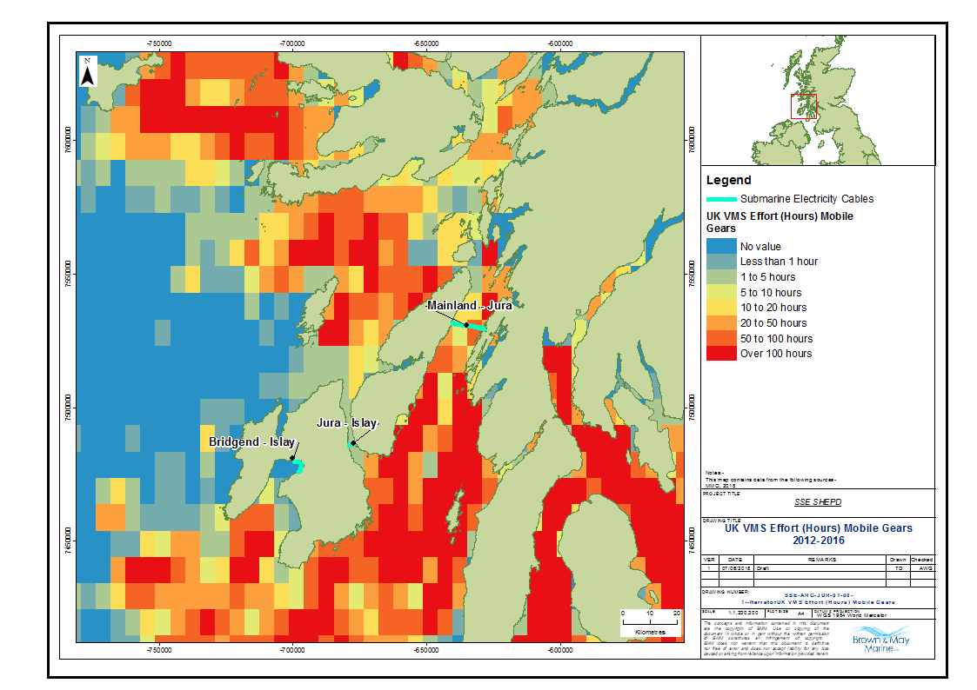
Figure 13 Average VMS Effort for Mobile Gears (Hours) (2012-2016)

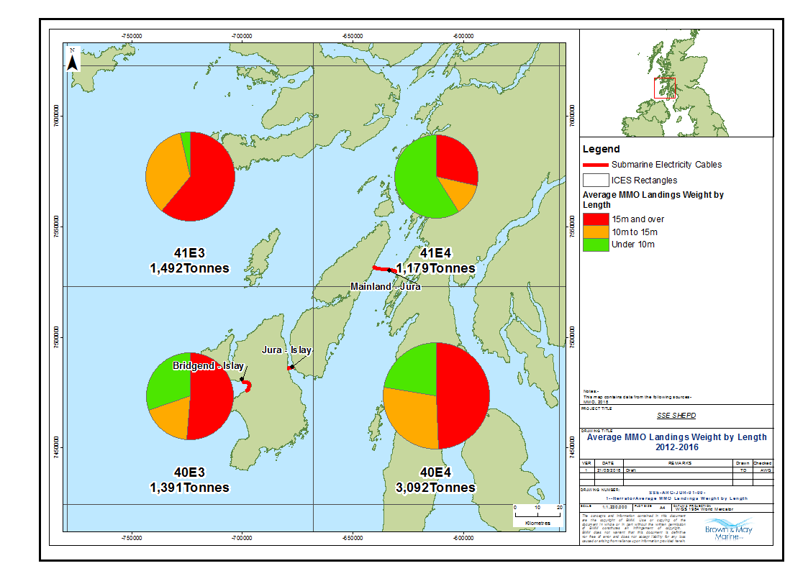
Figure 14 Average Landings Weight by Vessel length (2012-2016)

- Other Sea Users Charts
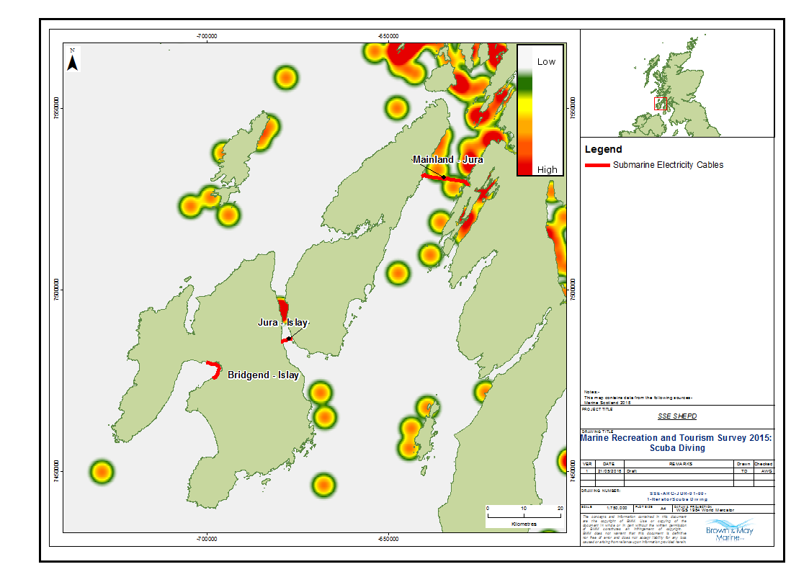
Figure 15 Scuba Diving (Source: SMRTS 2015)

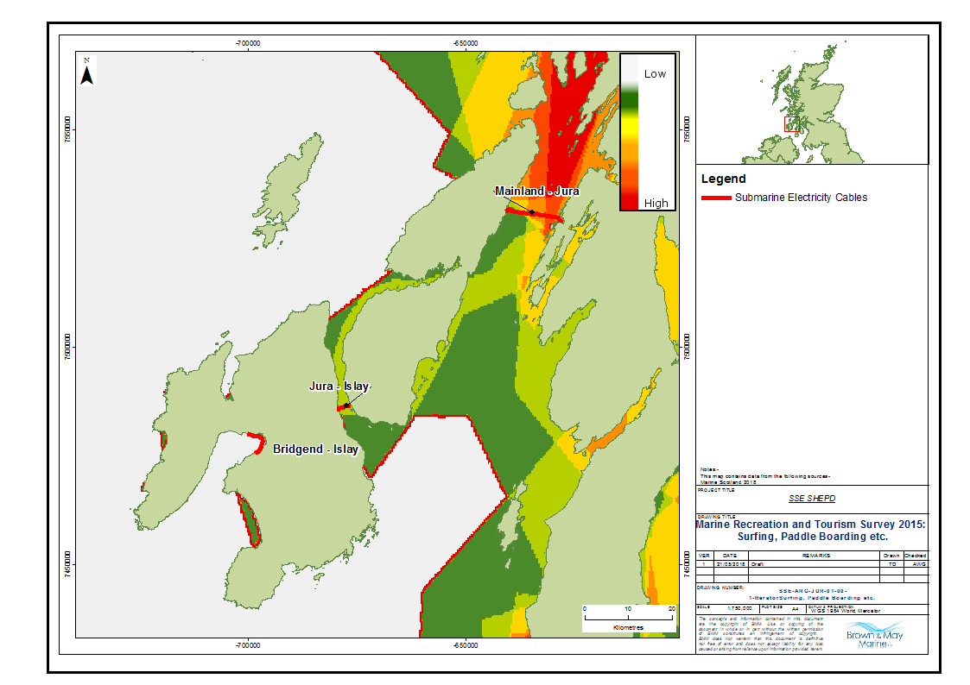
Figure 16 Surfing /Paddle Boarding (Source: SMRTS 2015)

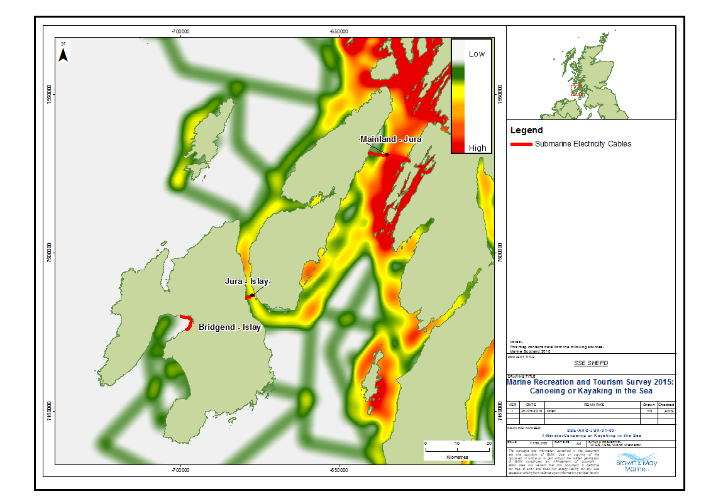
Figure 17 Canoeing or Kayaking (Source: SMRTS 2015)
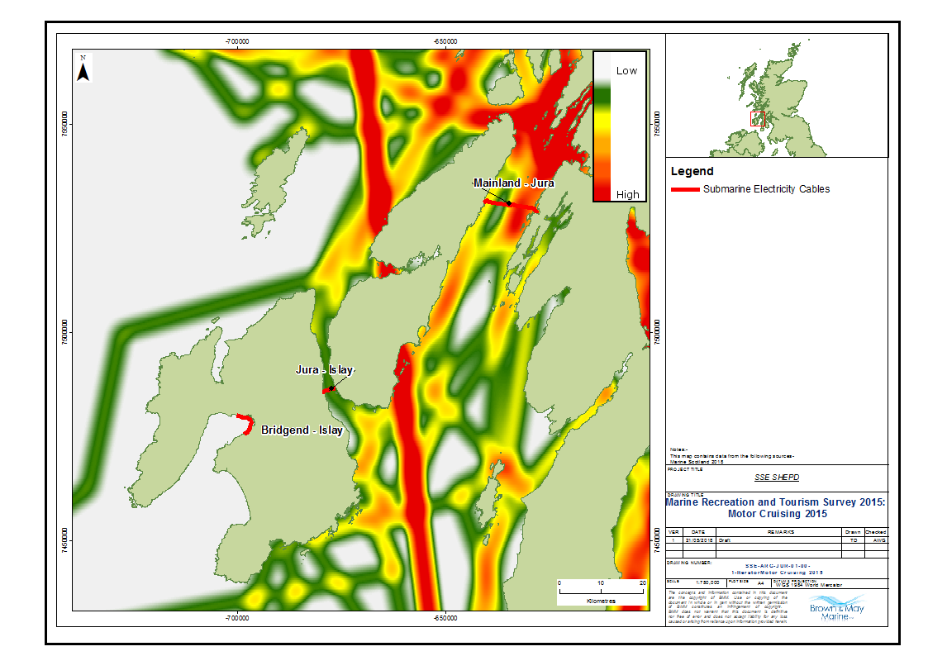
Figure 18 Motor Cruising (Source: SMRTS 2015)
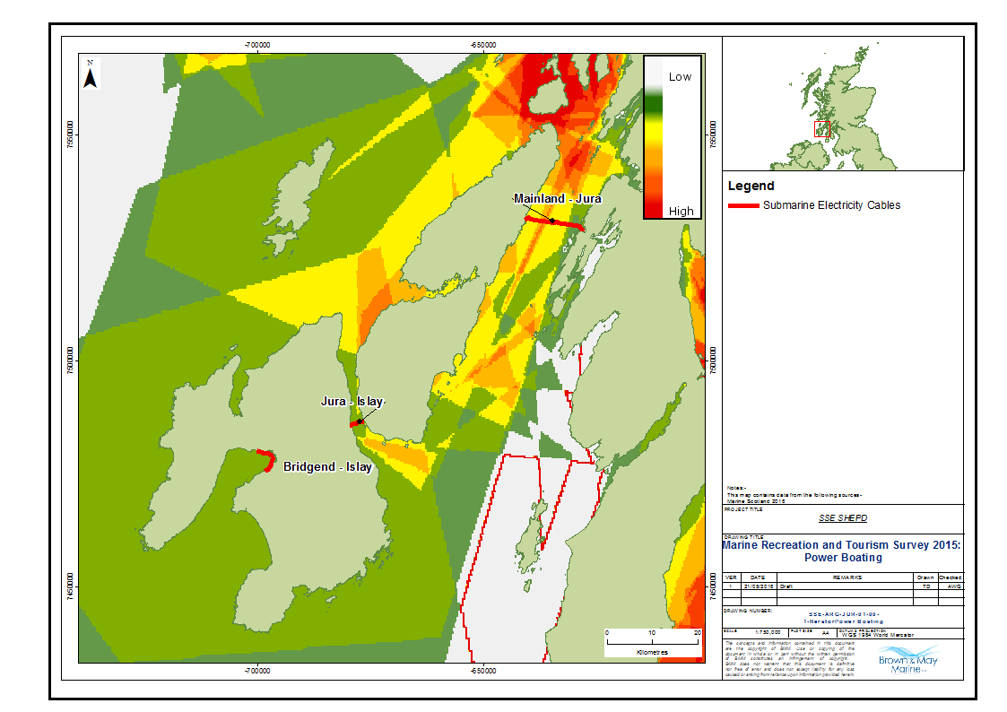
Figure 19 Power Boating (Source: SMRTS 2015)

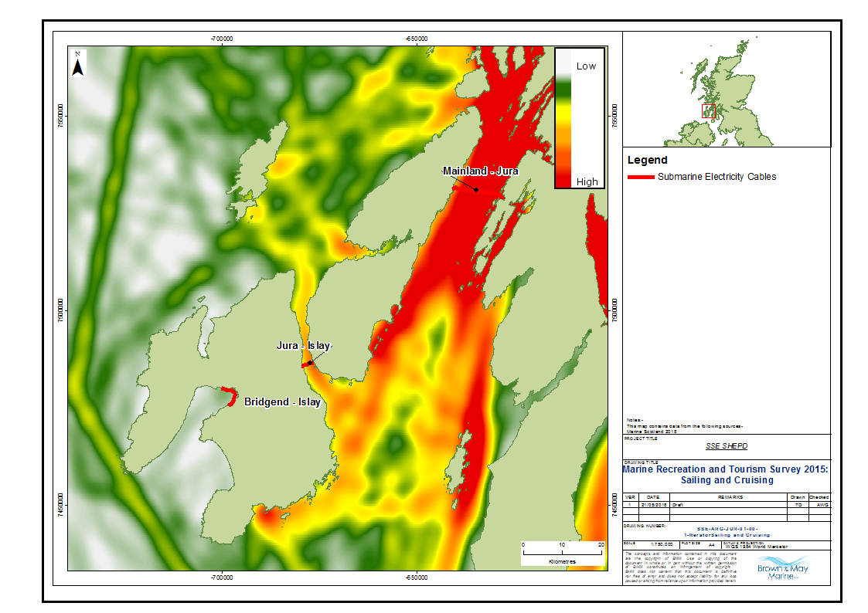
Figure 20 Sailing and Cruising (Source: SMRTS 2015)

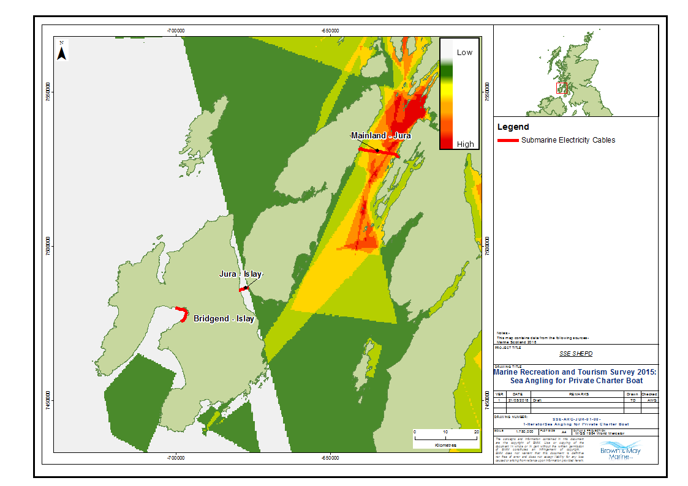
Figure 21 Sea Angling for Private Charter (Source: SMRTS 2015)
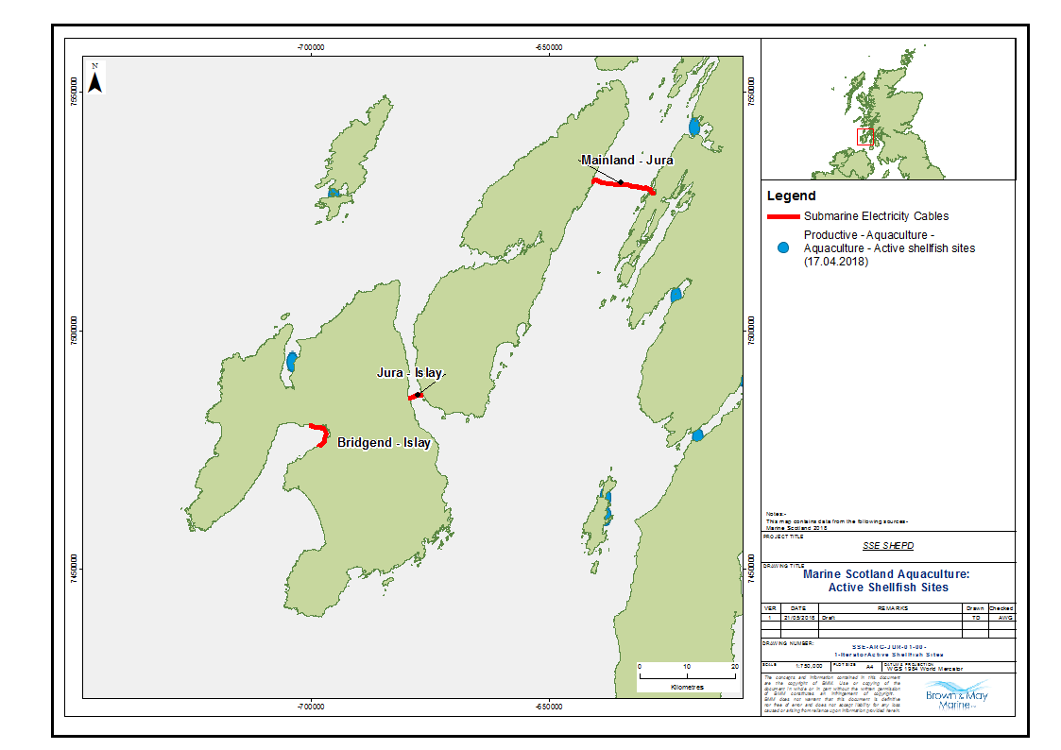
Figure 22 Active Shellfish Aquaculture Sites
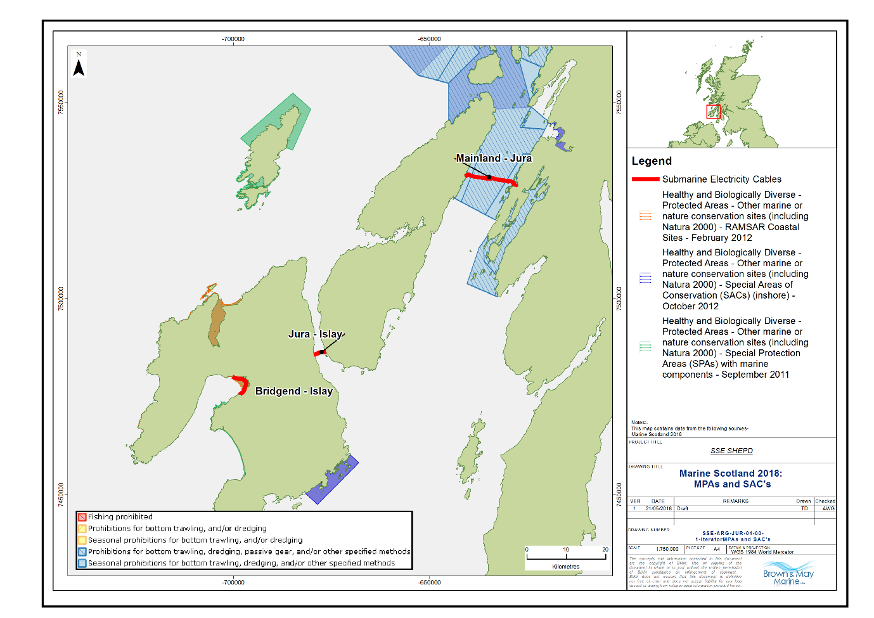
Figure 23 Conservation Zones MPA’s and SAC’s (Marine Scotland, 2018)

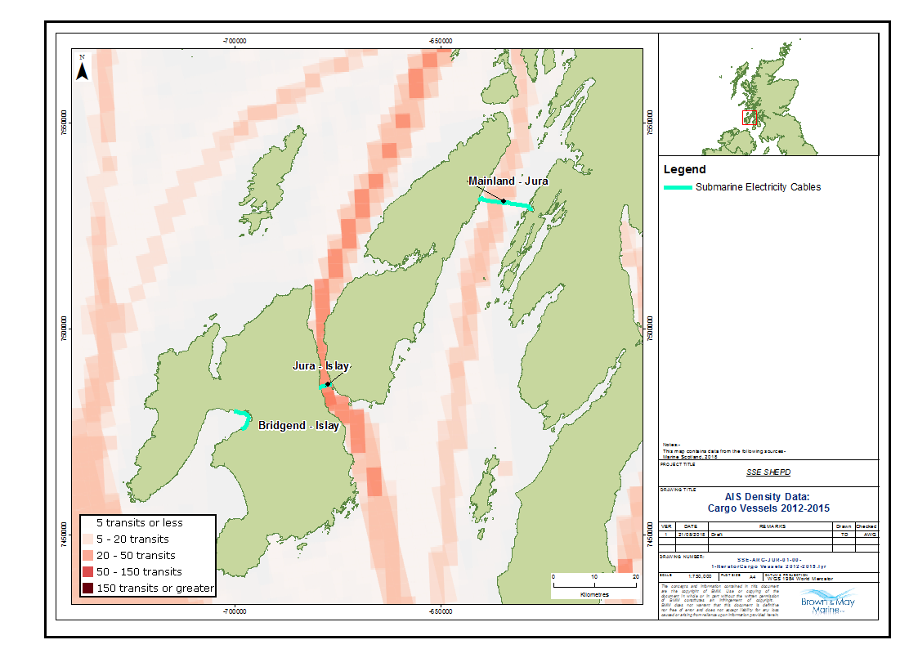
Figure 24 AIS Density for Cargo Vessels 2012-2015 (Marine Scotland, 2018)

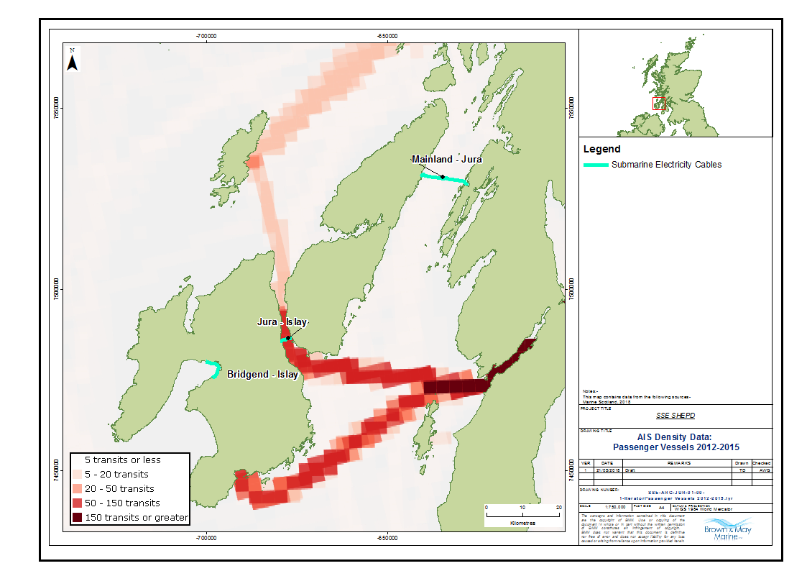
Figure 25 AIS Density for Passenger Vessels 2012-2015 (Marine Scotland, 2018)
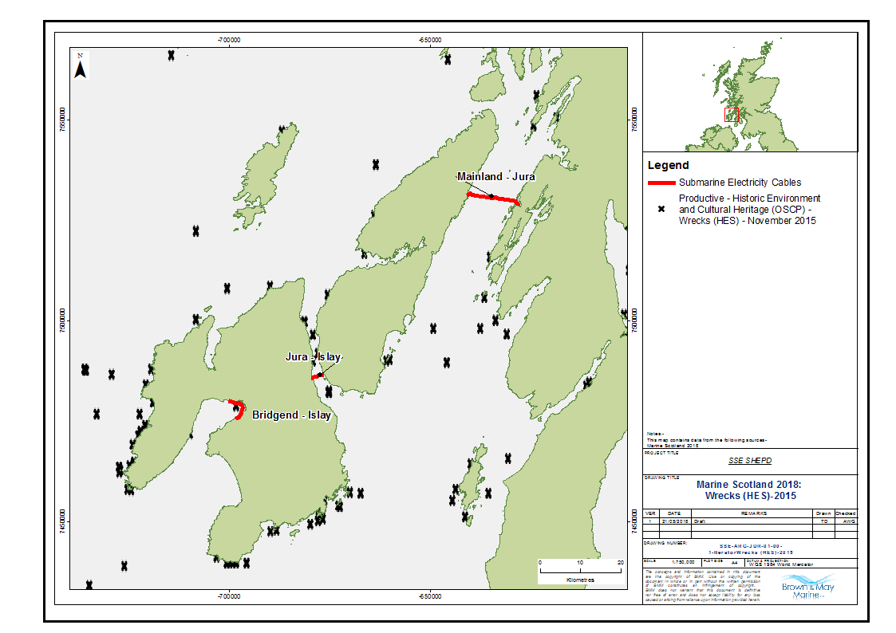
Figure 26 Marine Wreck Sites (Marine Scotland, 2018)

The Pre-application Consultation Report is required by Marine (Scotland) Act 2010: Section 24
The flyer will contain the following information: submarine electricity cable specific information; useful contacts; working area; national and regional charts; site specific charts.
For details see Appendix D: Notice to Mariners example template.
Appendix A FLMAP Standard Operating Procedures
For details see Appendix E: Communication programme
Fishing Liaison with Offshore Wind and Wet Renewables Group (FLOWW) Best Practice Guidance for Offshore Renewables Developments: Recommendations for Fishing Liaison, 2014
European Subsea Cables Association
Appendix C Marine Mitigation and Co-existence Planning
Appendix B Company Fishing Liaison Officer Specification
As detailed in Appendix F Commercial Fishing Charts
http://www.gov.scot/Resource/0049/00497904.pdf Scottish Marine Recreation and Tourism Survey (SMRTS) 2015
Marine Scotland National Marine Plan Interactive; https://marinescotland.atkinsgeospatial.com/nmpi/
Timetable of ferry services: https://www.calmac.co.uk/article/2971/Islay-Kennacraig---Port-EllenPort-Askaig
Cefas, Marine Consents and Environment Unit (MCEU), Department for Environment, Food and Rural Affairs (DEFRA) and Department of Trade and Industry (DTI) (2004) Offshore Wind Farms - Guidance note for Environmental Impact Assessment In respect of FEPA and CPA requirements, Version 2
This impact is not included in the current Cost Benefit Analysis Methodology. We will carry out a literature review to see if there is a quantifiable link between submarine electricity cable and this impact.
This impact is not included in the current Cost Benefit Analysis Methodology. We will carry out a literature review to see if there is a quantifiable link between submarine electricity cable and this impact.
This impact is not included in the current Cost Benefit Analysis Methodology. We will carry out a literature review to see if there is a quantifiable link between submarine electricity cable and this impact.
This impact is not included in the current Cost Benefit Analysis Methodology. We will carry out a literature review to see if there is a quantifiable link between submarine electricity cable and this impact.
This impact is not included in the current Cost Benefit Analysis Methodology. We will carry out a literature review to see if there is a quantifiable link between submarine electricity cable and this impact.
This impact is not included in the current Cost Benefit Analysis Methodology. We will carry out a literature review to see if there is a quantifiable link between submarine electricity cable and this impact.

