Business Case

Application guidance
Independent Framework for
Transfer and Delegation

Guidance Notes

General
Applicants should provide a business case proportionate to the scale of the project proposed. There is no template provided for your business case, nor have word limits been set. However, when compiling your business case, please use the six section headings noted below and try to be as succinct as possible.

Please note that supporting information on transfer and delegation is available on both Crown Estate Scotland and Scottish Government: Marine Scotland Information websites. Specifically, A Guide to a Successful Application and Community Engagement Guidance should be consulted alongside completing this business case.

Your completed business case should be e-mailed to the Crown Estate Strategy Unit (CESU) within the Scottish Government at CESU@gov.scot with the subject title as ‘Full Business Case’ and your ‘Organisation Name’. Please use the format Proposal Name: Document Name when naming any documents.

Business Case Section Headings
Please use the following section headings as the basis of your business case.

General
Please provide the following details:
- Organisation name and contact details.
- Name of proposal
- Name of the asset(s)/location(s) and nature of management sought (transfer or delegation)
- Project summary, noting key locations, activities and aims. (C. 200 words as a guide)

Please note, non-personal details will be available to the public to support community awareness and engagement in the development of the proposal.

Your Proposal

Your Proposal Overview, Aims and Objectives
Please use this section to outline your organisation’s proposal including aims and objectives and their alignment to key national or local strategies or outcomes.

This should include the nature of the proposal and the assets covered by the proposal. You should also include the management approach (stating clearly whether it is transfer or delegation that is being sought), the timescale, geographical scale (including a map), mapping of your outcomes to the National Performance Framework and identification of the key individuals and their relevant skills relating to the proposal.

When describing the location of the proposed works, include a list of the positions outlining the boundary of the asset area. Digitised GIS data is also acceptable, i.e. in the form of a shapefile.

Positions should be provided by supplying coordinates. Please state the coordinate reference system used, e.g. British National Grid or WGS84. You should consider the suitability of the coordinate reference system used for your specific geographic location. For exclusively land based, or very near coast, British National Grid is recommended. For areas further offshore, WGS84 is a recommended coordinate reference system.

BNG positions take the form of Eastings and Northings and are expressed as 2 numbers representing distance from an initial point.
Example
Eastings: 386639, and Northings: 853666.
This can also be expressed as an X and Y position on some resources. E.g. 386639, 853666

Under WGS84, positions can be provided as coordinates (Latitude and Longitude). This differs from the eastings and northings as they are presented in Degrees, Minutes and Seconds.
Coordinates provided in this format should take the form:
55°55’44’’N 2°22’11’’W, if seconds are used or, 55° 55.555’N 002° 22.222’W if using decimal minutes. Decimal degrees are also accepted (55.51234N, 2.12345W).

It is important that the correct positions, in the correct format, are included with this business case, as any errors will result in delays to your application being progressed.

Please also include within your business case, a map of the proposed area of sufficient scale and accuracy to enable mapping of the boundaries. Alternatively, if digitised GIS data is included in your business, provide an indicative map. Any map should be marked to indicate:

• the full extent of the asset in question
• the coordinates defining the location of the asset

If they are subject to copyright, it is the responsibility of the applicant to obtain necessary approvals to reproduce the documents and to submit suitably annotated copies with the application.

Online resources are available to assist with determining the approximate location of co-ordinates, such as Grid Reference Finder.

If required, GIS Support is available from Crown Estate Scotland – please email CESU@gov.scot if you wish to request this support.

Finance
Please provide relevant budget or financial projections that underpin your proposal. Please also indicate any assumptions you have made in drawing these projections together including an indication of how you will meet any financial liabilities connected to the asset, if management of that asset is transferred to you.

Enhancing Value
The Scottish Crown Estate must be managed in a way to ensure that it contributes to the sustainable development of Scotland. Managers of assets have a key duty to maintain and seek to enhance the value of these and the income arising from them. Please tell us how you think your proposal will achieve this, including:

- What potential costs/savings result from your proposal?
- How the assets will be managed in a way that is likely to contribute to:
  - Social Wellbeing
  - Environmental Wellbeing
  - Regeneration
  - Economic Development
- Does your proposal focus in any particular area, e.g. economic development or environmental wellbeing, if so why?
Applicants should build upon the Expression of Interest (EOI) by detailing potential costs and savings that may occur as a result of the proposal and any increase or reduction in regulatory burden.

Community Engagement
Both the word and the spirit of the Scottish Crown Estate Act 2019 encourage, support and demand strong community engagement in management of the Estate. Involving the wider community is an integral part of managing the asset. The power to transfer or delegate aspects of management of the Crown Estate in Scotland exists to support community aspiration and enable more local impact on decision making. The process of applying to take on transfer or delegation of management functions therefore requires significant community input to the design of proposals, as well as a commitment to real and ongoing partnership with affected organisations and communities.

The guiding principles are that community engagement should be effective, fair and efficient, for both the participant and the organisation undertaking the work. This means engagement must meet the needs and expectations of the people involved, be well informed and properly planned, and give people who may face additional barriers to getting involved an equal opportunity to participate.

Please use this section to tell us about the people you expect to be most impacted by your proposal. This could include relevant stakeholders, tenants and other users of the proposal area and how you plan to engage them with the application. You may find that an engagement plan will help to lay out your activities in an accessible way.

Guidance on community engagement can be found here.

Relationship management
Please tell us about other interests associated with the proposal areas and how you plan to manage any possible conflicts of interest that may arise. It may be helpful to build a stakeholder map for your proposal which takes in geographical, sectoral and interest groups. This could be accompanied by a conflicts matrix if you feel there may be a need to manage multiple interests/uses in a confined space.

Applicants are recommended to consult the Crown Estate Scotland Interactive Map to identify current tenants in or adjacent to the proposal area.

Risk
Please tell us about the risks associated with your proposal and how you plan to manage them.
This should include the liabilities and risks associated with the proposal including a risk register incorporating potential impacts on all users of the asset as well as the measures you are taking or plan to take to control/manage the risk.
In developing this register please note the current definitions, measures and scoring used by Crown Estate Scotland. This information will be shared with you as part of your EOI feedback along with a steer in terms of existing risks being managed by the current manager - which should also help you in the development of this section.

Impact Assessments
Please complete appropriate impact assessments that relate to your proposal, if an impact assessment is not considered as appropriate please provide the rational as to why the impact assessment has not been undertaken. Please see a list of potential impact assessments below:
- Equality Impact Assessment (EQIA)
- Business and Regulatory Impact Assessments (BRIAs)
- Child Rights and Wellbeing Impact Assessment (CRWIA)
- Fairer Scotland Duty
- Island Community Impact Assessment (ICIA)
- Strategic Environmental Assessment (SEA)

Declaration
Please add the following declaration to your submission:

“By signing below, I acknowledge that I have read the supporting information. I also agree that I have full authority to submit this expression of interest on behalf of the organisation and all information submitted is correct and true.”

Signature____________________________________________ Date_____________________
Please note that a typed signature is accepted.

Supporting Document Checklist
Please use the following checklist to ensure you have included all relevant information:
- A budget/financial projections for your project
- Names and details of relevant contacts including those who will have access to confidential information.
- A map of your project area including assets targeted by the proposal. If required, GIS Support is available from Crown Estate Scotland – please email
CESU@gov.scot if you wish to request this support.
- A risk register including proposed control measures.
- Copies of relevant documentation
  - e.g. − Data Protection Policy (including GDPR)
  - Health and Safety Policy
  - Environmental Policy
  - Any other relevant documents such as copies of relevant insurance etc
- Impact Assessments

Any additional documents should be labelled in the format Proposal Name: Document Name

What Happens Next?
Please note that the submission of a full business case does not form a guarantee of your proposal being granted. Your business case will be reviewed by the full assessment panel and the appropriate due diligence of your organisation will be carried out as part of this process.

We aim to respond to your proposal within 30 working days. However, we may be unable to respond within this timeframe if your proposal is particularly complex. Should your proposal take longer to review, we aim to send you a further acknowledgement advising you when we will be able to respond.
If your proposal is to progress beyond the business case submission stage, a CESU officer will continue to liaise with you on the next steps. These will include detailed discussions necessary for your proposal to be progressed, Scottish Ministers carrying out a public consultation and terms for either a transfer or delegation being drafted and scrutinised (see figure 1 below.)

Scottish Ministers are the ultimate decision makers in this process and only when the full application process has concluded, will proposals be approved or not.

Figure 1. Steps of the application process for transfer or delegation 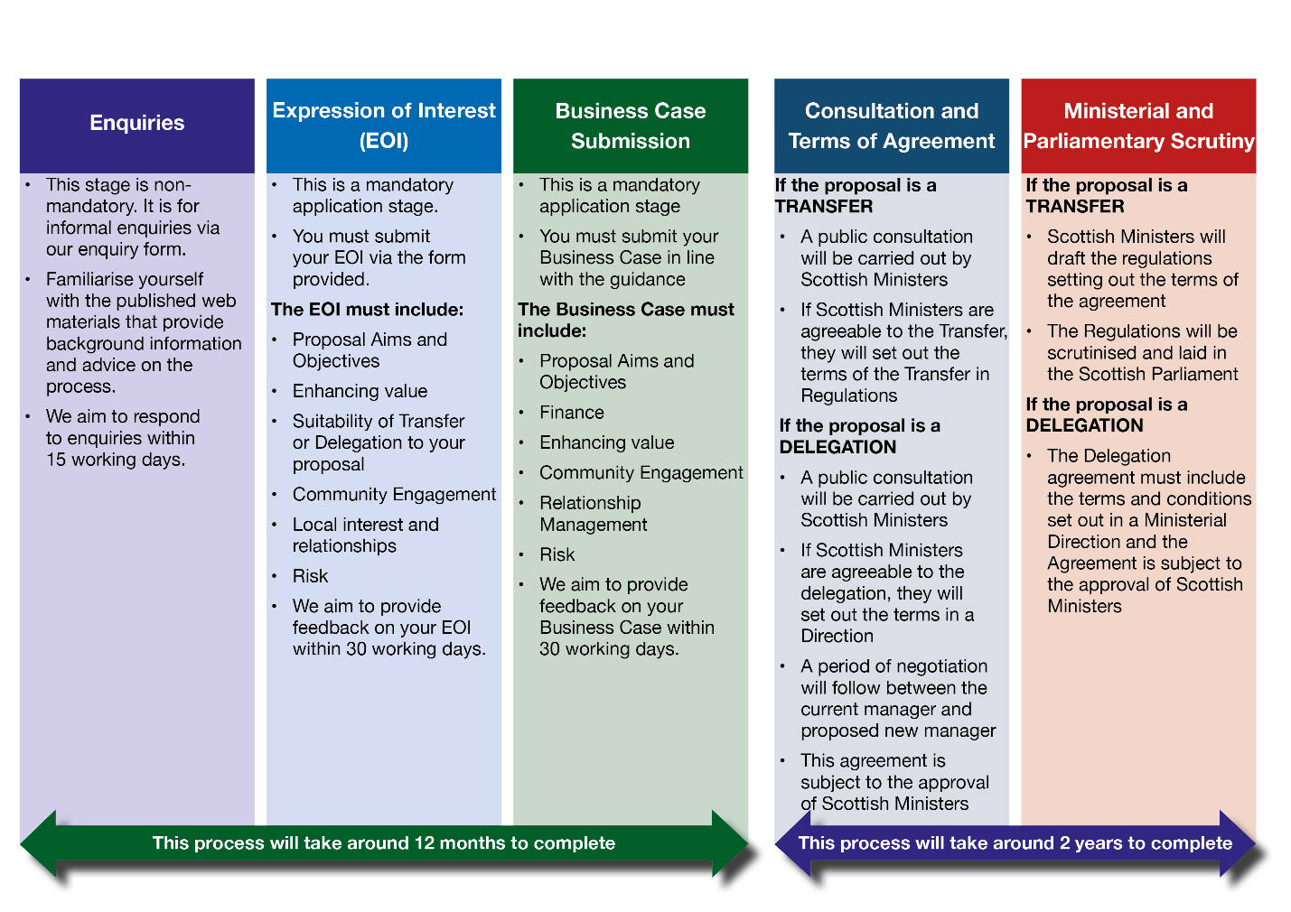

Privacy Policy
Our privacy policy can be found here

