## A828 Connel Bridge Refurbishment - Summary of Proposed Works

The proposed works is as follows:

1. Installation of a Temporary Walkway
2. Deck Replacement
3. Overhead Beam Modification
4. Ancillary Works

It has been confirmed through previous correspondence with Argyll and Bute Council that the planned painting of the bridge will not require Listed Building Consent or Planning permission.

## Temporary Walkway

A temporary walkway is to be installed to the east elevation of the bridge. This will allow pedestrians full, unrestricted access throughout Phase 2 – Deck Replacement. It is planned for the walkway to start and terminate at the ends of the steel bridge section (indicative sketches below).



Figure – Indicative plan of walkway



Figure – Indicative section of walkway

The footway will be 1.5m wide with 1.4m high parapets and will likely be made from steel and/or aluminium components.

To aid the passing of wheelchairs, passing places will be specified at 4no locations on the walkway. It is noted that the existing footway on the bridge is 1.2 metres.

The longitudinal gradient will be no steeper than 1 in 20 (5%) and appropriate lighting and surfacing will be installed.

At the entry and exit points of the walkway, a section of the masonry and steel parapets will have to be temporarily removed (see Figure 3). This will be reinstated when the walkway is removed.

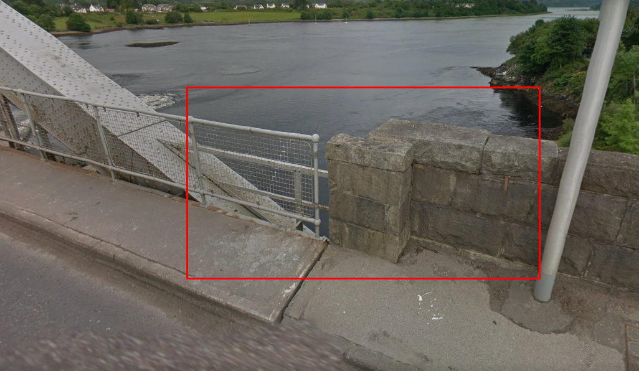

Figure – Section of parapet to be removed

The BT telecommunication cables will be diverted to the outside of the east truss elevation, under the temporary walkway. This will clear the service bay area, leaving only the water main. The water main will be renewed within the extents of the existing service bay.

It is planned to complete the design and construction of the walkway in the Financial Year 2021/22.

## Deck Replacement (Phase 2)

In advance of the deck replacement, the supporting steelwork below will be modified to ensure it can sustain the load of the new deck.

New, 20mm thick steel plates (stiffeners) will be welded to each of the 51cross girders. To provide a fixed point for deck sliding, new longitudinal restraints will be installed at 3 locations on the bridge. The diagrams below highlight the new deck, footway structure, longitudinal restraint and stiffeners.

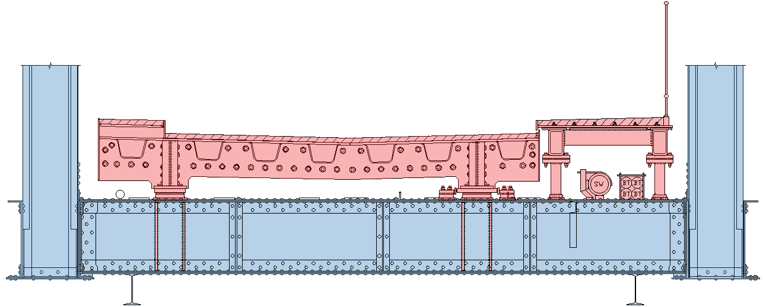

Figure – Cross section. New elements highlighted in red. Existing highlighted in blue.

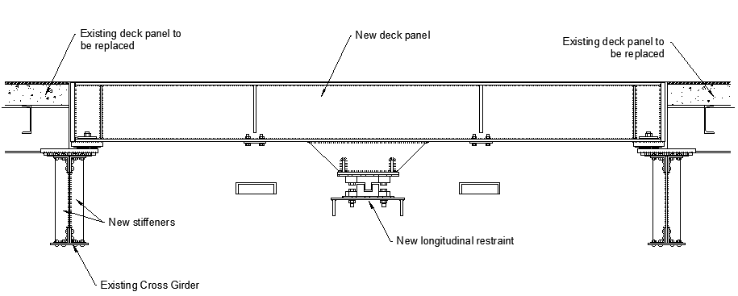

Figure 5 – Longitudinal section of new deck/longitudinal restraint

### 2.1 Deck Design

The carriageway bridge deck will be a steel orthotropic design, with two longitudinal beams spanning each of the 51no. cross girders. The new steel deck will replace the existing composite concrete/steel deck.

The permanent footway will also be made of steel and will be a separate structure, comprising of two longitudinal box beams supporting a deck plate. This in turn, will be supported by 2no. posts footed at every cross girder.

From road level, there will be little change in appearance from the existing deck to the new deck. The kerb lines currently seen on the existing deck will appear to be slightly different. The lateral position of the kerbs will remain the same, but instead of concrete kerbs seen on the current view, there will be steel plates installed as upstands.

From below, there will also be very little change in appearance. At distance, the bridge deck will appear the same colour and configuration.

The ‘saw-toothed’ expansion joints between cantilever spans and suspended span will be replaced by the same type of expansion joint.

2no. rail expansion joints will be installed to each of the joints between the steel bridge and masonry approaches.

|  |  |
| --- | --- |
| Figure 6 – Existing saw-tooth joint | Figure 7 - Example of a new saw-tooth joint |
|  |  |
| Figure 8 – Existing ‘Plug’ joint | Figure 9 – Example of new modular rail joint |
|  |  |

24no. drainage gullies will be installed to the centre of the carriageway. These will be installed to each intermittent deck panel and will have the same location and appearance as existing.

## Overhead Steelwork Modification (Phase 3)

To mitigate bridge strikes, overhead steelwork will be modified to increase the available headroom. It is planned to execute this task during the bridge painting phase, to utilise scaffolding access.

The method can be seen below.

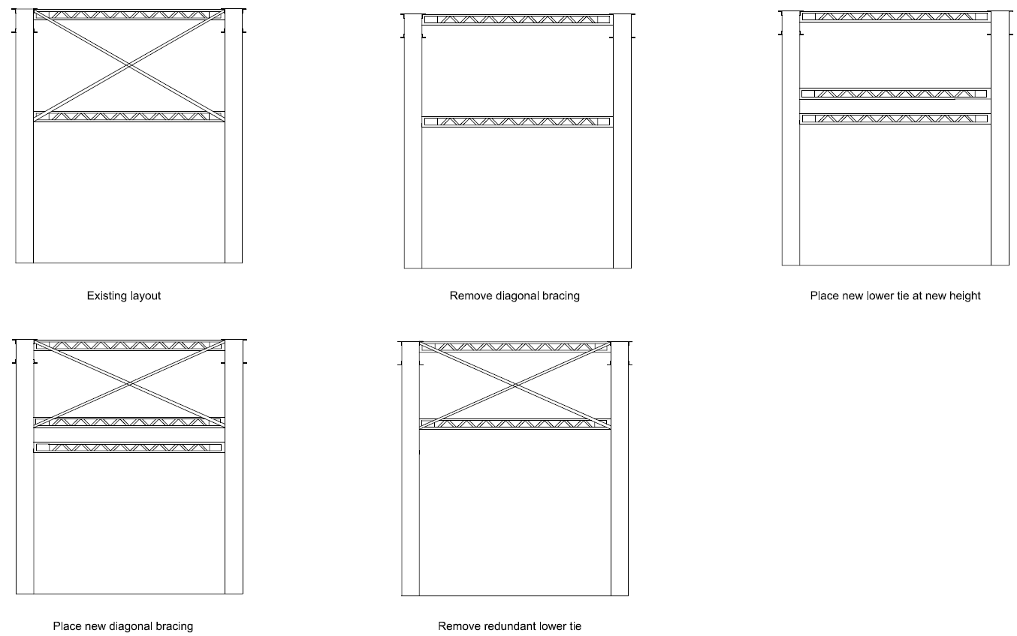

Figure 10 – Concept procedure for modifying overhead steelwork

Firstly, the cross bracing and lower horizontal beams will be unfastened. The cross-bracing beams will be cut to size, and a new horizontal beam will be installed.

The above procedure will apply to 21 of the straight horizontal beams, as they are necessary to retain the lateral stability of the bridge. 22no. other horizontal beams, which carry no lateral loading shall be removed (Figure 11). It is thought these redundant beams were used to support cable trays (now removed).

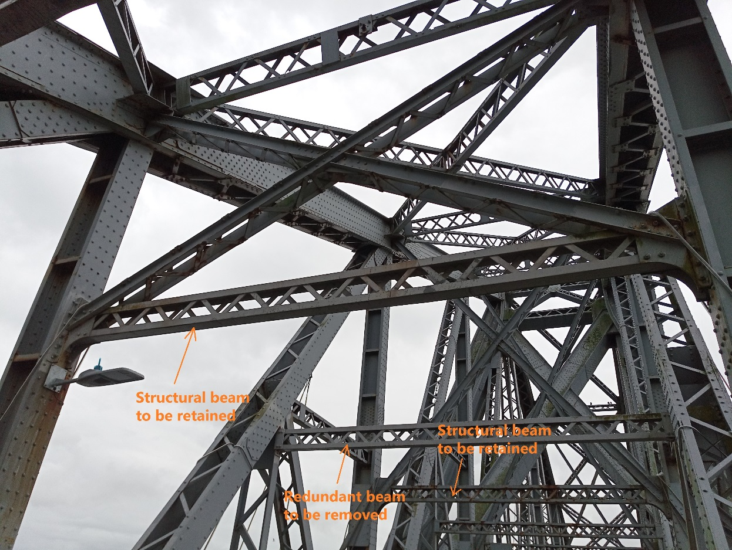

Figure 11 – Photo showing overhead beams to be retained or removed after modifications

The curved beams at the portal ends will be moved up the inclined plane of the Back Ties of the bridge (see Figure 12). The cross bracing (highlighted in blue) will be shortened to fit.

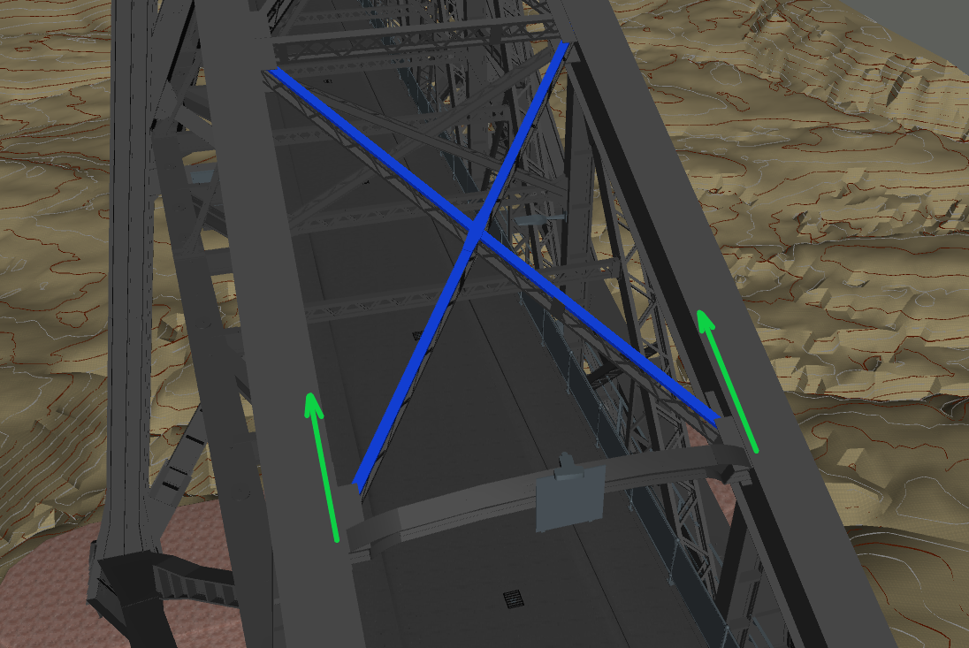

Back Tie

Figure 12 – Concept for modification at the curved overhead beams

New inclined members will be installed to the outer sides of 6no. portals, so that they connect with the new horizontal beams at their raised height (Figure 13).

Figure 13 – Outer inclined member to be replaced

## Ancillary Works

*4.1 Refurbishment to Masonry Viaducts and Abutment*

The two masonry viaduct approaches and the two masonry piers of the bridge have some vegetation build-up. Some mortar loss was also visible from previous inspections. According to the 2017 Principal Inspection, the masonry approaches appear to have some water seeping through the spandrel wall above the spring line. There is currently no provision for surface water drainage to the masonry arch structures.

To address the issue of water seepage, drainage will be installed to the carriageway surface of the masonry approach viaducts.

Defective or missing mortar will be renewed or applied to the whole masonry approach structures. Mortar repairs and de-vegetation will also be carried out to the masonry piers (as shown below).

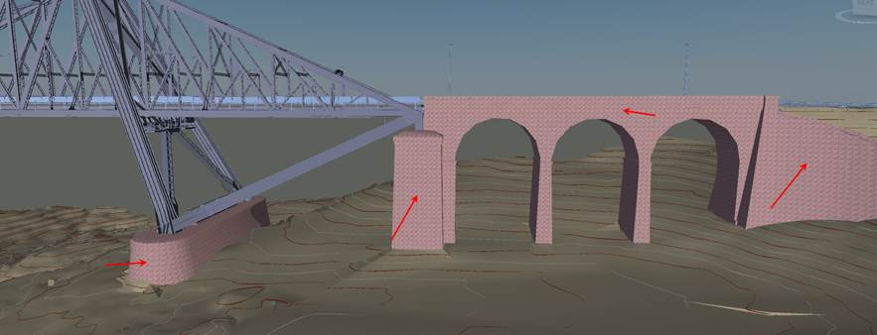

Figure 14 – North Masonry Viaduct and abutment

*4.2 Installation of Anchor Chamber Covering Hatches*

The anchor ties are critical bridge elements, anchoring the cantilever spans to the masonry piers at the north and south ends of the bridge. The 4no. ties are situated in 7.8m deep chambers, then below this level the ties are encased in concrete.

From recent inspections, two of the chambers can fill with water as their drainage appears to be blocked. New the drainage is proposed to the 2no. blocked chambers and covering hatches are proposed to the top openings of all 4 chambers. This will stop rain water entering the chambers and also provide a sheltered environment for the critical anchor ties.

The hatches will be of steel and neoprene construction.

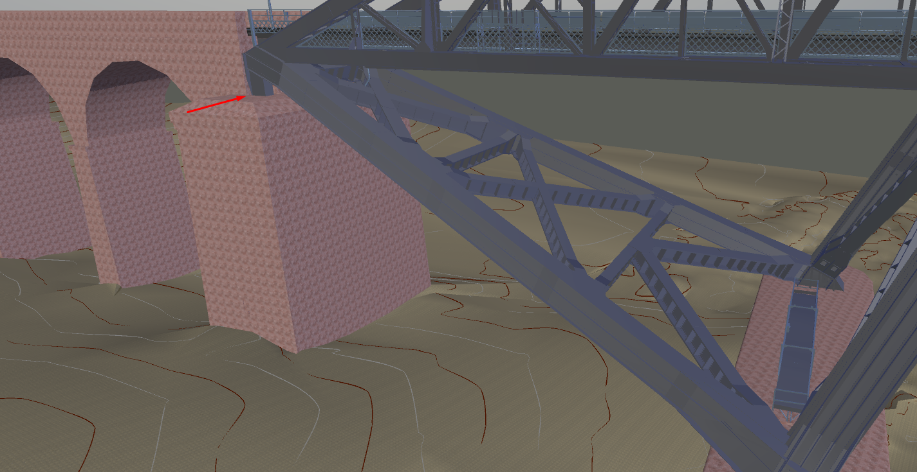

Figure 15 – Location of 1 of 4 anchor chamber openings

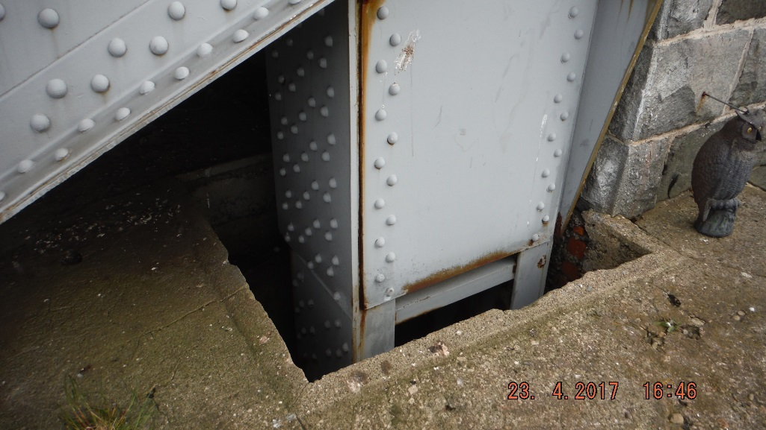

Figure 16 – Opening of anchor chamber